**Department of Computer Science**

**Lab Manual**

**of**

**SPEECH PROCESSING AND RECOGNITION**

**MAI574**

**Class Name: V MScAIML**

**Master of Science Artifitial Intelligence and Machine Learning**

**2025-26**

**Prepared by: (your name) Verified by: Faculty name:**

**Department Overview**

Department of Computer Science of CHRIST (Deemed to be University) strives to shape outstanding computer professionals with ethical and human values to reshape nation’s destiny. The training imparted aims to prepare young minds for the challenging opportunities in the IT industry with a global awareness rooted in the Indian soil, nourished and supported by experts in the field.

**Vision**

The Department of Computer Science endeavours to imbibe the vision of the University “**Excellence and Service”**. The department is committed to this philosophy which pervades every aspect and functioning of the department.

**Mission**

“To develop IT professionals with ethical and human values”. To accomplish our mission, the department encourages students to apply their acquired knowledge and skills towards professional achievements in their career. The department also moulds the students to be socially responsible and ethically sound.

**Introduction to the Programme**

Machines are gaining more intelligence to perform human like tasks. Artificial Intelligence has spanned across the world irrespective of domains. MSc (Artificial Intelligence and Machine Learning) will enable to capitalize this wide spectrum of opportunities to the candidates who aspire to master the skill sets with a research bent. The curriculum supports the students to obtain adequate knowledge in the theory of artificial intelligence with hands-on experience in relevant domains with tools and techniques to address the latest demands from the industry. Also, c andidates gain exposure to research models and industry standard application development in specialized domains through guest lectures, seminars, industry offered electives, projects, internships, etc.

**Programme Objective**

● To acquire in-depth understanding of the theoretical concepts in Artificial Intelligence and Machine Learning

● To gain practical experience in programming tools for Data Engineering, Knowledge Representation, Artificial intelligence, Machine learning, Natural Language Processing and Computer Vision.

● To strengthen the research and development of intelligent applications skills through specialization based real time projects.

● To imbibe quality research and develop solutions to the social issues.

Programme Outcomes:

PO1 : Conduct investigation and develop innovative solutions for real world problems in industry and research establishments related to Artificial Intelligence and Machine Learning PO2 : Apply programming principles and practices for developing automation solutions to meet future business and society needs.

PO3 : Ability to use or develop the right tools to develop high end intelligent systems

PO4 : Adopt professional and ethical practices in Artificial Intelligence application development

PO5 : Understand the importance and the judicious use of technology for the sustainability of the environment.

**MAI574– SPEECH PROCESSING AND RECOGNITION**

**Total Teaching Hours for Semester: 75 (3+4)**

**Max Marks:150                         Credits: 5**

**Course Objectives**

This course enables the learners to understand fundamentals of speech recognition, speech production and representation. It also enables the learners to impart knowledge on automatic speech recognition and pattern comparison techniques. This course helps the learners to develop automatic speech recognition model for different applications.

**Course Outcomes**

**After successful completion of this course students will be able to**

CO1: Understand the speech signals and represent the signal in time and frequency domain.

CO2: Analyze different signal processing and speech recognition methods.

CO3: Implement pattern comparison techniques and Hidden Markov Models (HMM)

CO4: Develop speech recognition system for real time problems.

**Unit-1         Teaching Hours: 15**

**FUNDAMENTALS OF SPEECH RECOGNITION**

Introduction- The Paradigm for Speech Recognition- Brief History of speech recognition research- The Speech Signal: The process of speech production and perception in human beings- the speech production system- representing speech in time and frequency domain- speech sounds and features.

**Lab Programs:**

1. Implement the task that takes in the audio as input and converts it to text.
2. Apply Fourier transform and calculate a frequency spectrum for a signal in the time domain.

**Unit-2                 Teaching Hours: 15**

**2.1 APPROACHES TO AUTOMATIC SPEECH RECOGNITION BY MACHINE:**

The acoustic phonetic approach-The pattern recognition approach-The artificial intelligence approach.

**2.2 SIGNAL PROCESSING AND ANALYSIS METHODS FOR SPEECH RECOGNITION:**

Introduction- spectral analysis models- the bank of filters front end processor- linear predictive coding model for speech recognition- vector quantization.

**Lab Programs:**

3. Implement sampling and quantization techniques for the given speech signals.

4. Explore linear predictive coding model for speech recognition

**Unit-3         Teaching Hours: 15**

**PATTERN COMPARISON TECHNIQUES**

Speech detection- distortion measure- Mathematical consideration- Distortion measure – Perceptual consideration- Spectral Distortion Measure- Incorporation of spectral dynamic feature into distortion measure- Time alignment and normalization.

**Lab Programs:**

1. Demonstrate different pattern in the given speech signal
2. Implement time alignment and normalization techniques

**Unit-4         Teaching hours: 15**

**THEORY AND IMPLEMENTATION OF HIDDEN MARKOV MODELS:**

Introduction- Discrete time Markov processes- Extension to hidden Markov Models- Coin - toss models- The urn and ball model- Elements of a Hidden Markov Model- HMM generator of observation- The three basic problems for HMM’s- The Viterbi algorithm- Implementation issues for HMM’s.

**Lab Programs:**

7. Implement simple hidden Markov Model for a particular application.

8.Apply Viterbi dynamic programming algorithm to find the most likely sequence of hidden states.

**Unit-5         Teaching Hours: 15**

**TASK ORIENTED APPLICATION OF AUTOMATIC SPEECH RECOGNITION:**

Task specific voice control and dialog- Characteristics of speech recognition applications- Methods of handling recognition error- Broad classes of speech recognition applications- Command and control applications- Voice repertory dialer- Automated call-type recognition- Call distribution by voice commands- Directory listing retrieval- Credit card sales validation.

**Lab Programs:**

9. Demonstrate automatic speech recognition for Call distribution by voice commands.

10. Apply speech recognition system to access telephone directory information from spoken spelled names (Directory listing retrieval).

**Text Books and Reference Books**

[1] Fundamentals of Speech Recognition, Lawrence R Rabiner and Biing- Hwang Juang. Prentice-Hall Publications, 20209.

[2] Introduction to Digital Speech Processing, Lawrence R. Rabiner, Ronald W. Schafer, Now Publishers, 2015.

**Essential Reading / Recommended Reading**

1. Intelligent Speech Signal Processing, Nilanjan Dey, Academic Press, 2019.
2. Speech Recognition-The Ultimate Step-By-Step Guide, Gerardus Blokdyk, 5STARCooks,2021.
3. Automatic Speech Recognition- A Deep Learning Approach, Dong Yu, Li Deng, Springer-Verlag London, 2015.

**Web Resources:**

1. [www.w3cschools.com](http://www.w3cschools.com)
2. <https://www.simplilearn.com/tutorials/python-tutorial/speech-recognition-in-python>
3. <https://realpython.com/python-speech-recognition/>
4. <https://cloud.google.com/speech-to-text/docs/tutorials>
5. <https://www.coursera.org/courses?query=speech%20recognition>
6. <https://pylessons.com/speech-recognition>

CO – PO Mapping

|  | PO1 | PO2 | PO3 | PO4 | PO5 |
| --- | --- | --- | --- | --- | --- |
| CO1 | 3 | 1 |  |  | 1 |
| CO2 | 2 | 2 |  |  | 1 |
| CO3 | 1 | 3 | 1 |  | 2 |
| CO4 | 1 | 1 | 3 | 1 | 3 |

**LIST OF PROGRAMS**

MSC 2025-2026

| Sl.no | Title of lab Experiment | Page number | RBT | CO |
| --- | --- | --- | --- | --- |
| 1 |  |  | L3 | CO1,3 |
| 2 |  |  | L3 | CO2,3 |
| 3 |  |  | L3 | CO3 |
| 4 |  |  | L3 | CO3 |
| 5 |  |  | L3 | CO3 |
| 6 |  |  | L3 | CO3,4 |
| 7 |  |  | L4 | CO3 |
| 8 |  |  | L3 | CO3 |
| 9 |  |  | L3 | CO4 |
| 10 |  |  | L5 | CO4 |

**Evaluation Rubrics:**  
(1) Implementation: 5 marks.  
(2) Complexity and Validation: 3 marks.  
(3) Documentation & Writing the inference: 2 marks.

**Submission Guidelines:**

* Make a copy of the lab manual template with your <name_reg:no_subject name >,
* Copy the given question and the answer (lab code) with results, followed by the conclusion of that lab. Title the lab as lab number.
* Keep updating your lab manual and show the lab manual of that particular lab for evaluation.
* Create a Git Repository in your profile <SPR lab-reg no> . Follow a different branch for each lab <Lab 1, Lab 2…>, and push the code to Git. The link should be provided in Google Classroom along with the PDF of the lab manual.
* Upload the PDF to Google Classroom before the deadline.

**Lab 1**

**Lab Exercise I: Sampling and Reconstruction of Speech Signals**

### **Aim**

To study sampling and reconstruction of speech signals at different sampling rates, evaluate reconstruction using zero-order hold and linear interpolation, and implement the source-filter model to analyze the effect of filtering, sampling, and reconstruction on speech quality.

**(1) Implement sampling and quantization techniques for the given speech signals.**(a) Plot the time domain representation of the original speech signal.  
(b) Sample the speech signal at different sampling rates (e.g., 8kHz, 16kHz, and 44.1kHz).  
(c) Plot sampled speech signal for each of these sampling rates.  
(d) Using the sampled signals from above, reconstruct the signal using:  
(i) Zero-order hold (nearest-neighbor interpolation)  
(ii) Linear interpolation.  
(e) Calculate the Mean Squared Error (MSE) between the original and the reconstructed signals for both methods.  
Write an inference on how sampling rates affect the quality and accuracy of the reconstructed speech signal.

**(2) Implement the source-filter model for a given speech signal and analyze the impact of sampling and reconstruction on the quality of the speech signal.**  
(a) Generate a synthetic speech signal using the source-filter model.  
(i) Create a source signal (e.g., a glottal pulse train for voiced sounds or white noise for unvoiced sounds).  
(ii) Apply a filter that models the vocal tract, represented by an all-pole filter or an FIR filter with formants (resonances of the vocal tract).  
(b) Plot the generated speech signal and analyze the effect of the filter on the original source.  
(c) Sample the speech signal generated above at different sampling rates (e.g., 8 kHz, 16 kHz, 44.1 kHz).  
(d) Reconstruct the signal using a suitable interpolation method (e.g., zero-order hold, linear interpolation).  
(e) Compute the Mean Squared Error (MSE) between the original and reconstructed speech signals.  
Write an inference on tasks such as creating the source-filter model, different sampling rates, and reconstruction of the sampled signals.

**Code with Results   
  
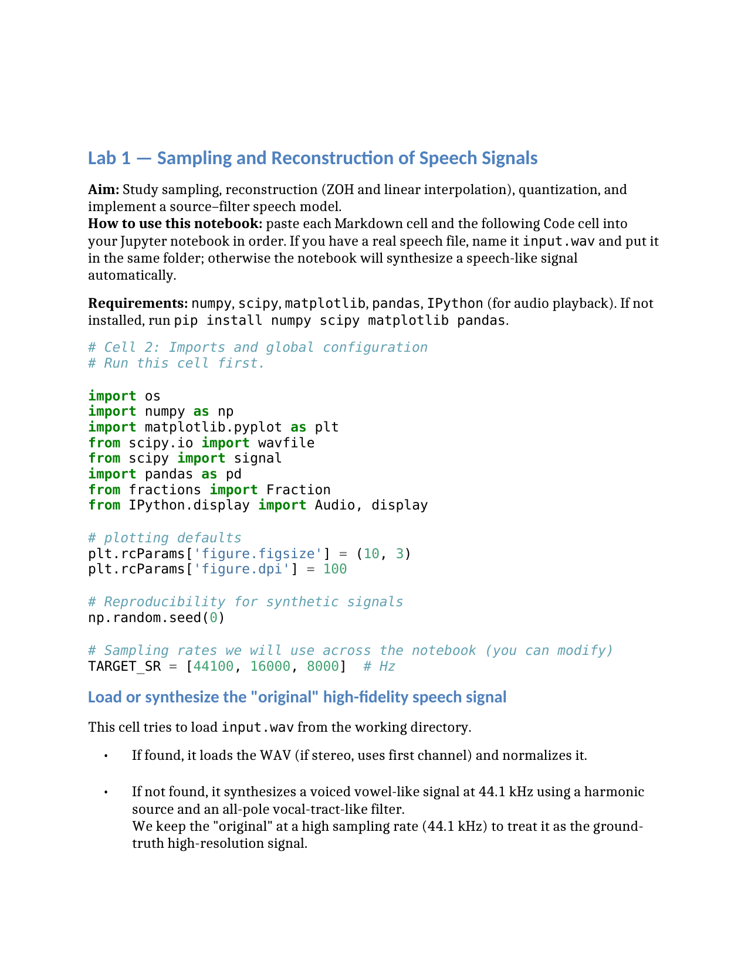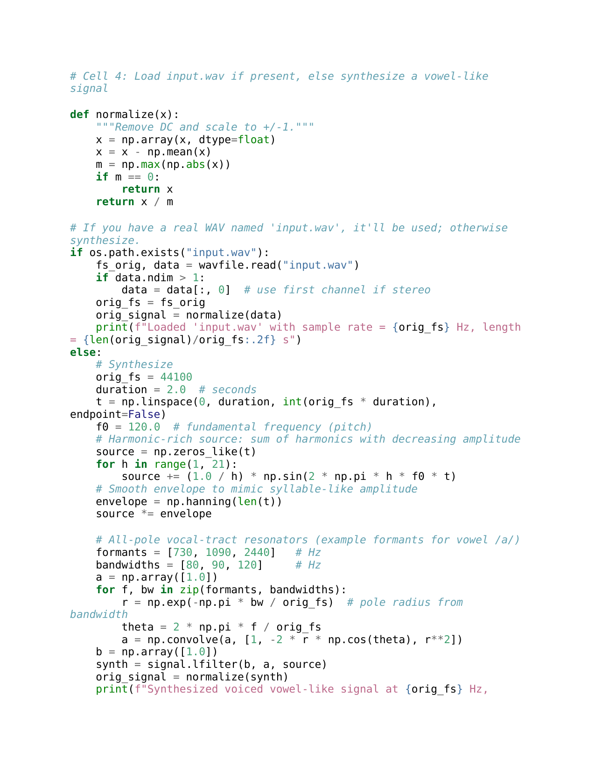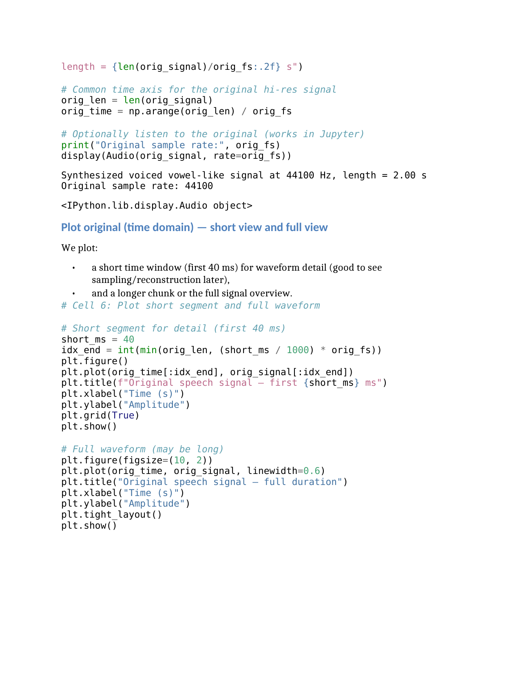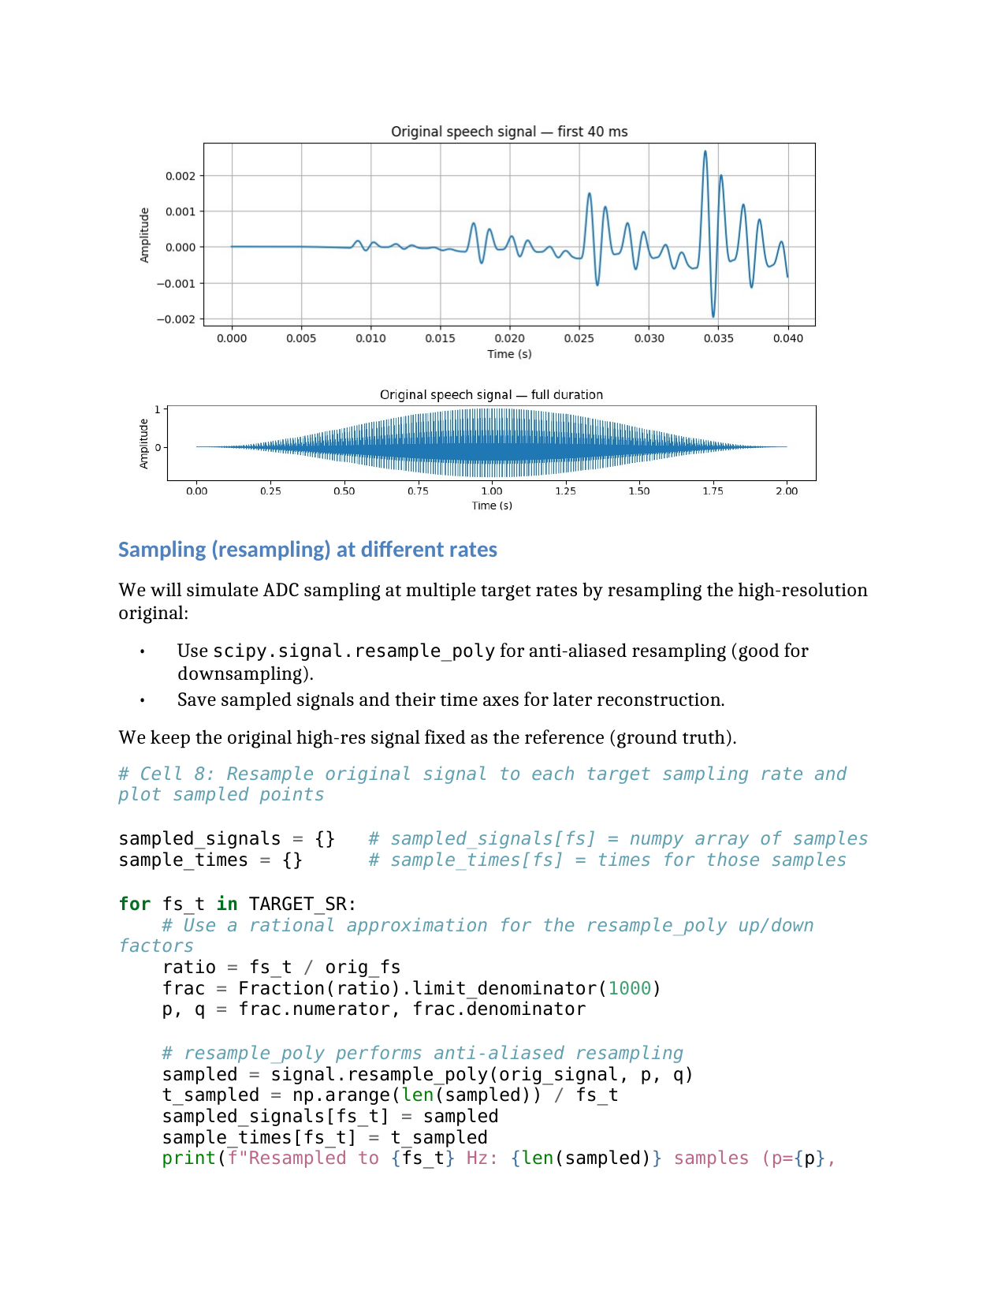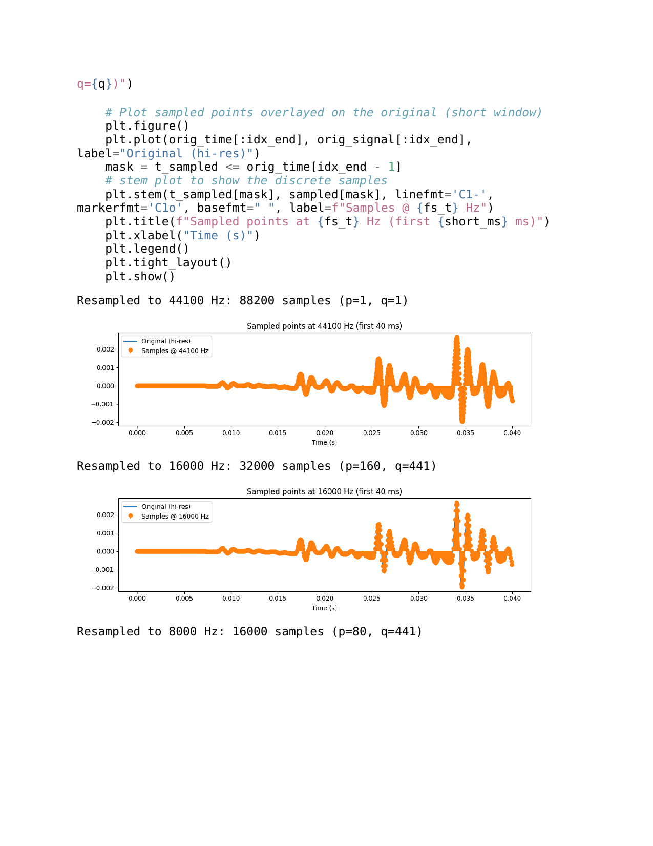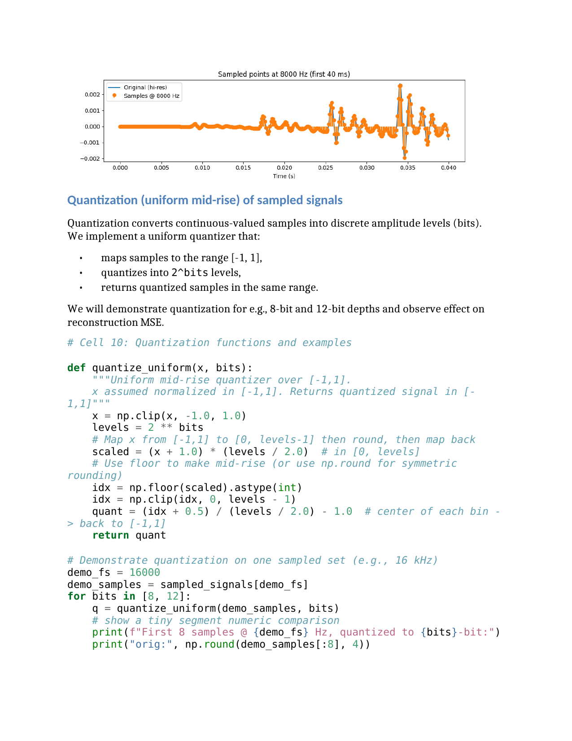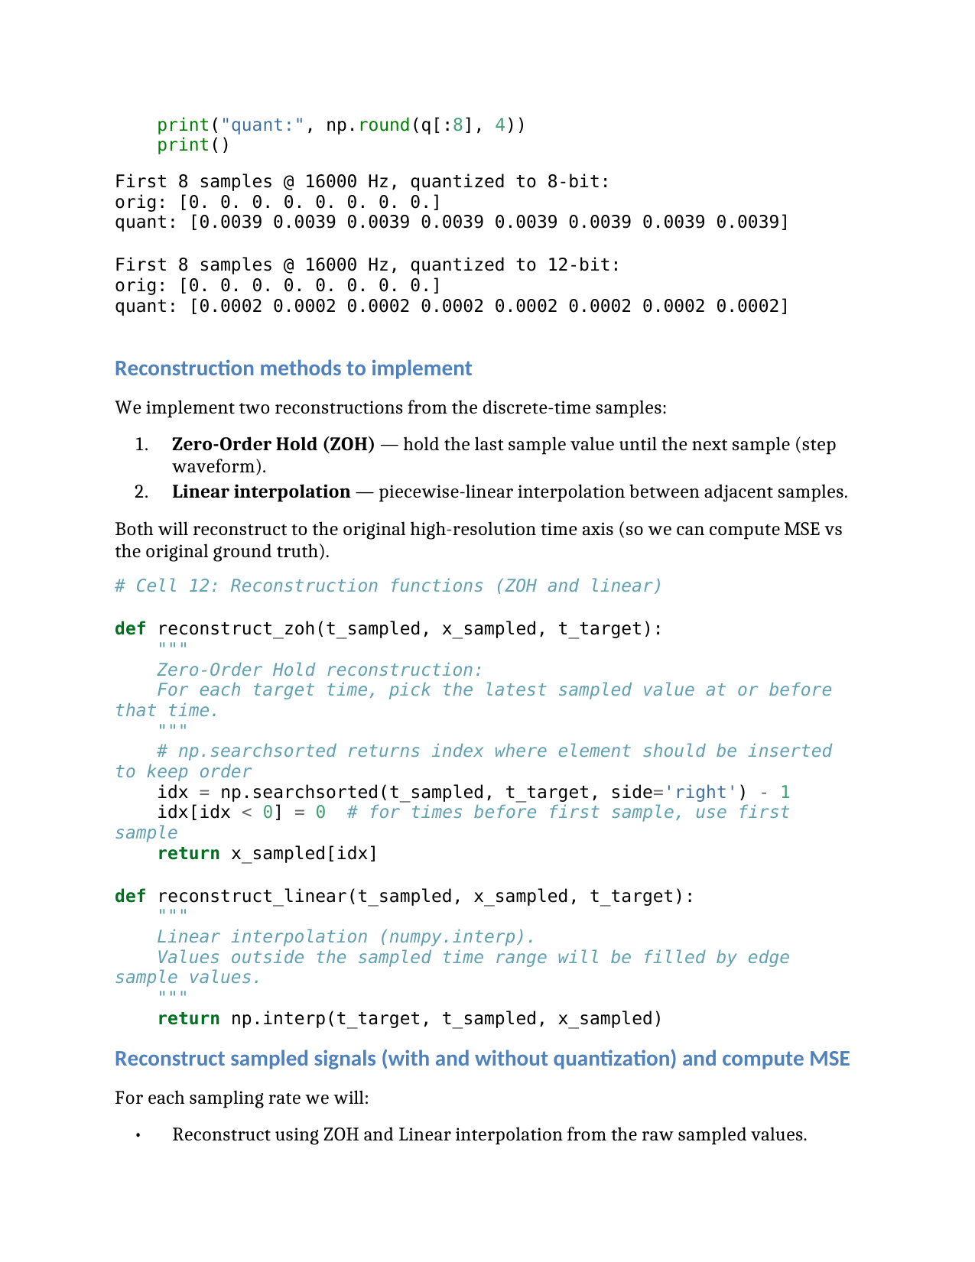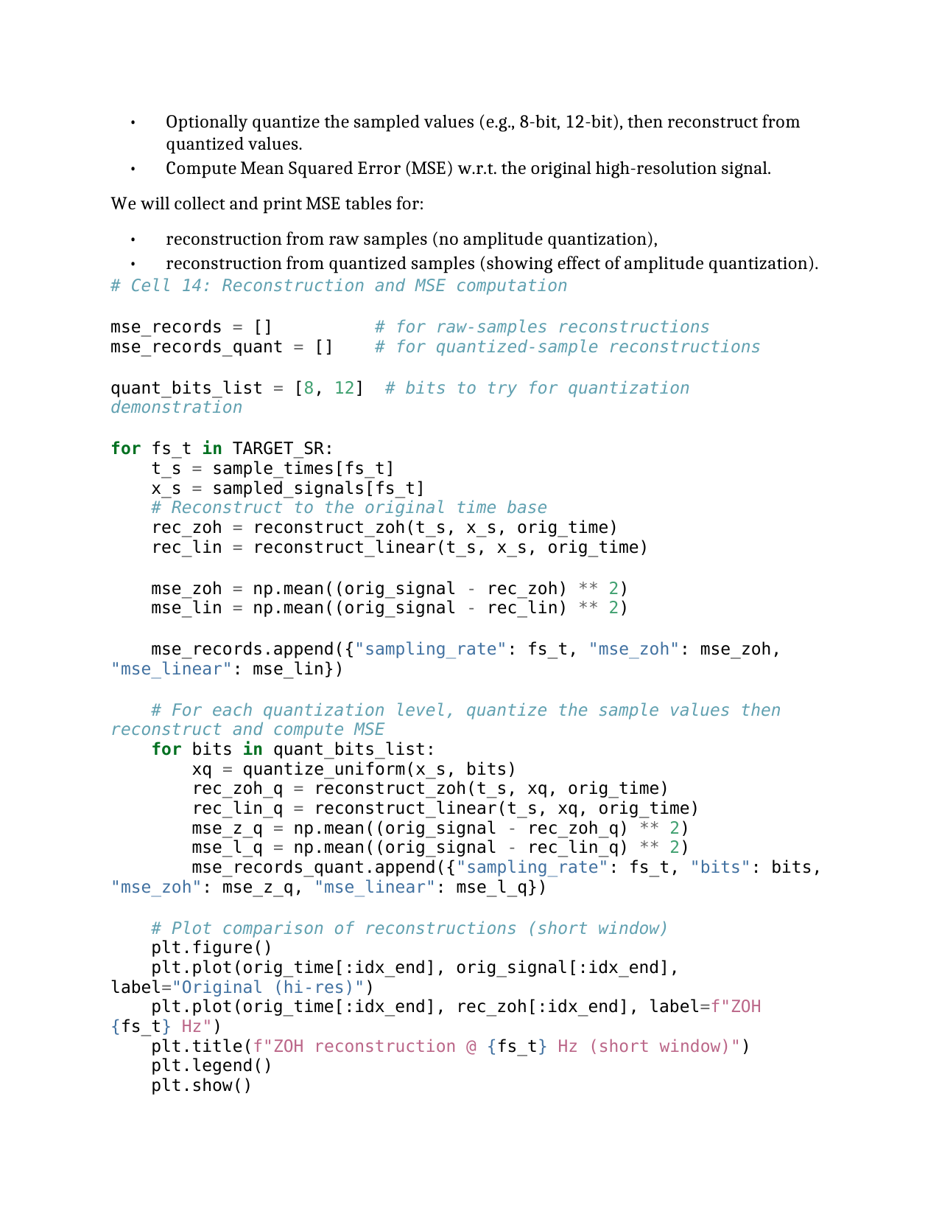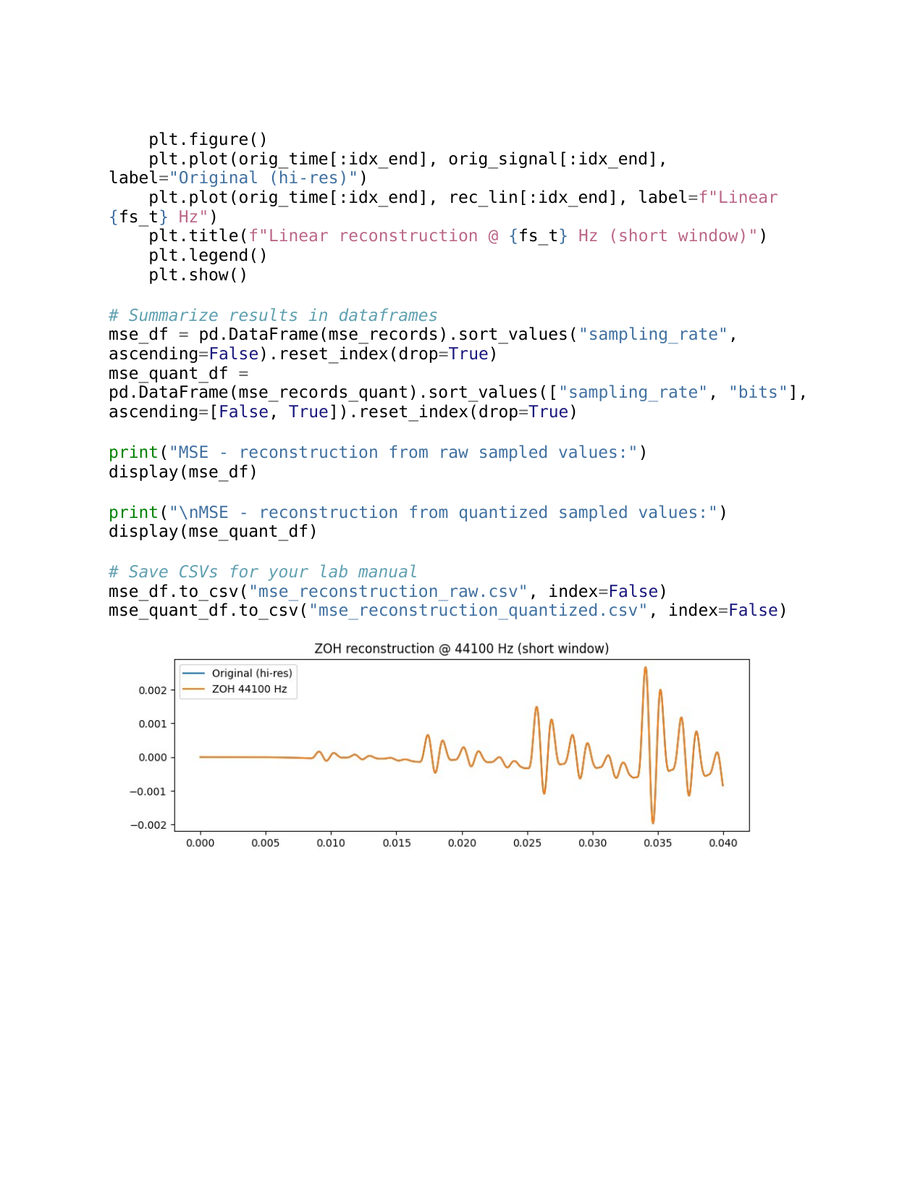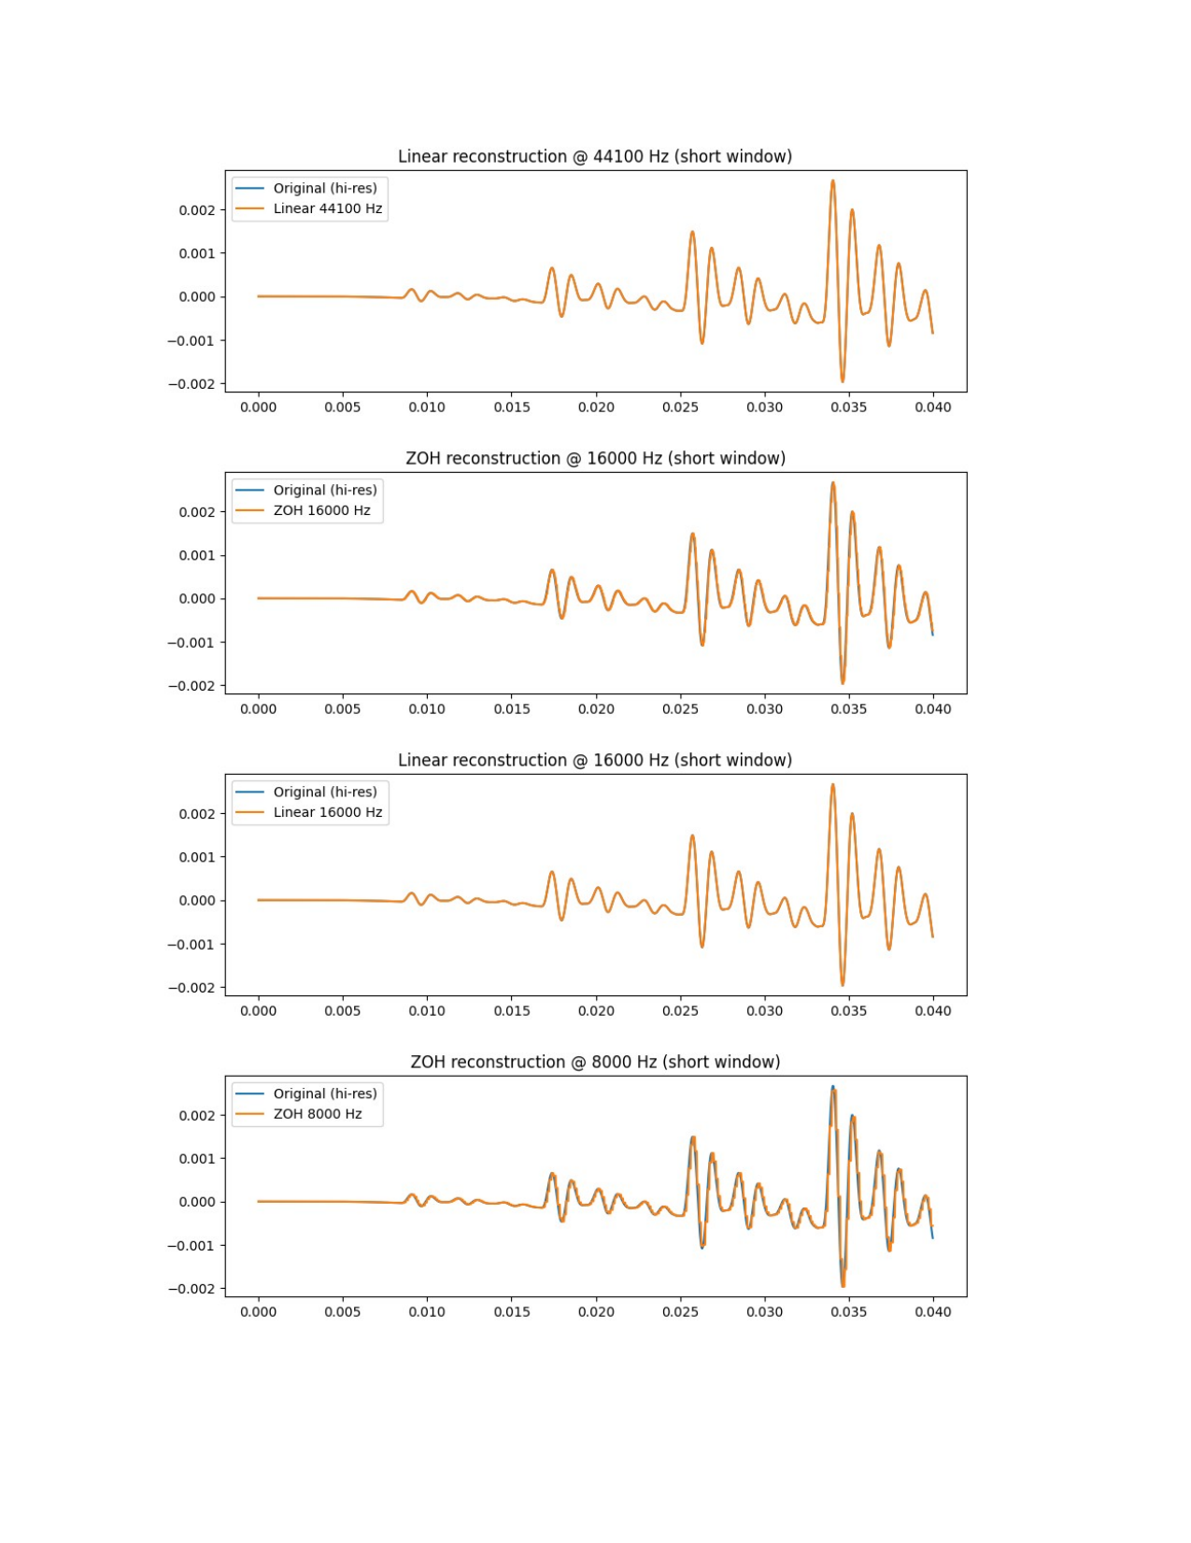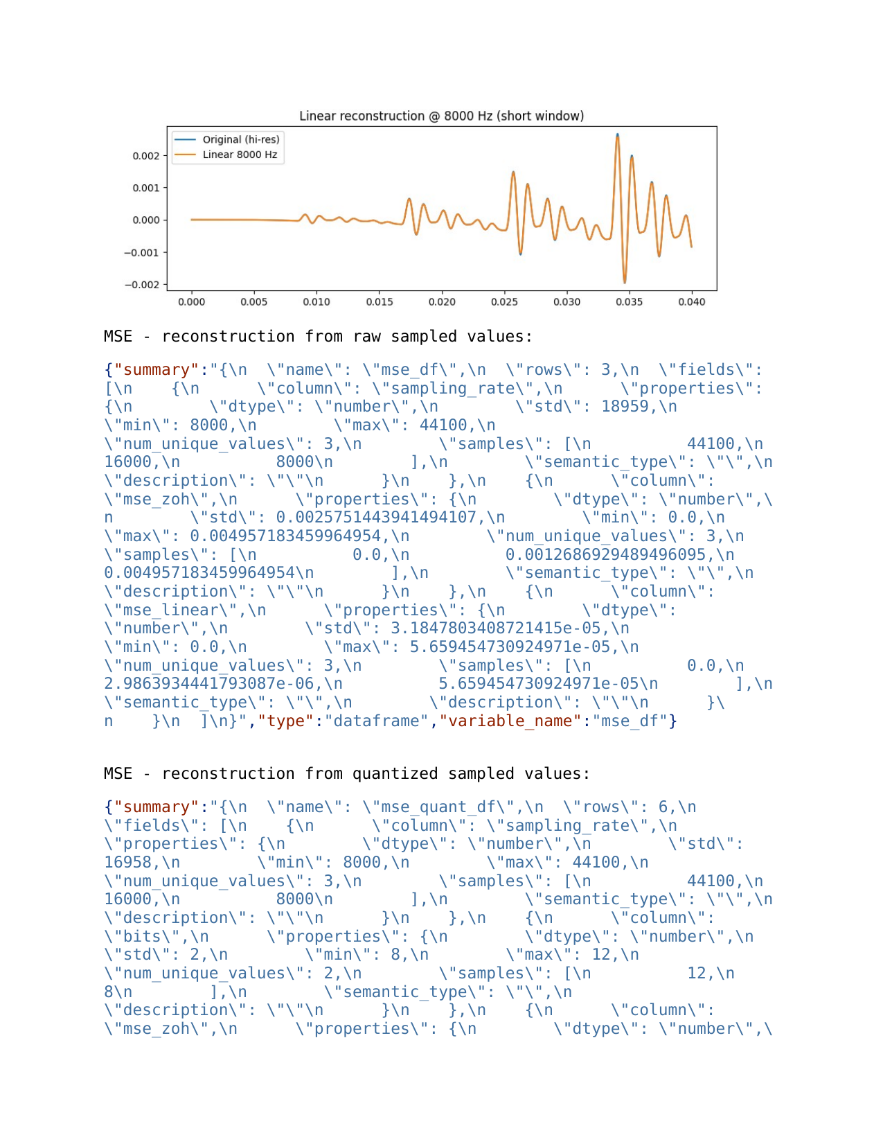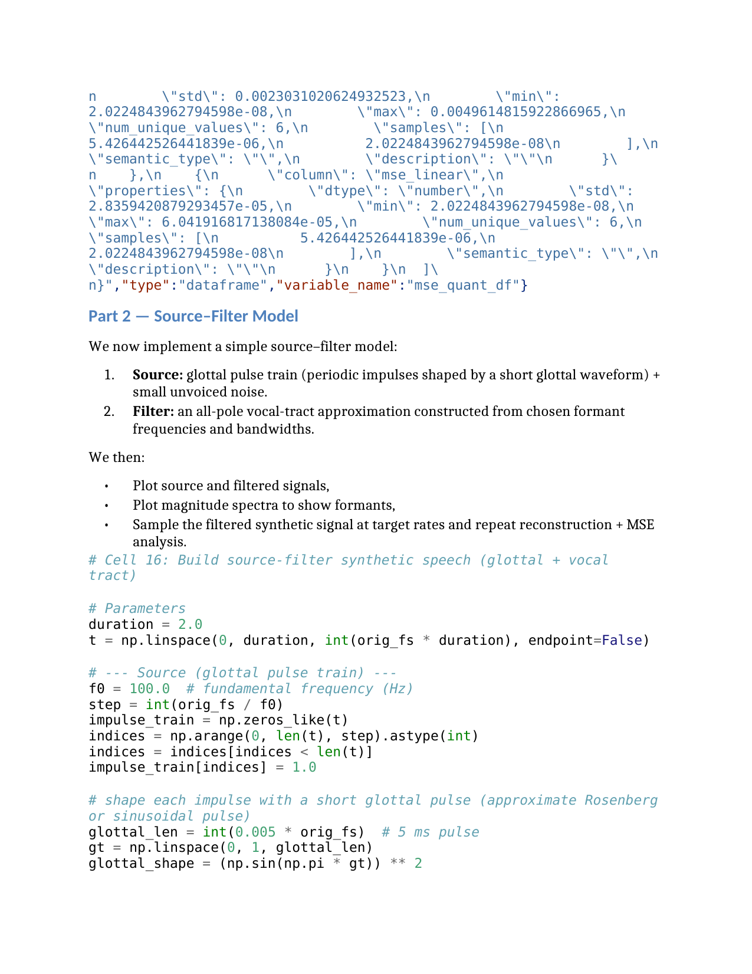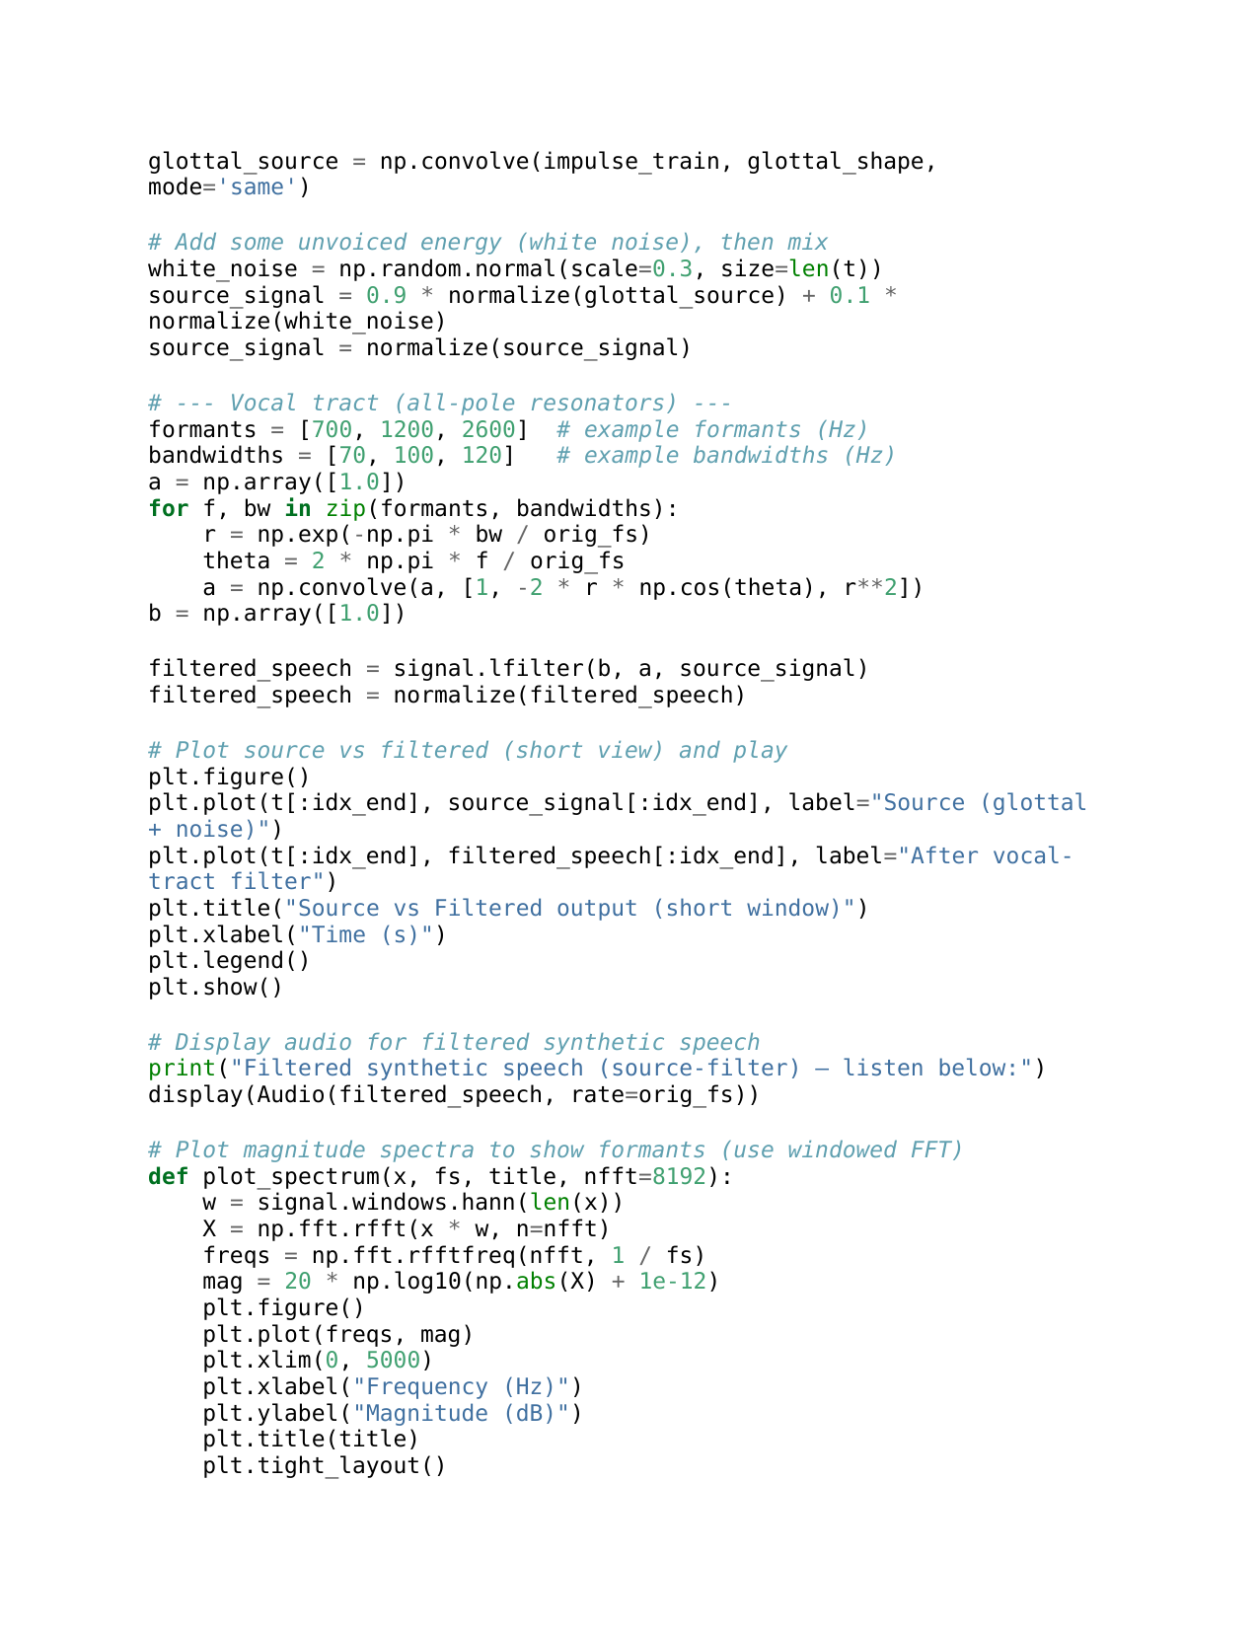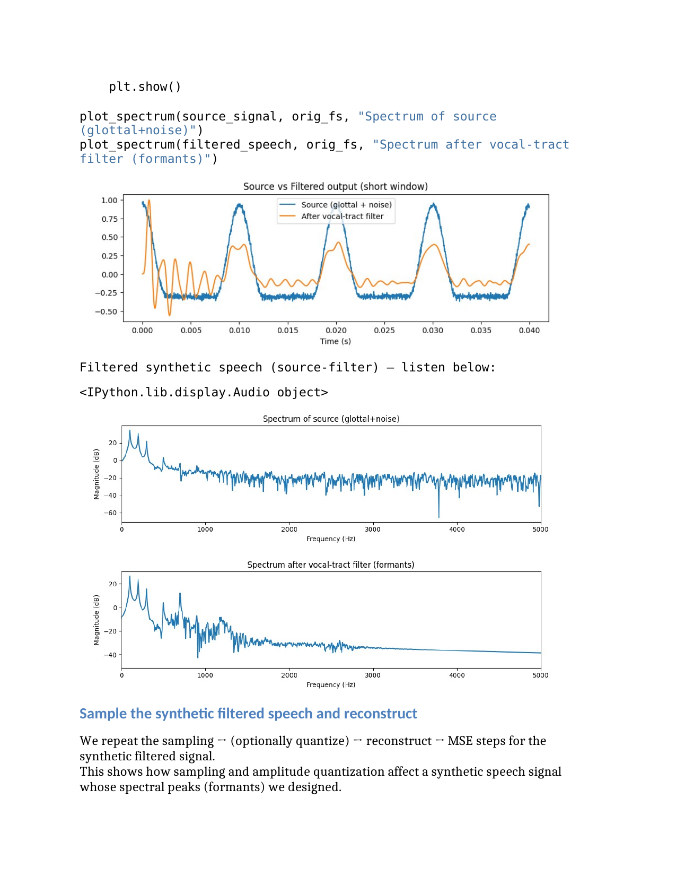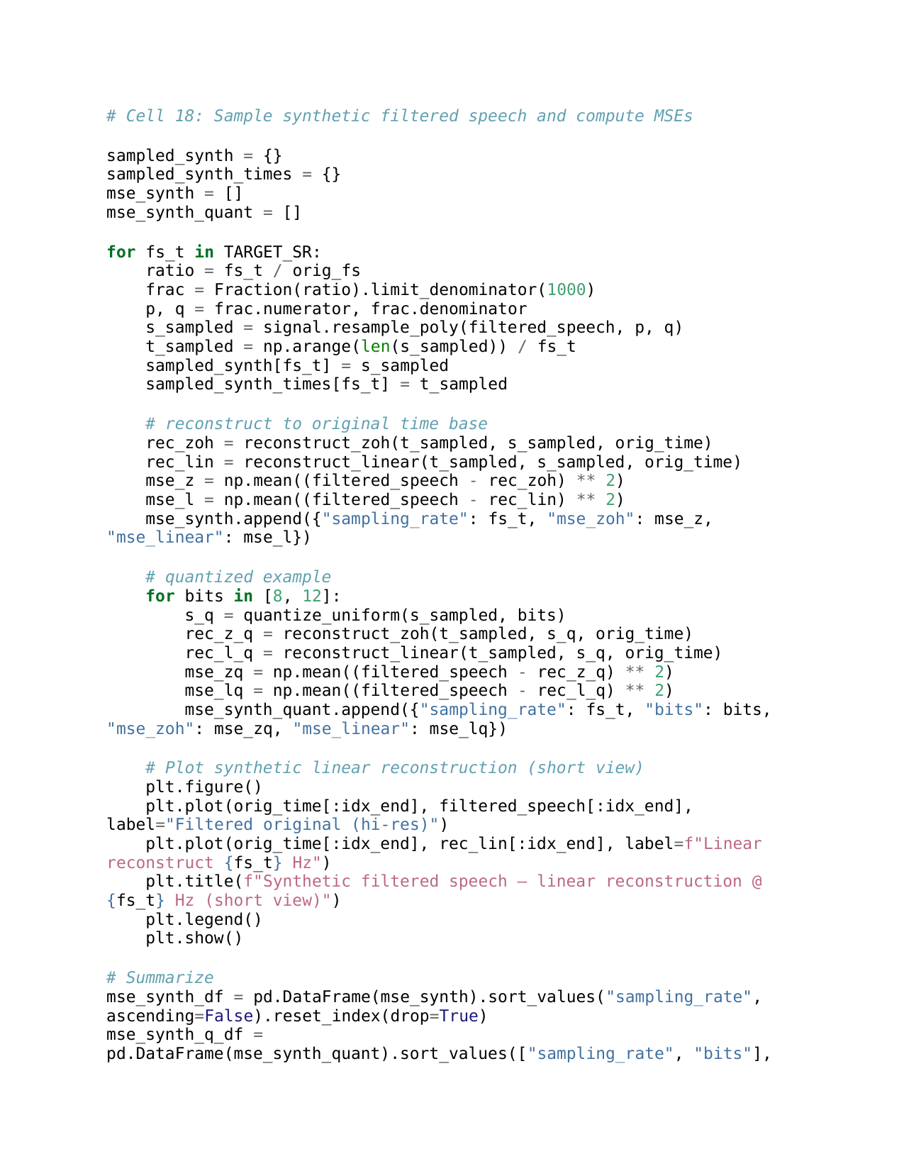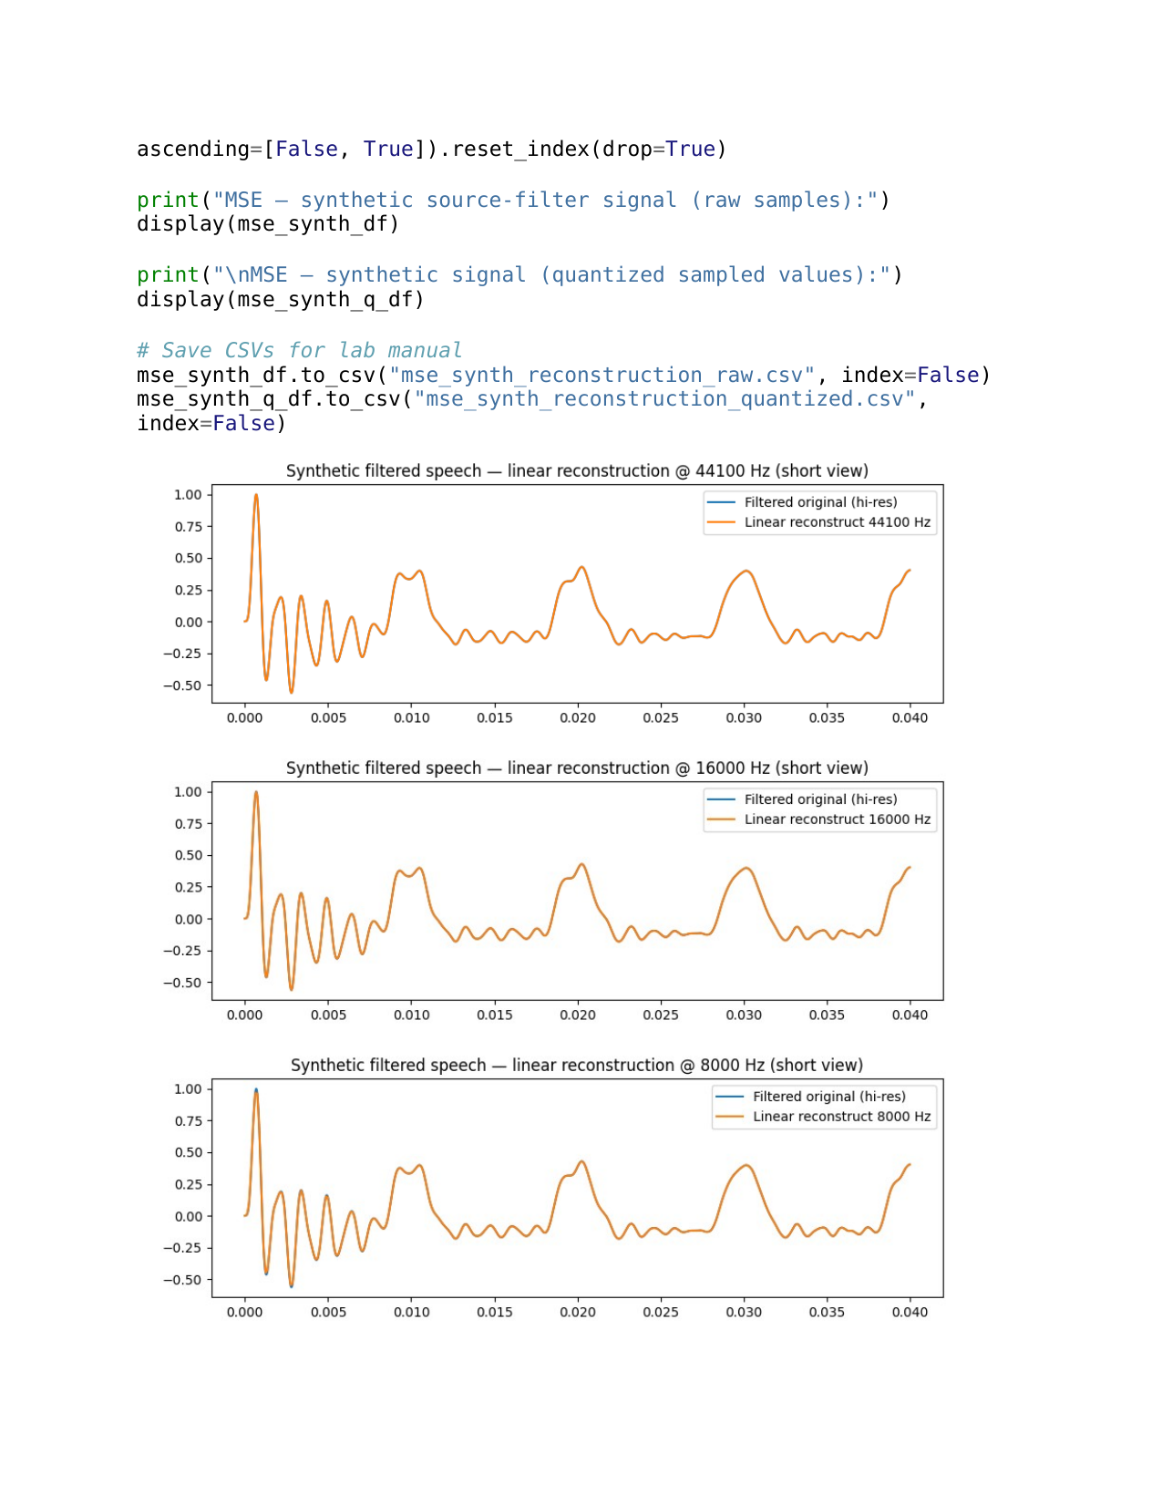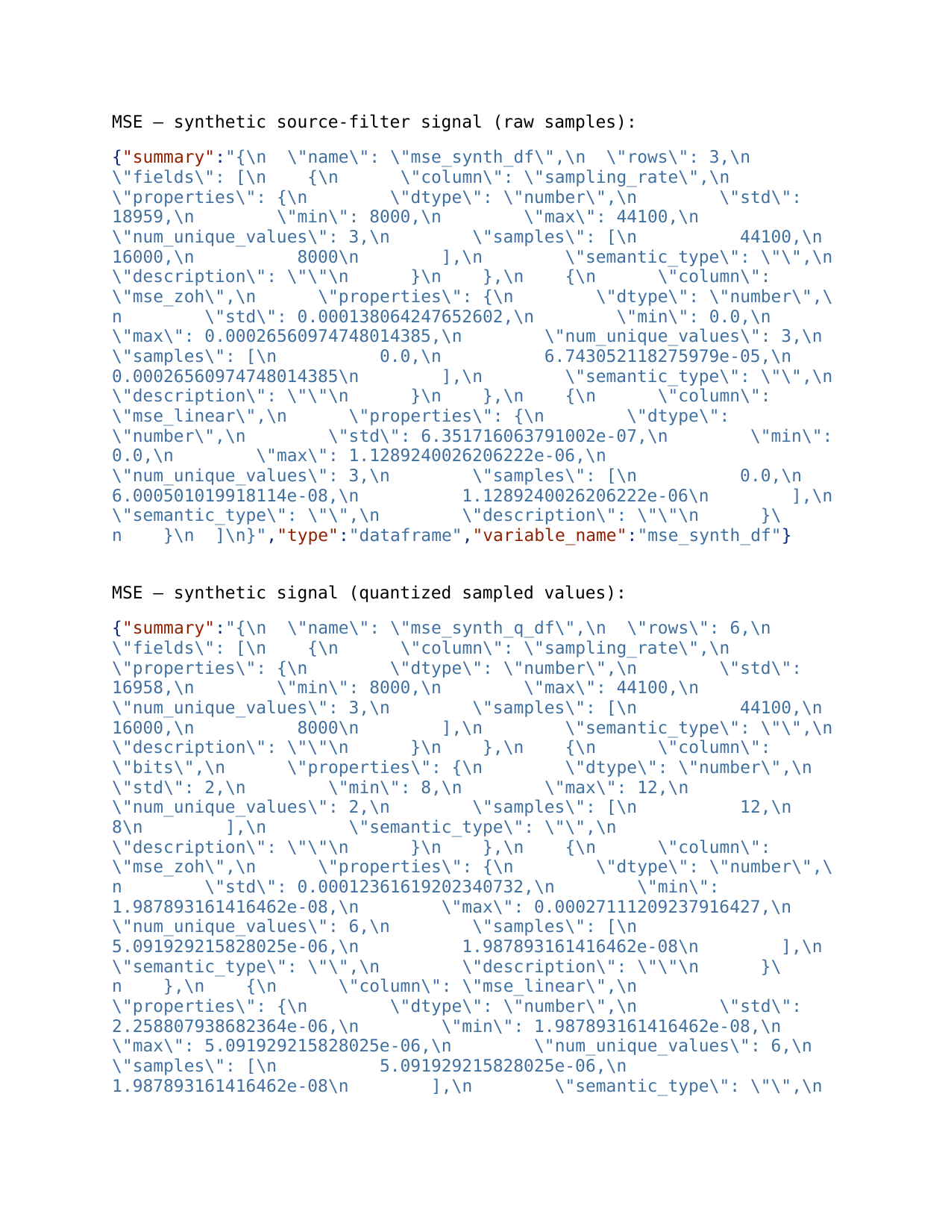**

**Conclusion /inference**

**- As sampling rate decreases, MSE between original and reconstructed signal increases (less high-frequency content is captured).**

**- Linear interpolation consistently yields lower MSE than ZOH (smoother transitions, fewer high-frequency reconstruction artifacts).**

**- Quantization (reduced bits) increases amplitude error and raises MSE; low-bit quantization is audible as distortion/noise.**

**- In the source-filter model, the filter imposes formant peaks in the spectrum. If sampling rate is too low (Nyquist < formant), those formants will be lost or aliased, degrading vowel quality / intelligibility.**

**- Practical note: 8 kHz can be sufficient for intelligibility (telephony), but 16 kHz or higher retains more timbral information.**

## Lab Exercise 2:

## Fourier Transform and Frequency Spectrum Analysis of Signals

### **Aim**

To study the Fourier Transform and analyze the frequency spectrum of different signals (sinusoidal, composite, exponential, and rectangular). To compare their time-domain representation with their frequency-domain characteristics using both the Discrete-Time Fourier Transform (DTFT) and the Discrete Fourier Transform (DFT).

**Questions**

**Question 1** (a) Generate a basic sinusoidal signal in the time domain. (For example, generate a sine wave with a frequency of 5 Hz, sampled at 1000 Hz.)  
 (b) Plot the time-domain waveform of the signal.  
 (c) Compute the Discrete-Time Fourier Transform (DTFT) and plot the continuous frequency spectrum.  
 (d) Compute the Discrete Fourier Transform (DFT) and plot the discrete frequency spectrum.

**Question 2** (a) Generate a composite signal by adding two or more sinusoidal signals of different frequencies and amplitudes.  
 (b) Plot the time-domain waveform of the composite signal.  
 (c) Compute the Discrete-Time Fourier Transform (DTFT) and plot the continuous frequency spectrum.  
 (d) Compute the Discrete Fourier Transform (DFT) and plot the discrete frequency spectrum.

**Question 3** (a) Generate an exponentially decaying signal.  
 (b) Plot the time-domain waveform.  
 (c) Compute the Discrete-Time Fourier Transform (DTFT) and plot the continuous frequency spectrum.  
 (d) Compute the Discrete Fourier Transform (DFT) and plot the discrete frequency spectrum.  
 (e) Analyze the relationship between the time-domain waveform and the frequency-domain representation.

**Question 4** (a) Generate a **rectangular pulse signal** of finite duration in the time domain.  
 (b) Plot the time-domain waveform.  
 (c) Compute the Discrete-Time Fourier Transform (DTFT) and plot the continuous frequency spectrum.  
 (d) Compute the Discrete Fourier Transform (DFT) and plot the discrete frequency spectrum.  
 (e) Analyze the relationship between the time-domain waveform and the frequency-domain representation.

**Evaluation Rubrics**

1. Implementation: 5 marks
2. Complexity and Validation: 3 marks
3. Documentation & Writing the inference: 2 marks

**Submission Guidelines**

* Prepare a single PDF containing answers for all questions with proper plots, results, and inferences.
* Each answer must include Python/Matlab code, output plots, and a conclusion.
* Title the file as: Lab_2_<YourName_RegNo>.
* Upload the PDF to Google Classroom before the deadline.
* Maintain a Git repository with separate branches for each lab (Lab1, Lab2, …). Push your code and include the repo link in your submission.

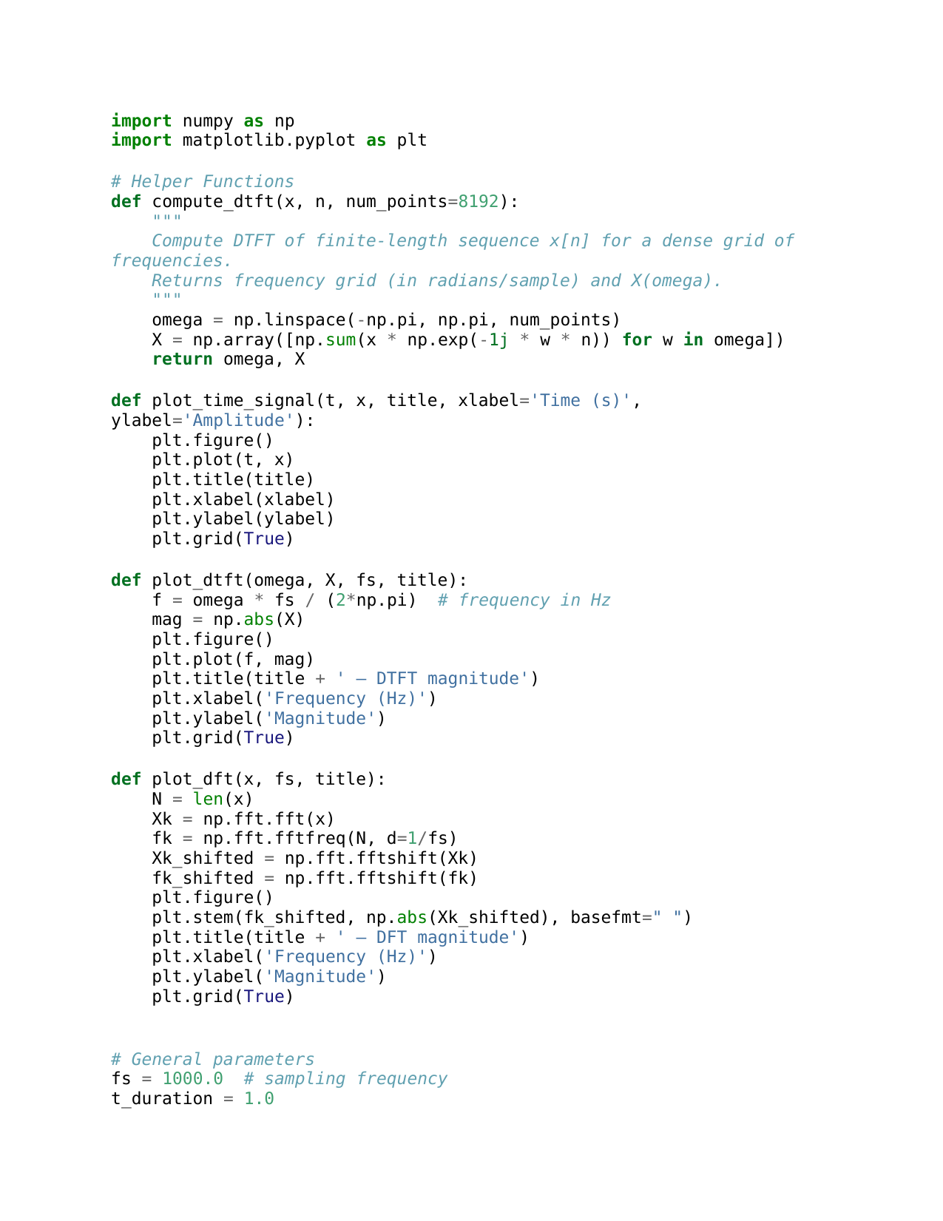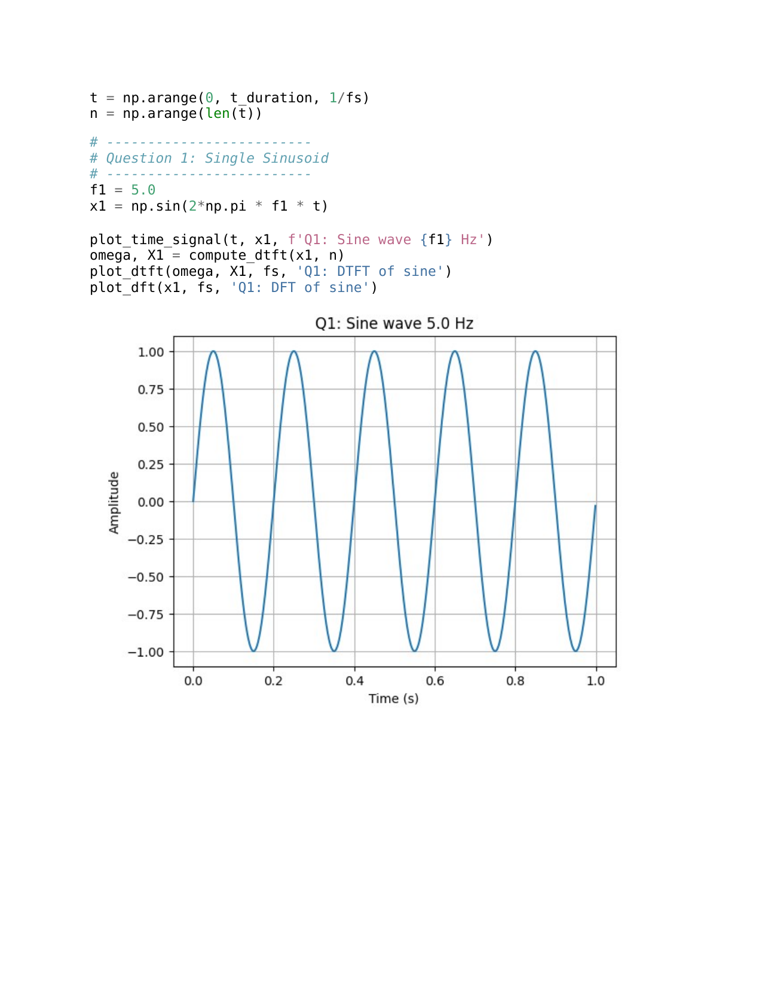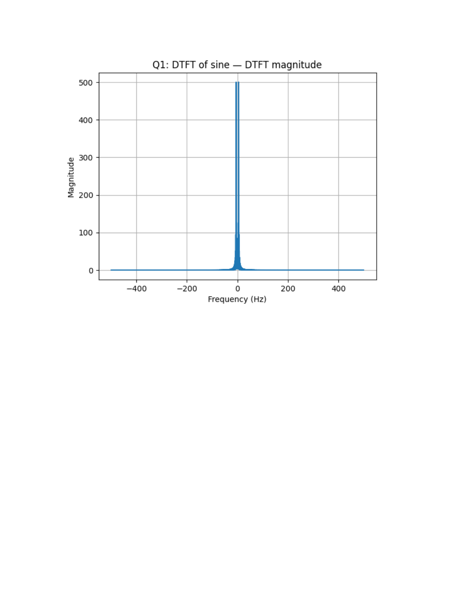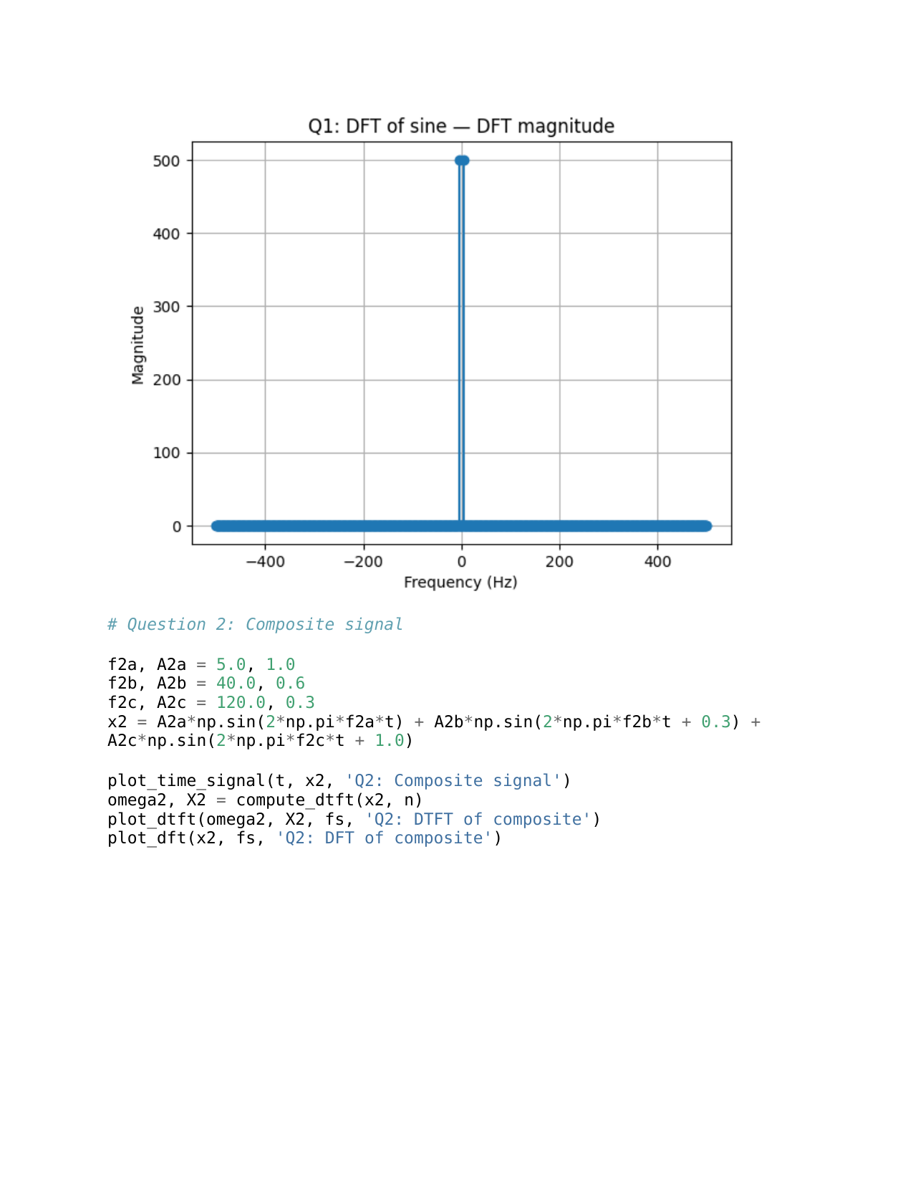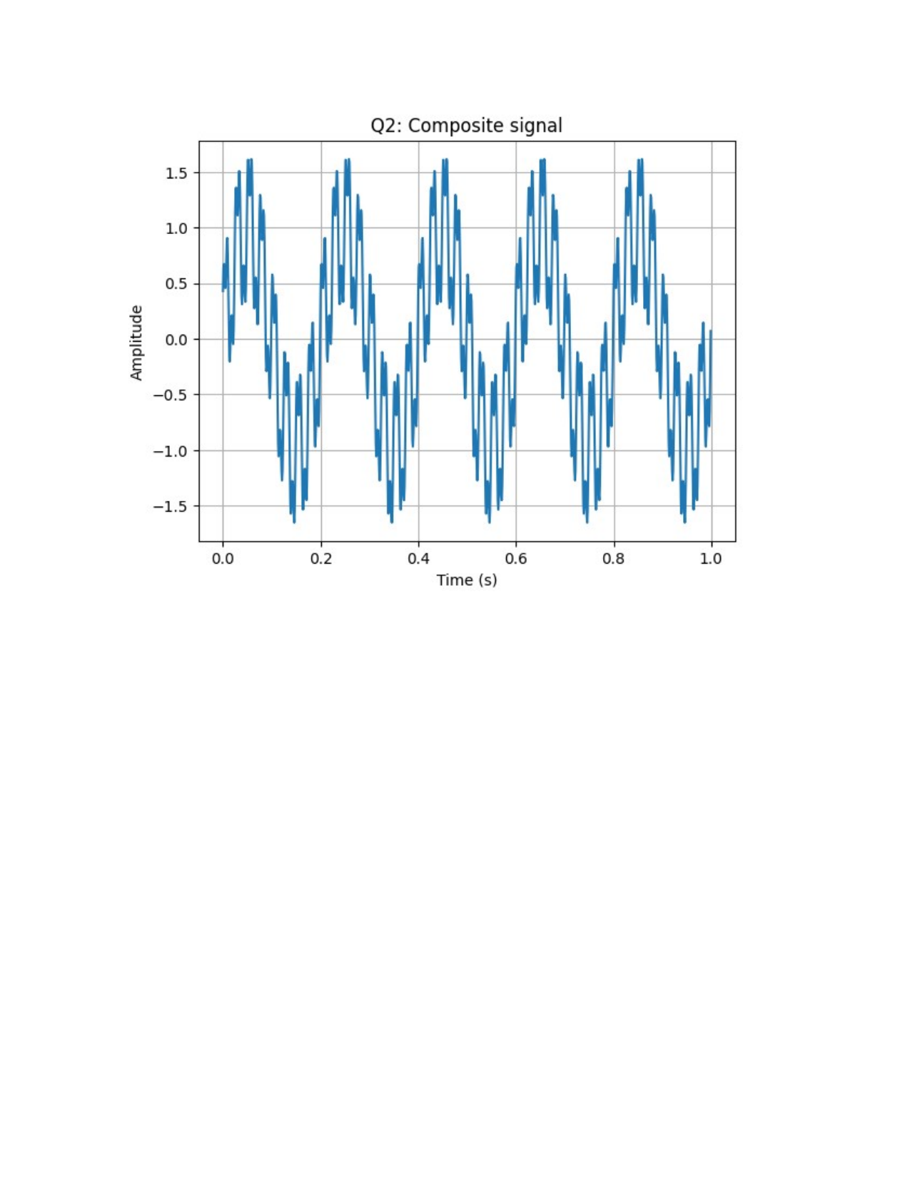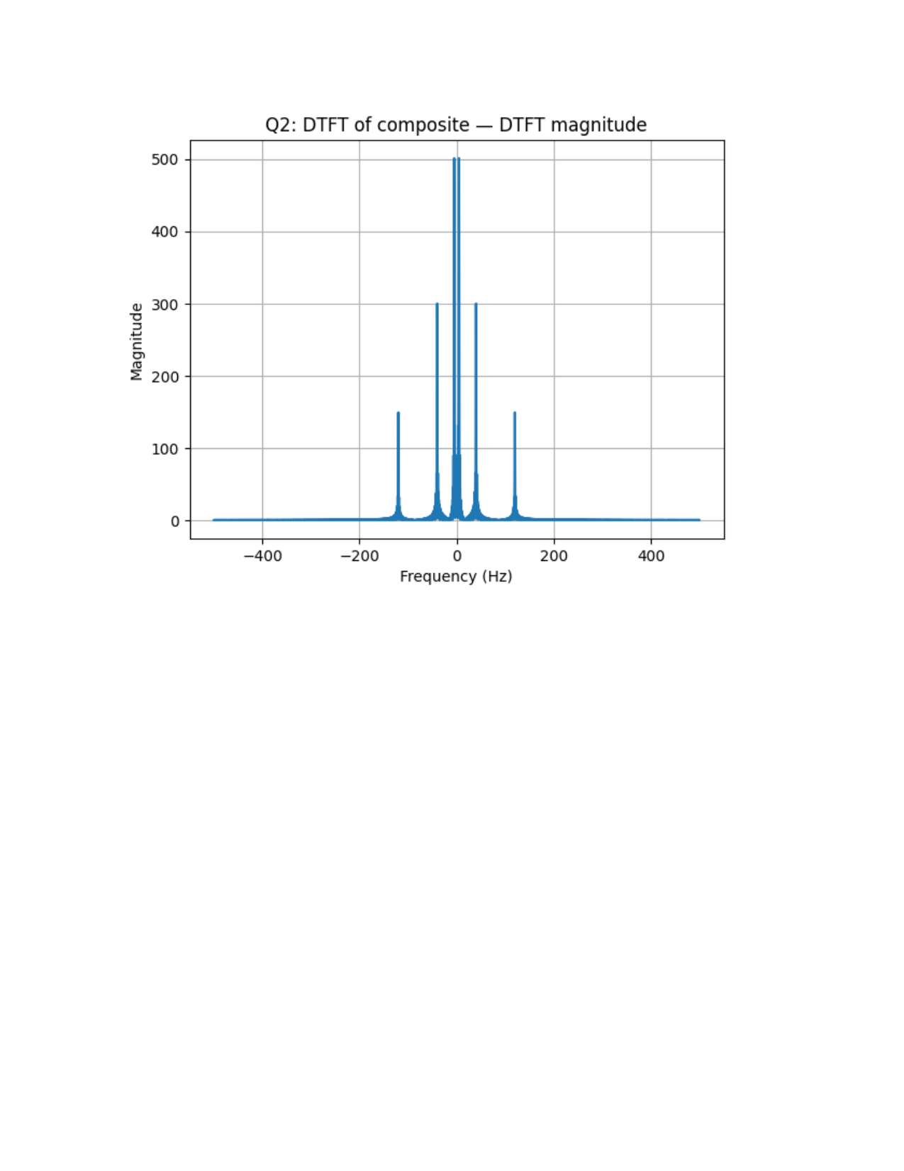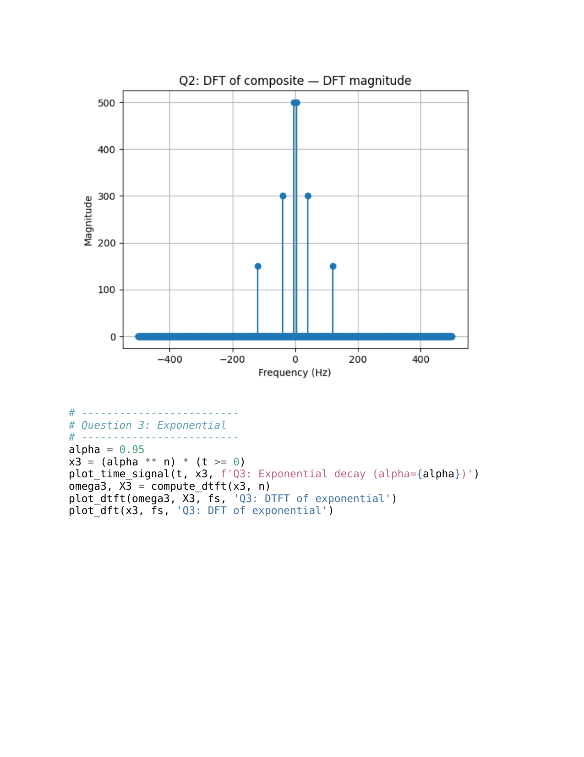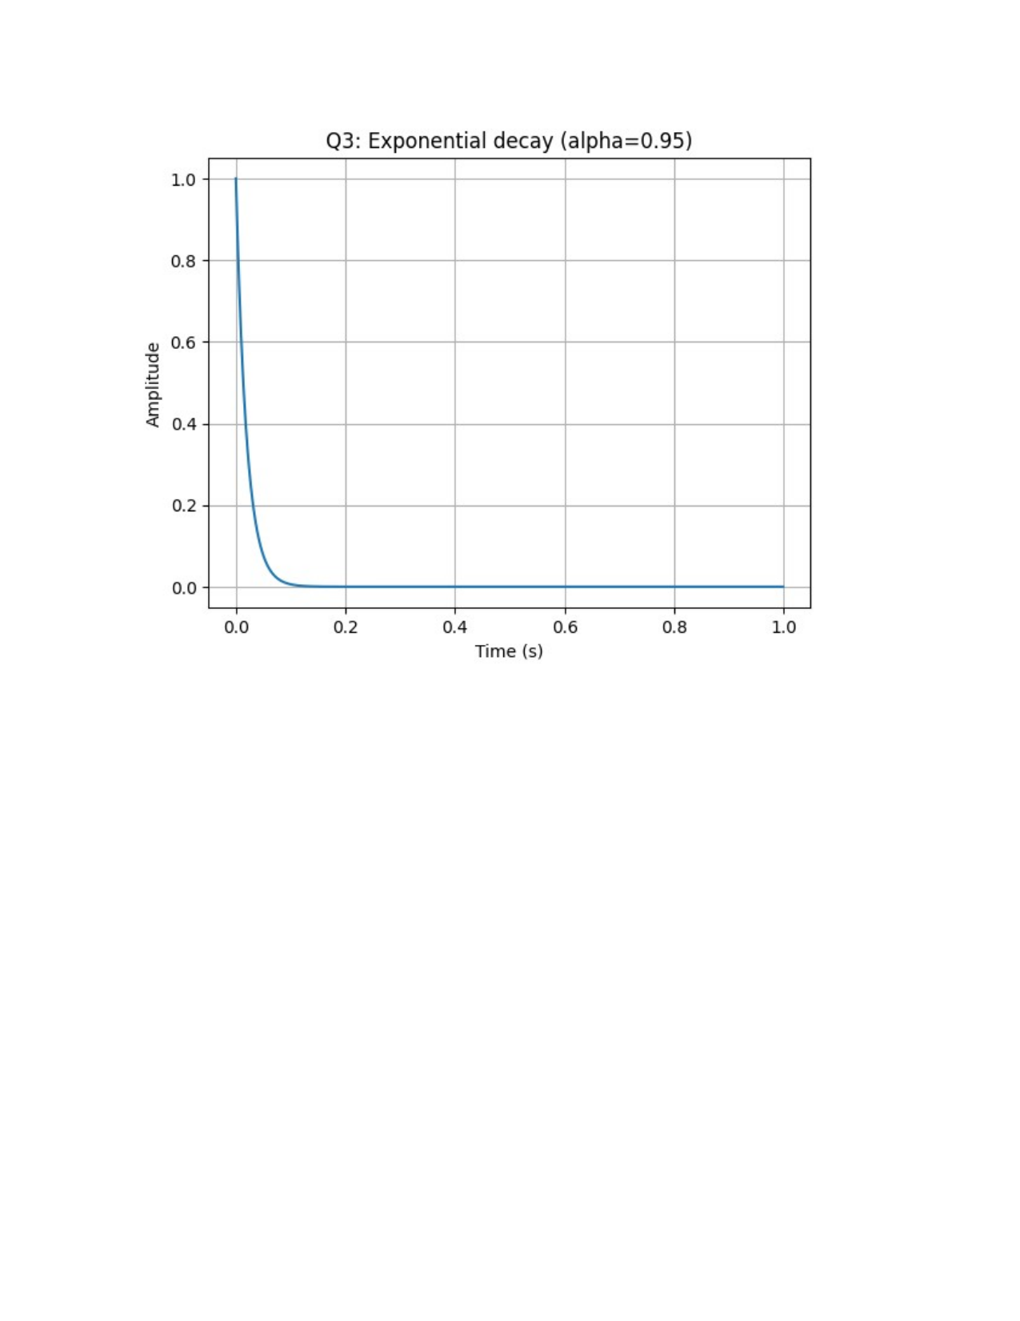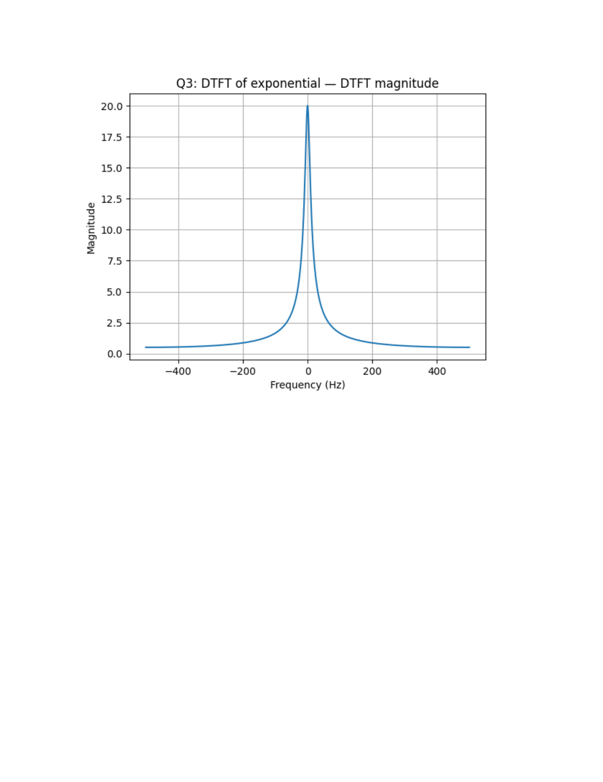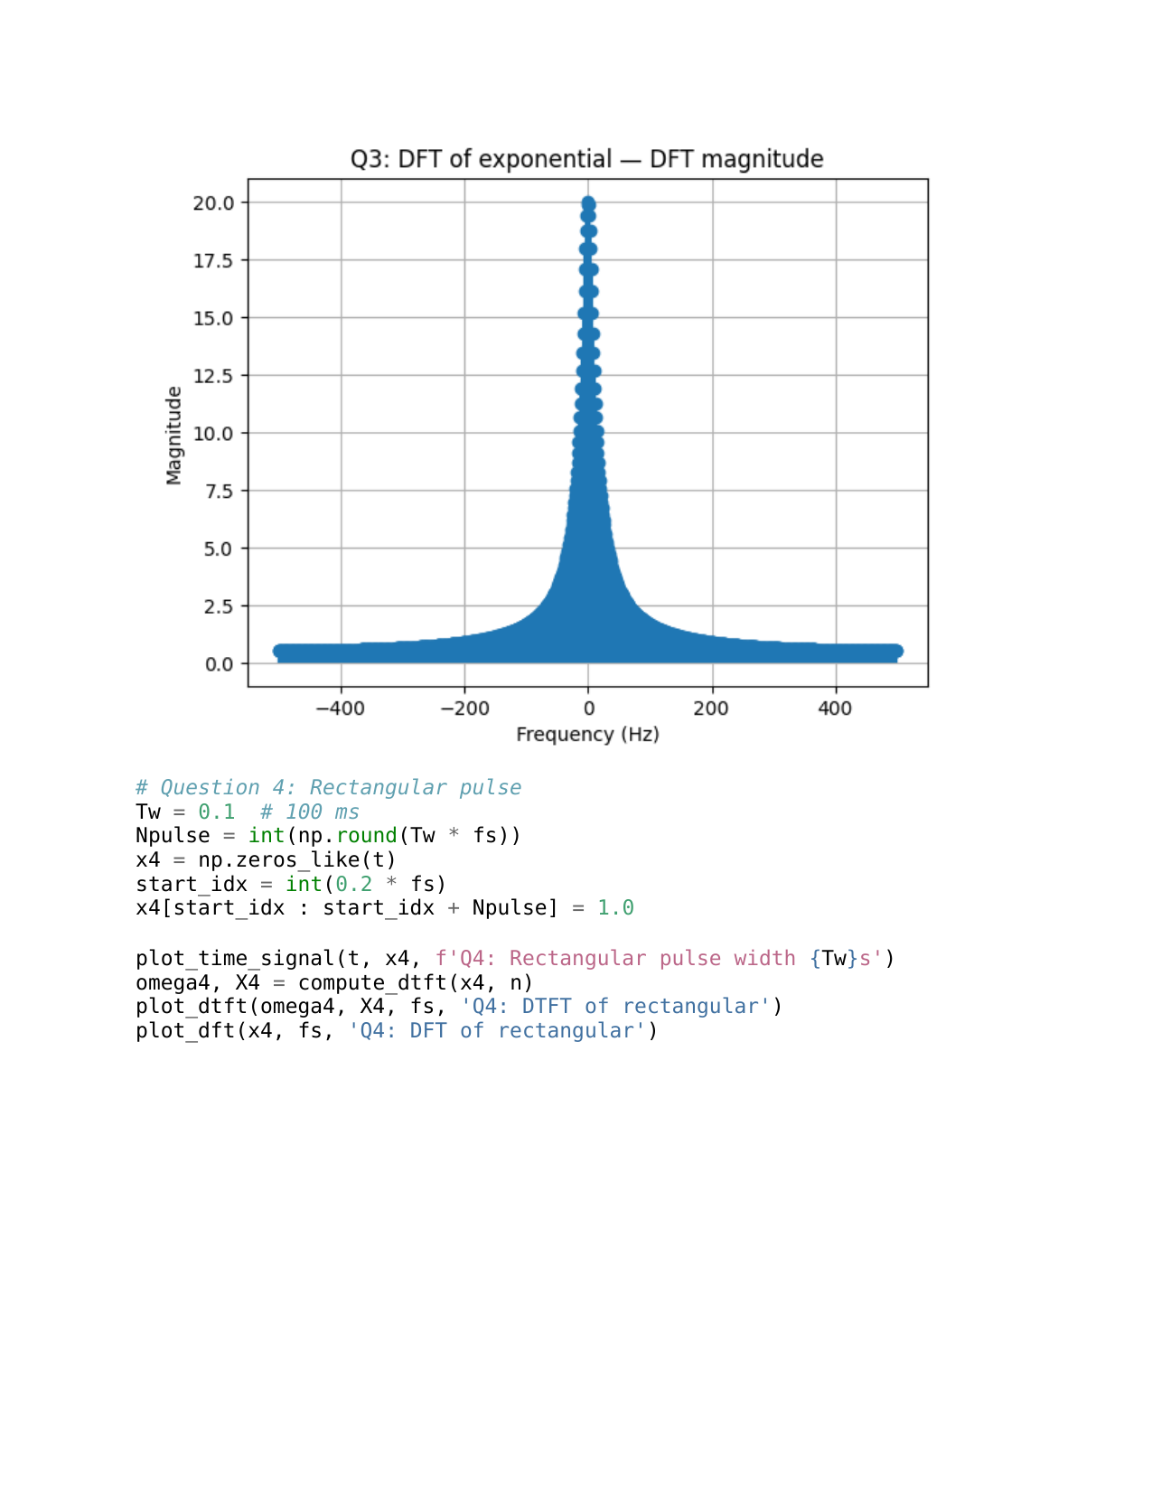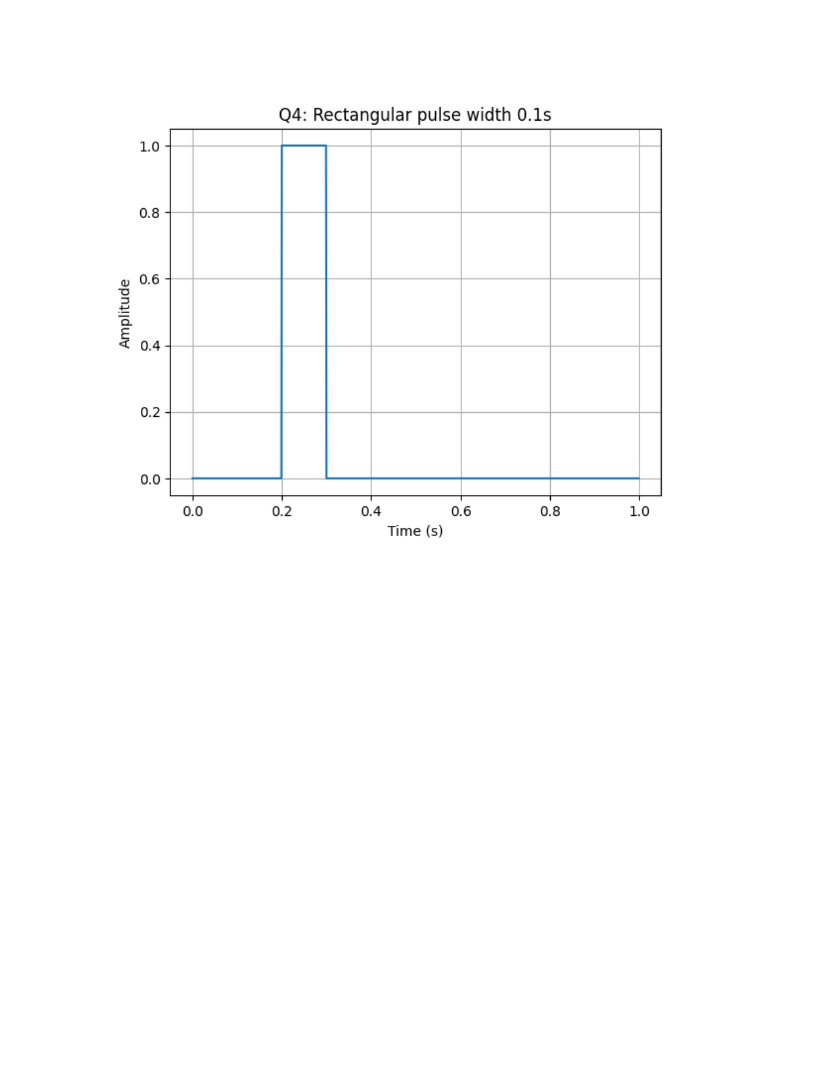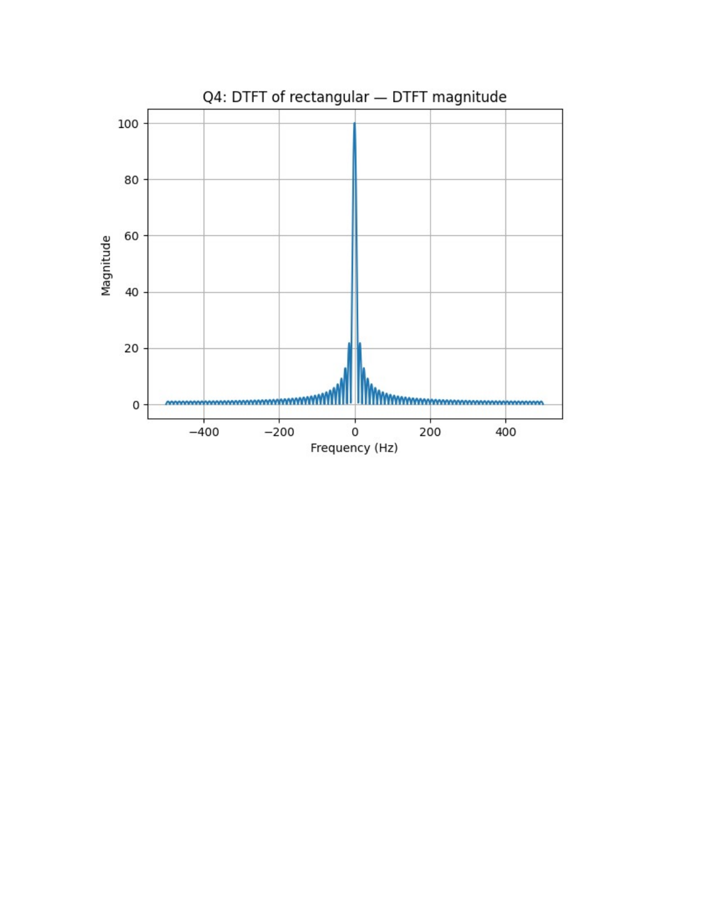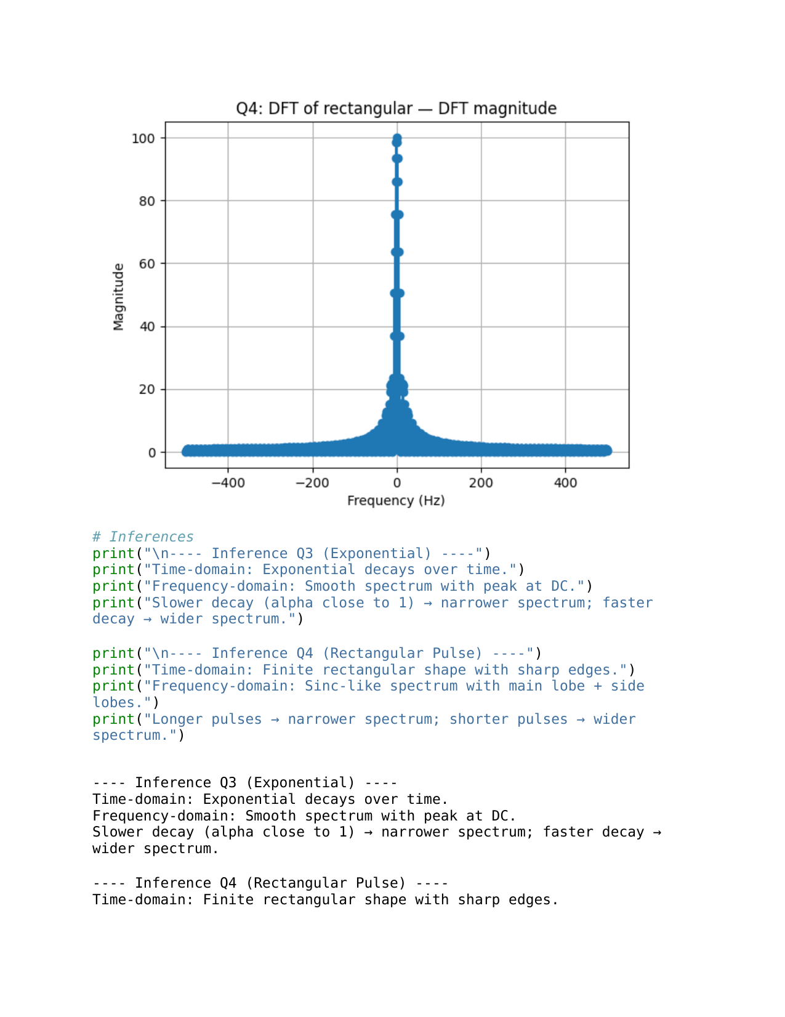

## Lab Exercise 3:

**Question: Speech-to-Text Application for Accessibility**

**Aim:**

To develop a Python-based speech-to-text system that converts spoken commands into text in real time, provides meaningful user feedback, handles errors gracefully, and allows comparison of different recognition methods.

*This is an open-ended question. You can explore more.*

### **Scenario:**

You have been hired as an AI engineer by a tech startup that focuses on enhancing accessibility for people with disabilities. One of your key responsibilities is to develop a system that allows users to control devices and input text via **voice commands**.

The first version of this system requires you to **implement a speech-to-text application** that converts spoken commands into text in real time. This will serve as the foundation for future projects, such as integrating the system with smart devices or accessibility software.

**Tasks:**

1. **Audio Capture***(mandatory task )*
   * Record spoken input using a **microphone**, OR use any speech audio file (e.g., .wav, .flac).

<https://drive.google.com/file/d/1BmlRHKnHWVtlM743vcjLGtaK_aRzd_Qa/view?usp=drive_link>

* + Provide feedback to the user: "Speak something...".

1. **Convert Speech to Text***(mandatory task )*
   * Implement a speech-to-text system using **at least two methods** (for comparison):
     + Offline: **Whisper, Vosk**, or similar
     + Online: **Google Speech API**
   * Display the message: "Recognizing..." while processing.
2. **Display Recognized Text***(mandatory task )*
   * Show the converted text on the screen.  
     Example: "Speech recognized: 'Turn on the lights in the living room.'"
   * Display "Speech successfully converted to text!" on successful recognition.
3. **Handle Errors and Exceptions***(mandatory task )*
   * **Unclear speech** (mumbling, low volume): Display a user-friendly message.  
      Example: "Speech Recognition could not understand audio. Please try speaking more clearly."
   * **Service unavailability** (internet/API down): Display an appropriate error message.
4. **Provide Feedback at Each Stage**
   * Before recording: "Speak something..."
   * During recognition: "Recognizing..."
   * On success: "Speech successfully converted to text!"
   * On failure: Provide meaningful error messages.
5. **Comparative Analysis**
   * Test the same audio file or spoken sentence using **multiple recognition methods**.
   * Fill in the **comparison table**:

| Audio Type | Whisper Output | Vosk Output | Google API Output | Any other python libraries can be added .. | Notes on Accuracy |
| --- | --- | --- | --- | --- | --- |
| Clear male voice |  |  |  |  |  |
| Clear female voice |  |  |  |  |  |
| Fast speech |  |  |  |  |  |
| Noisy background |  |  |  |  |  |
| Soft voice |  |  |  |  |  |

1. **Write a Brief Inference**
   * Summarize your observations about the system’s performance:
     + How accurately does it recognize speech?
     + How well does it handle errors?
     + Which method performed best for each scenario?
     + Suggestions for future improvements or project extensions.

**Deliverables**

1. Python code implementing the speech-to-text system.
2. Screenshots of the program running with sample inputs.
3. Completed **comparison table**.
4. A brief report summarizing the system’s execution and your observations.

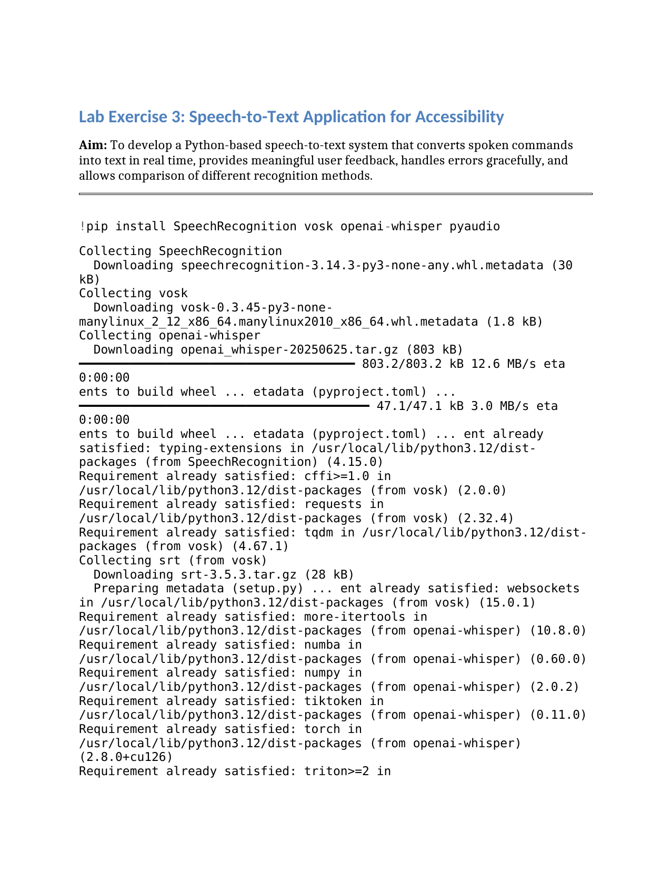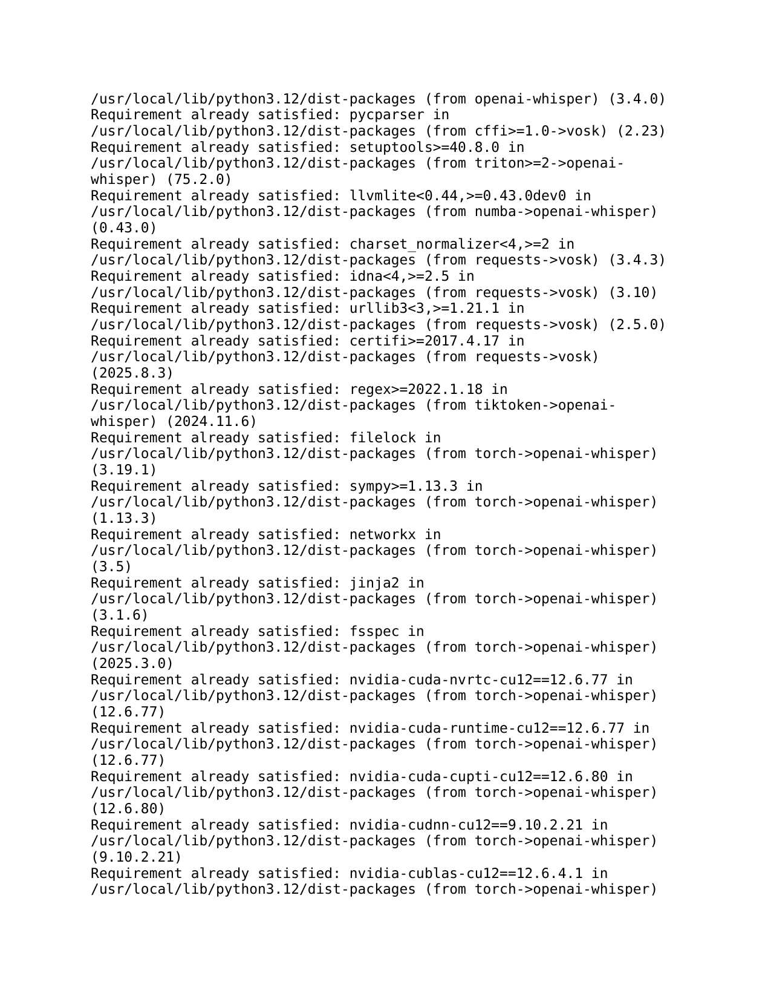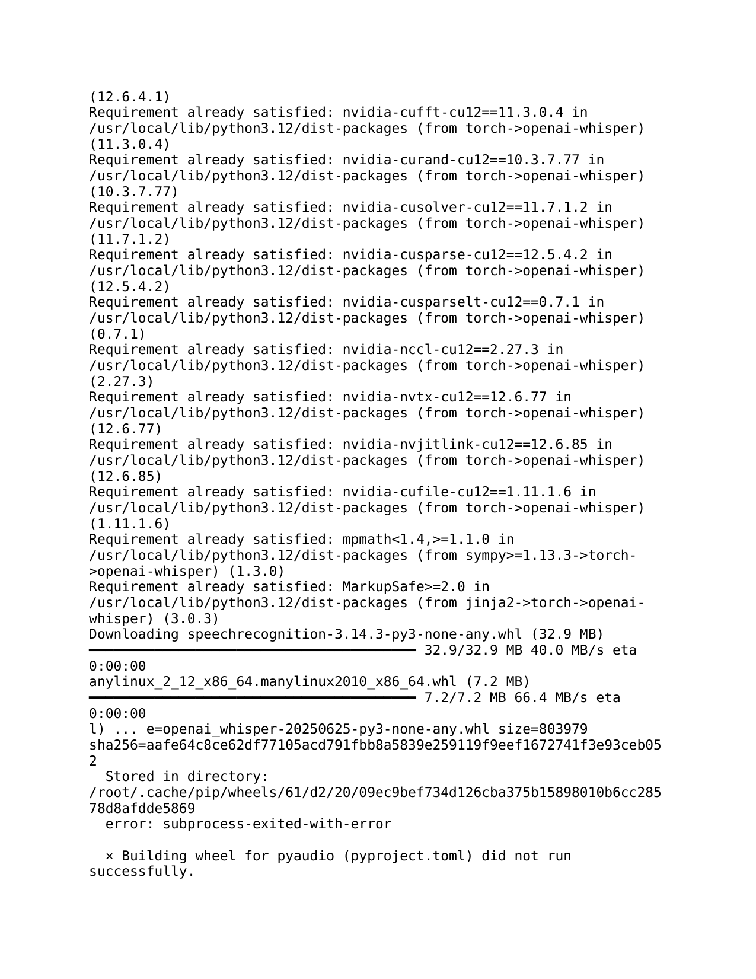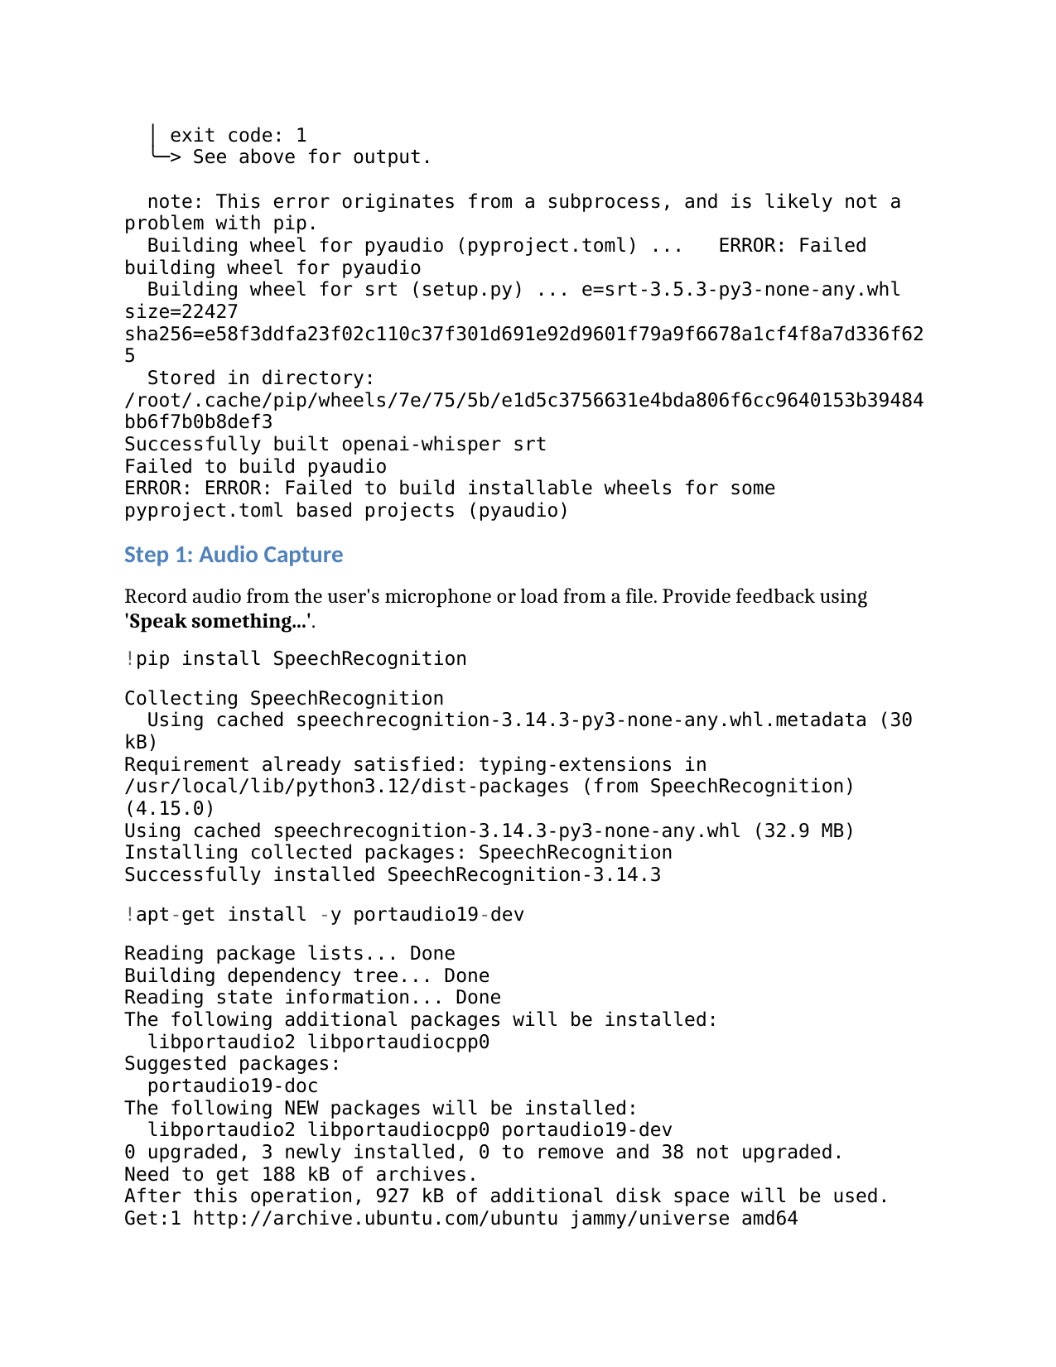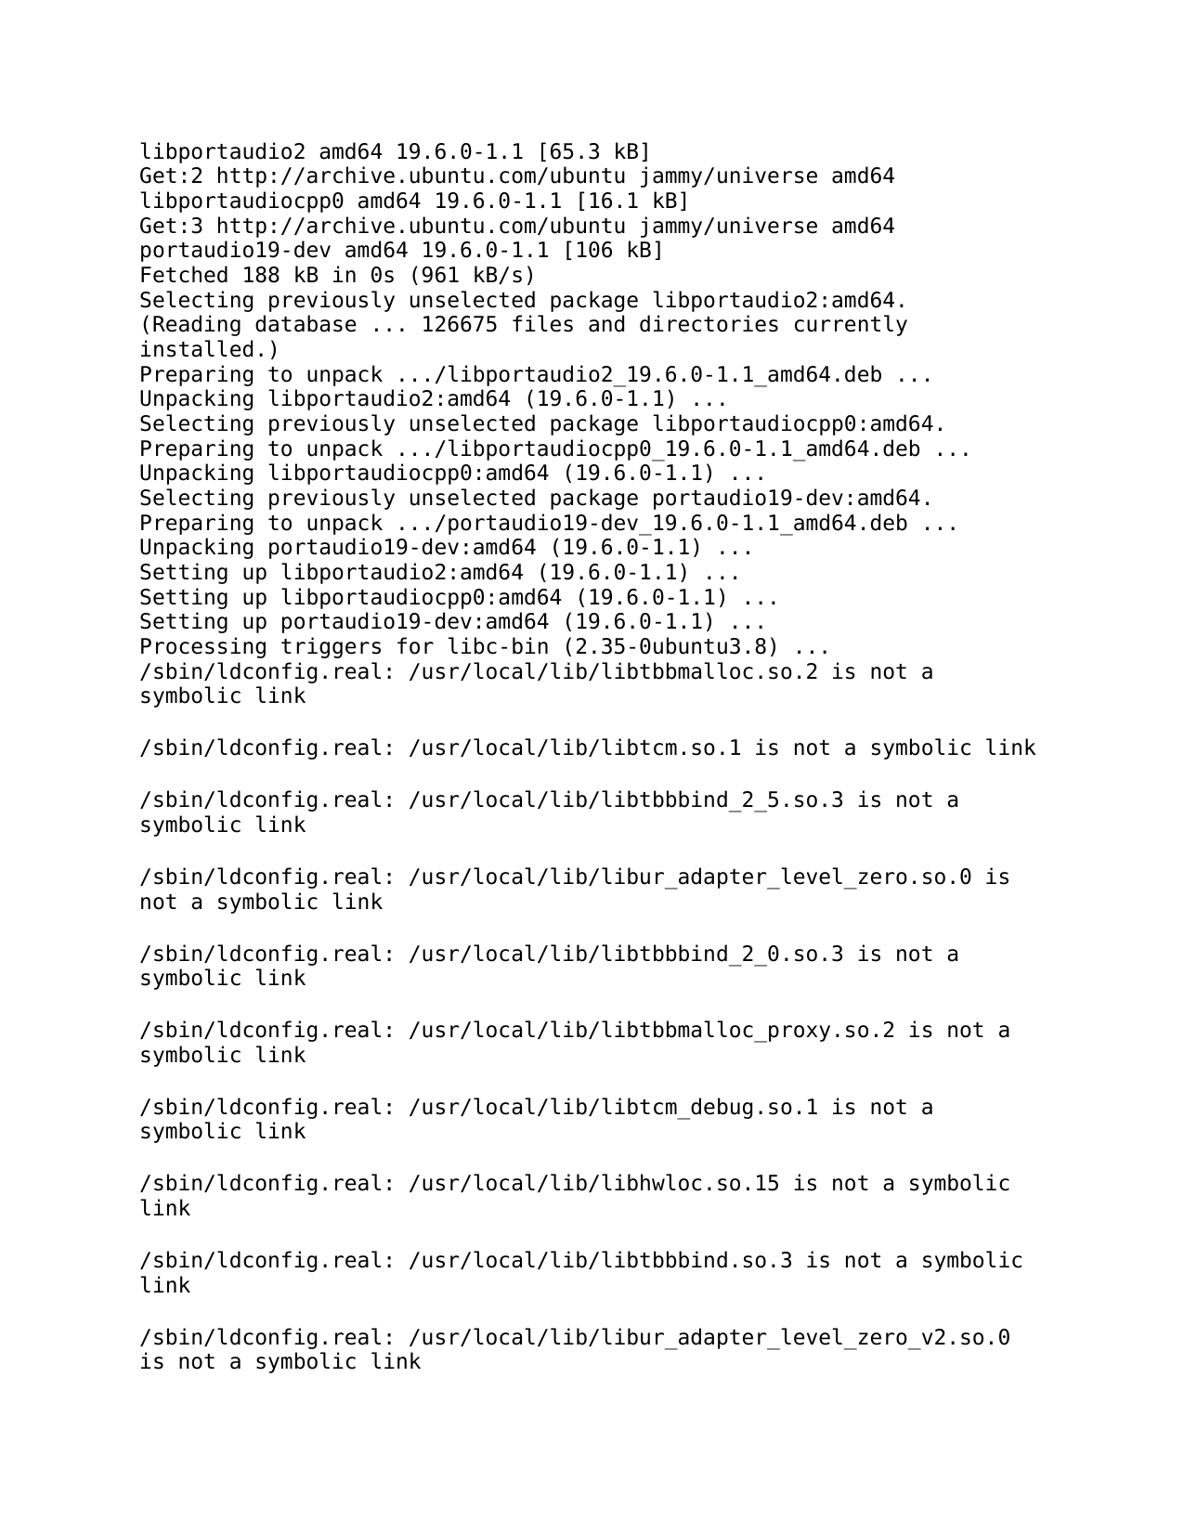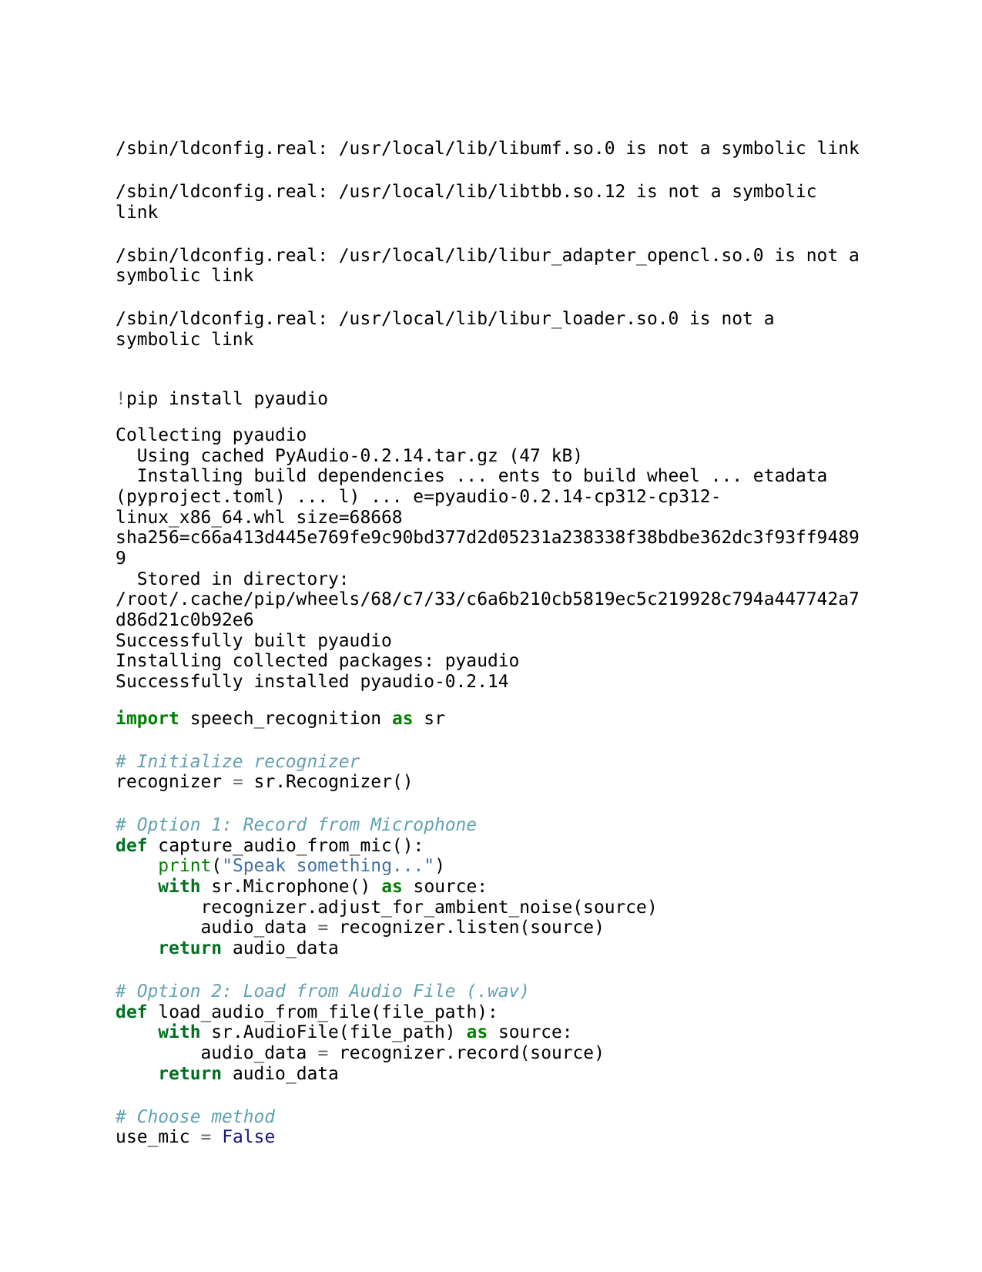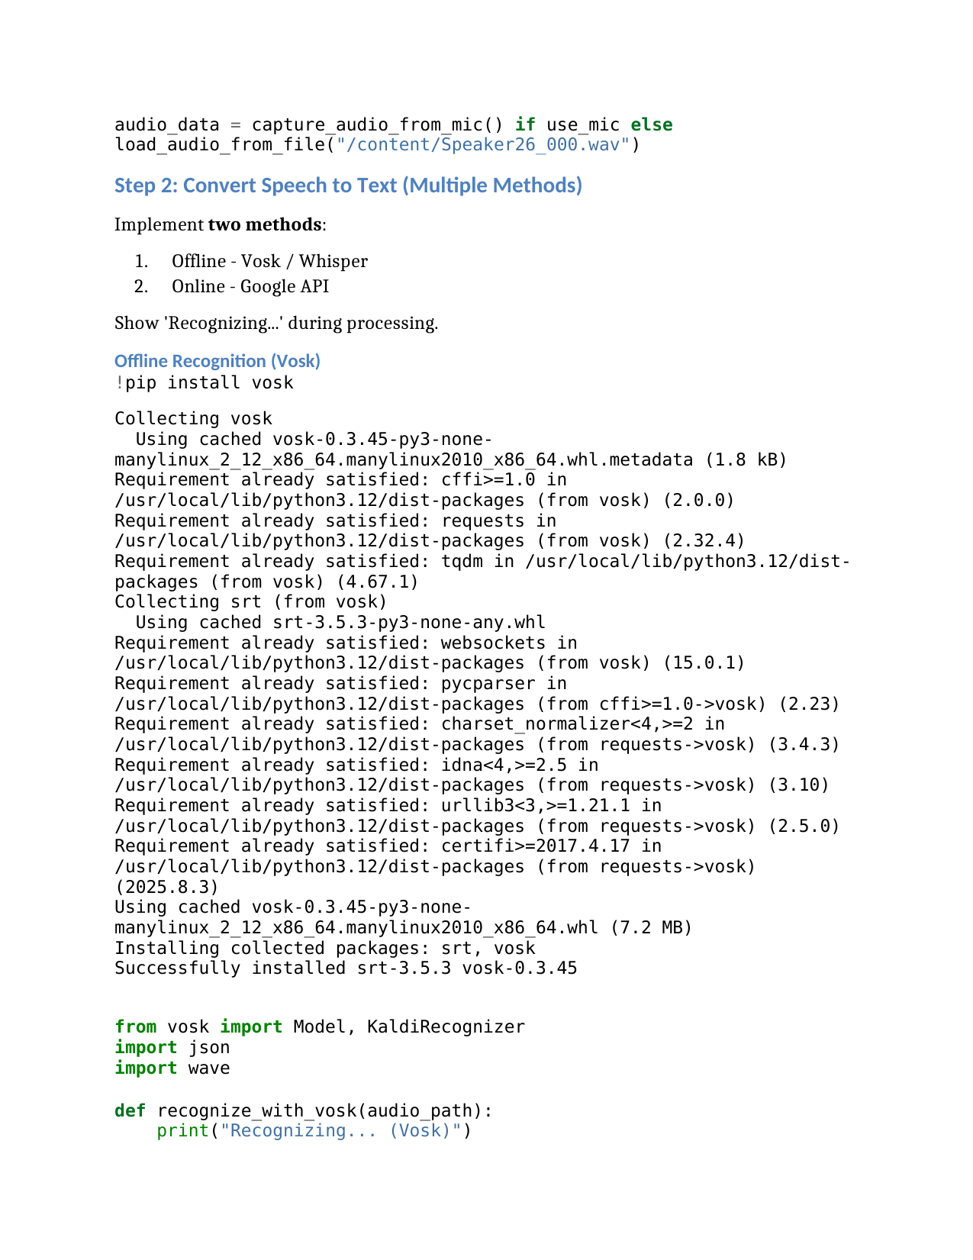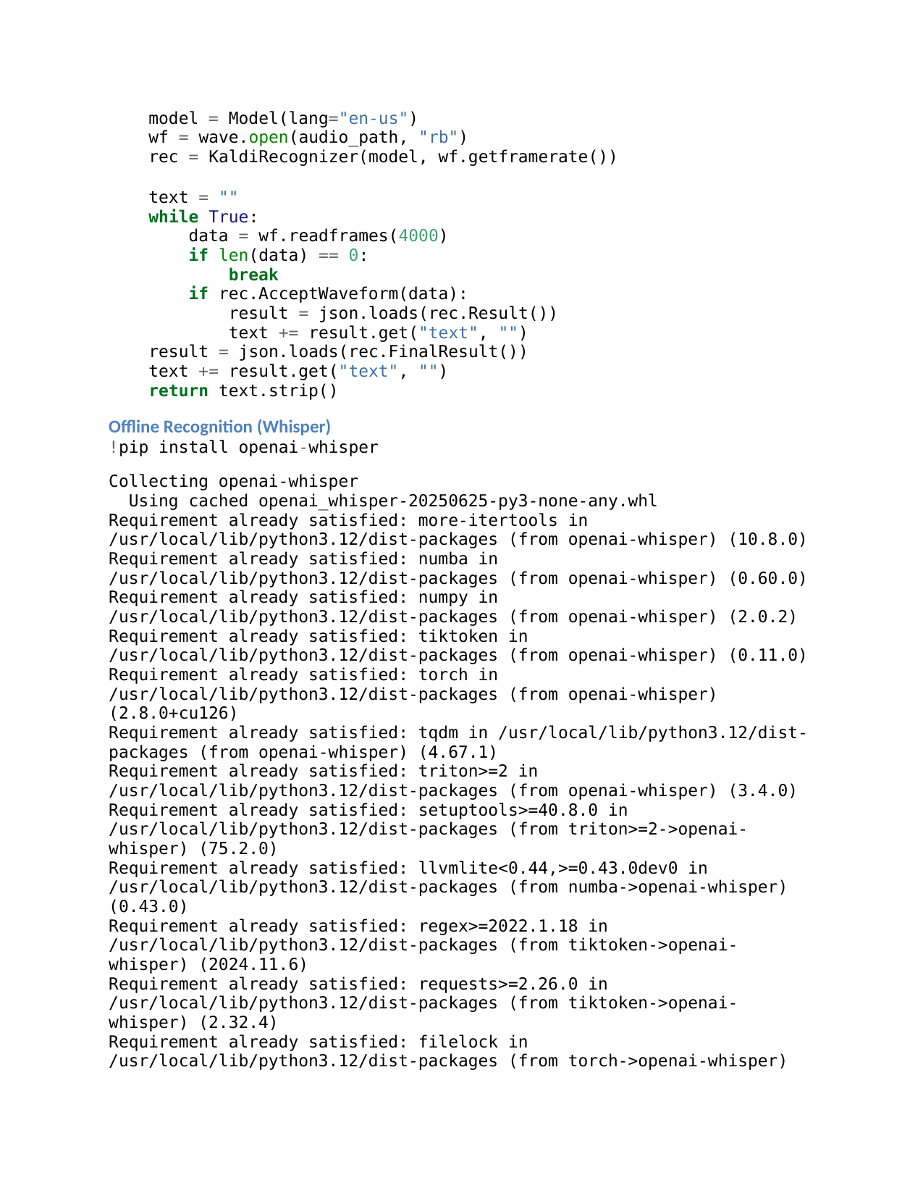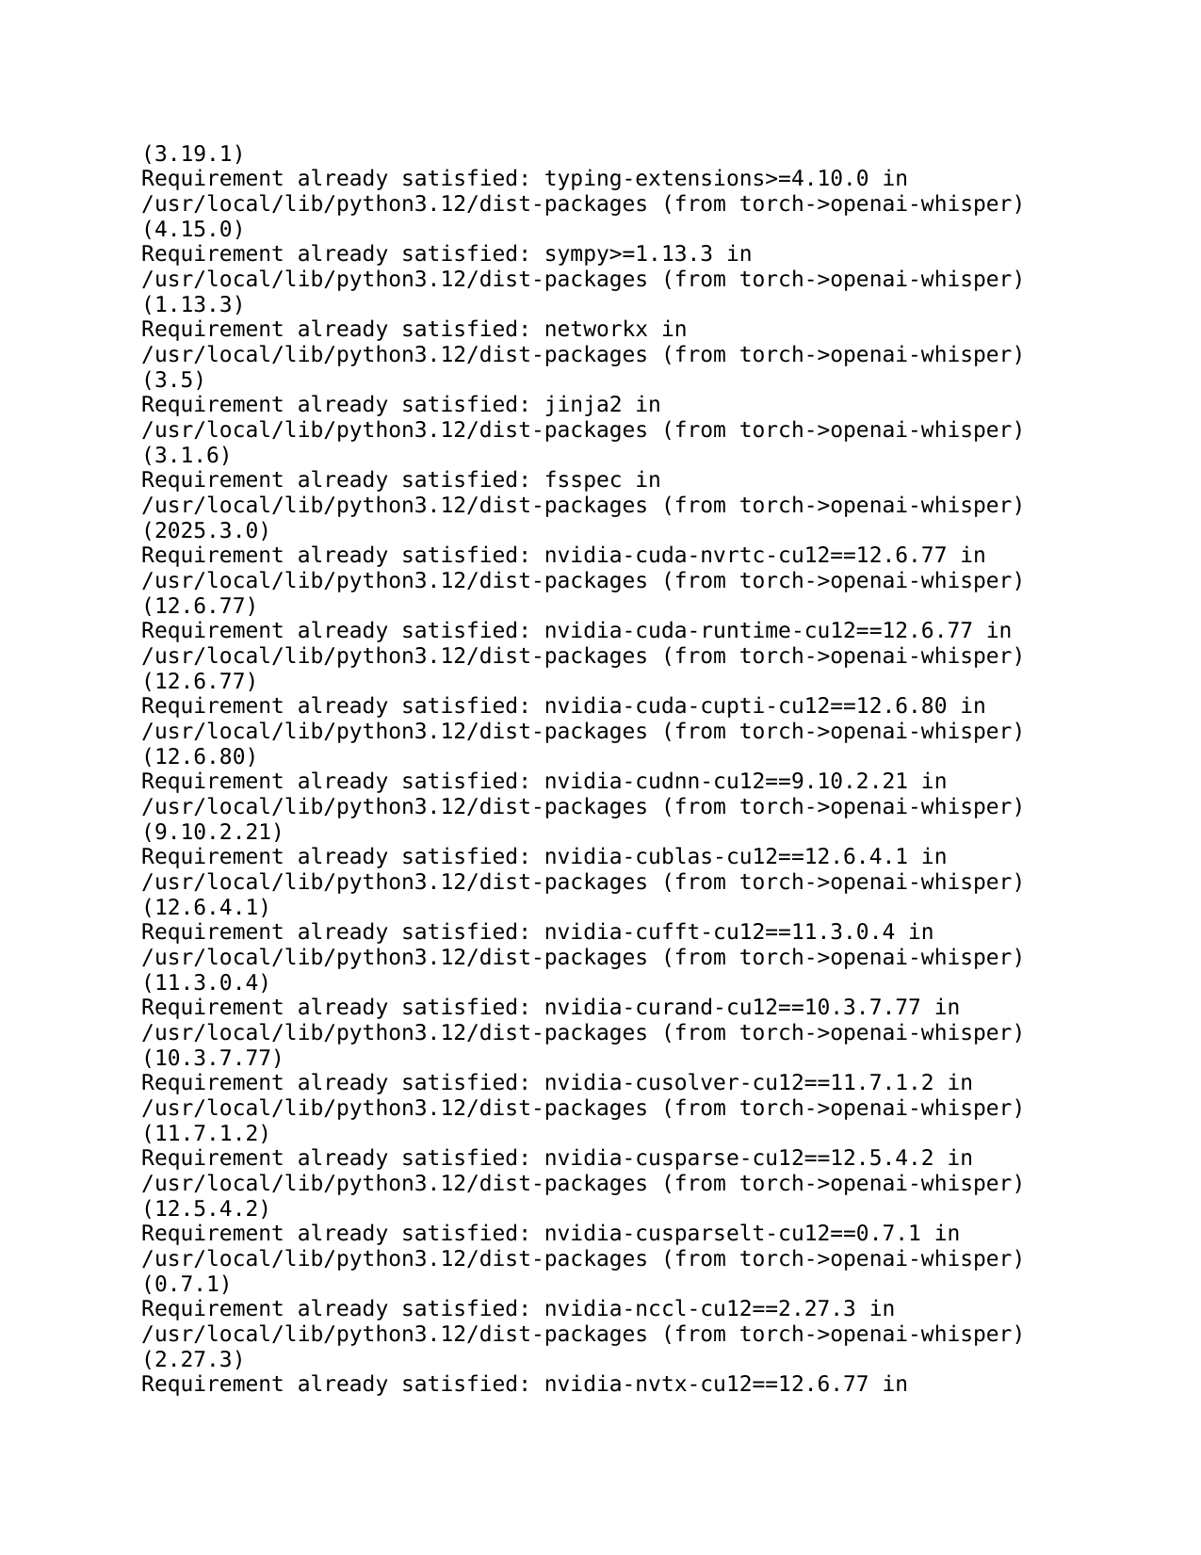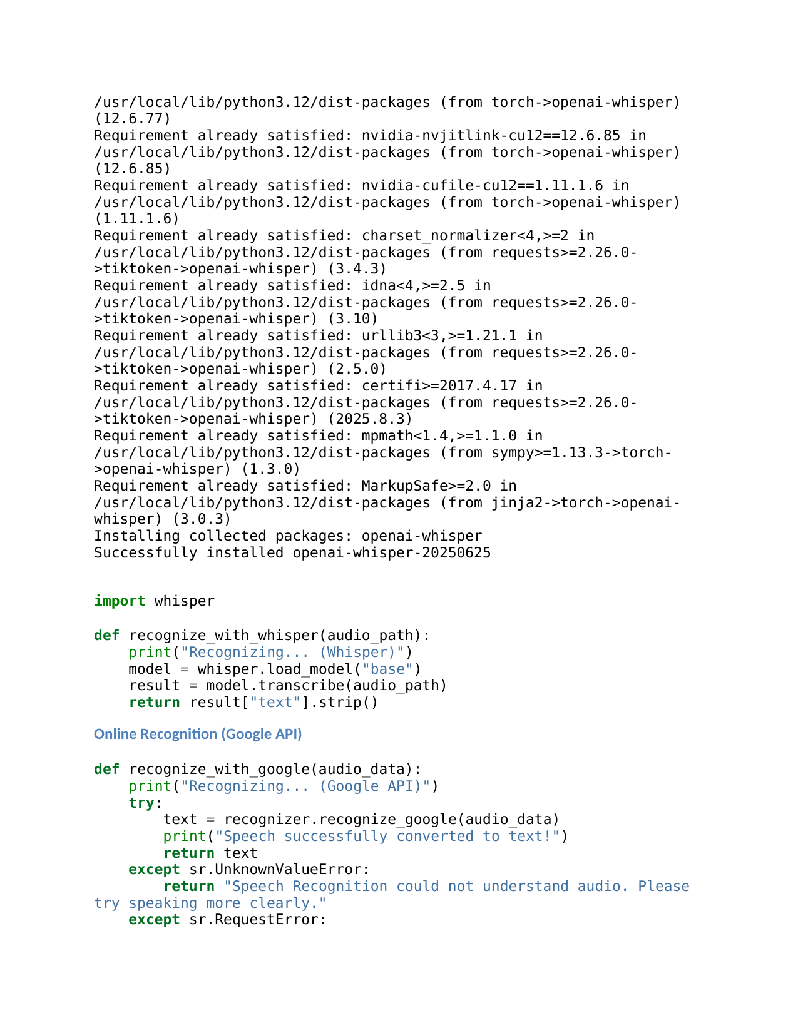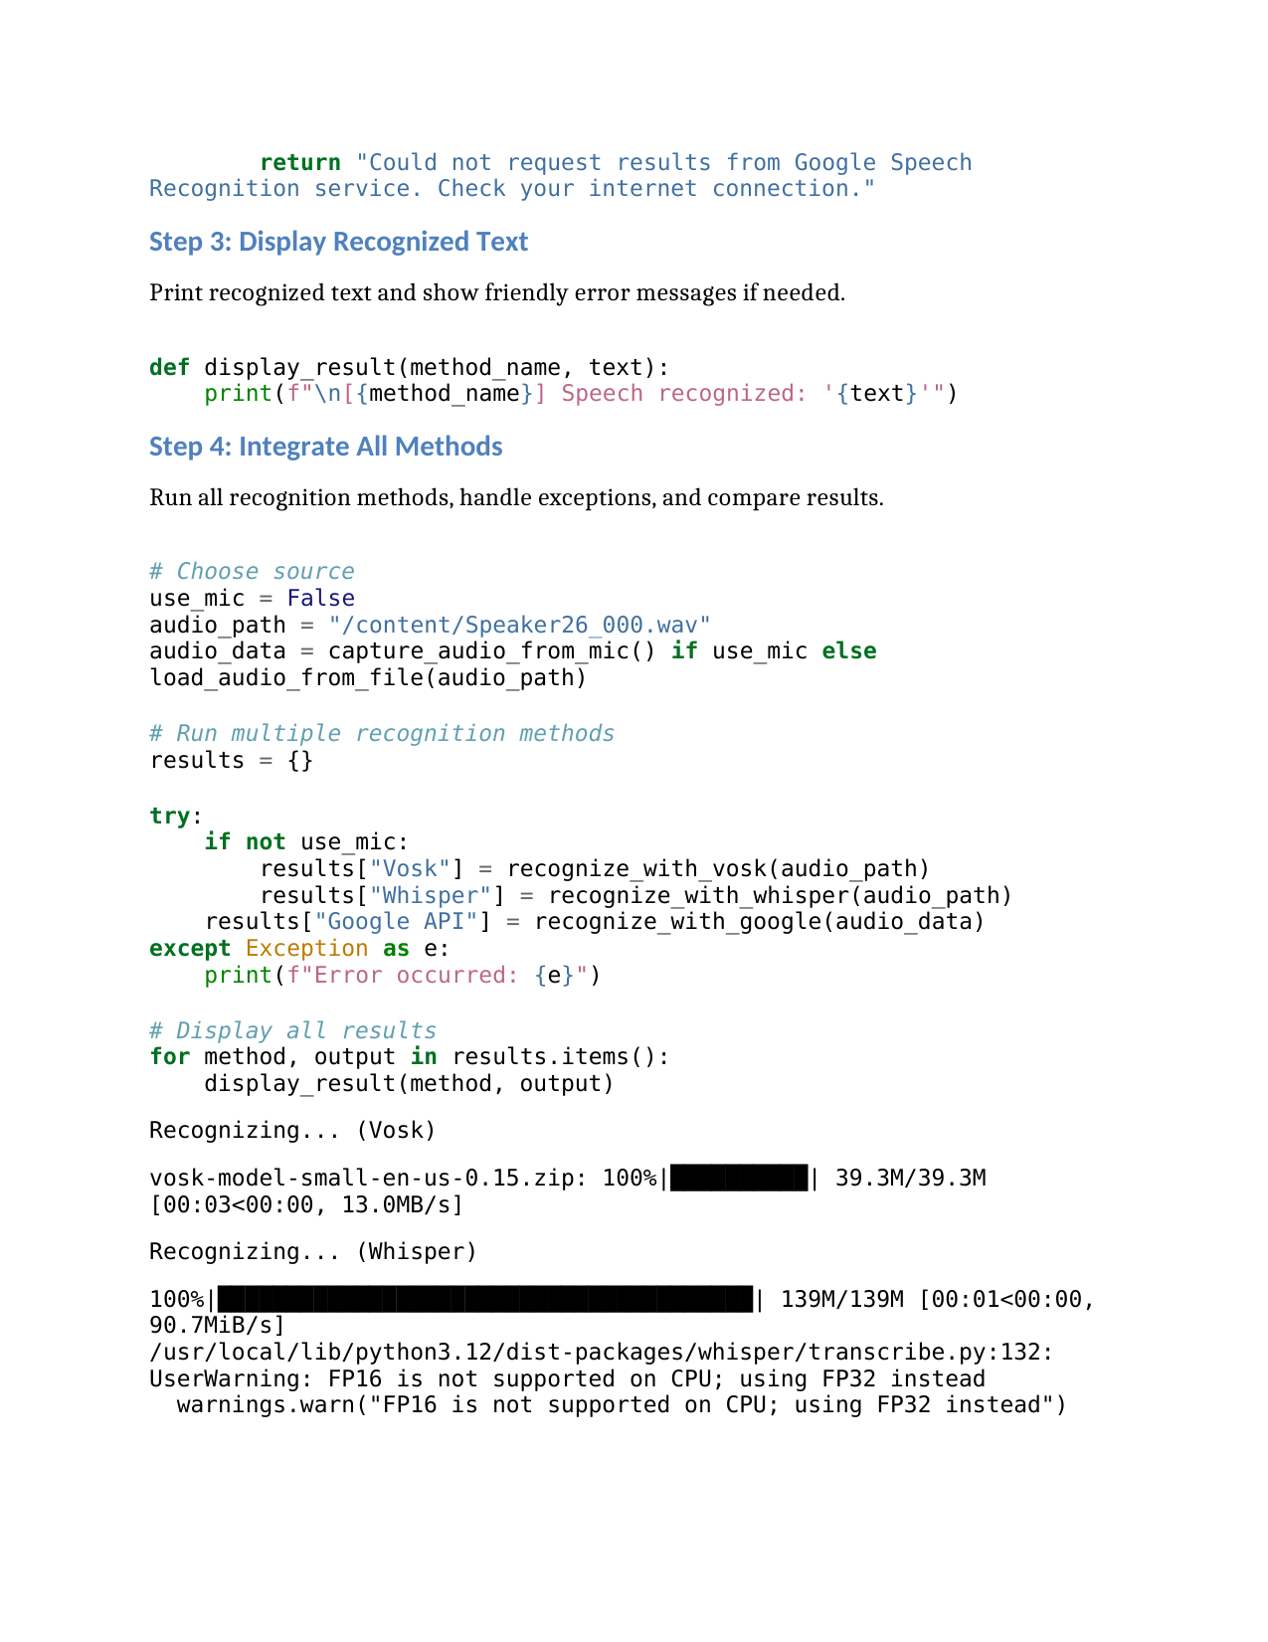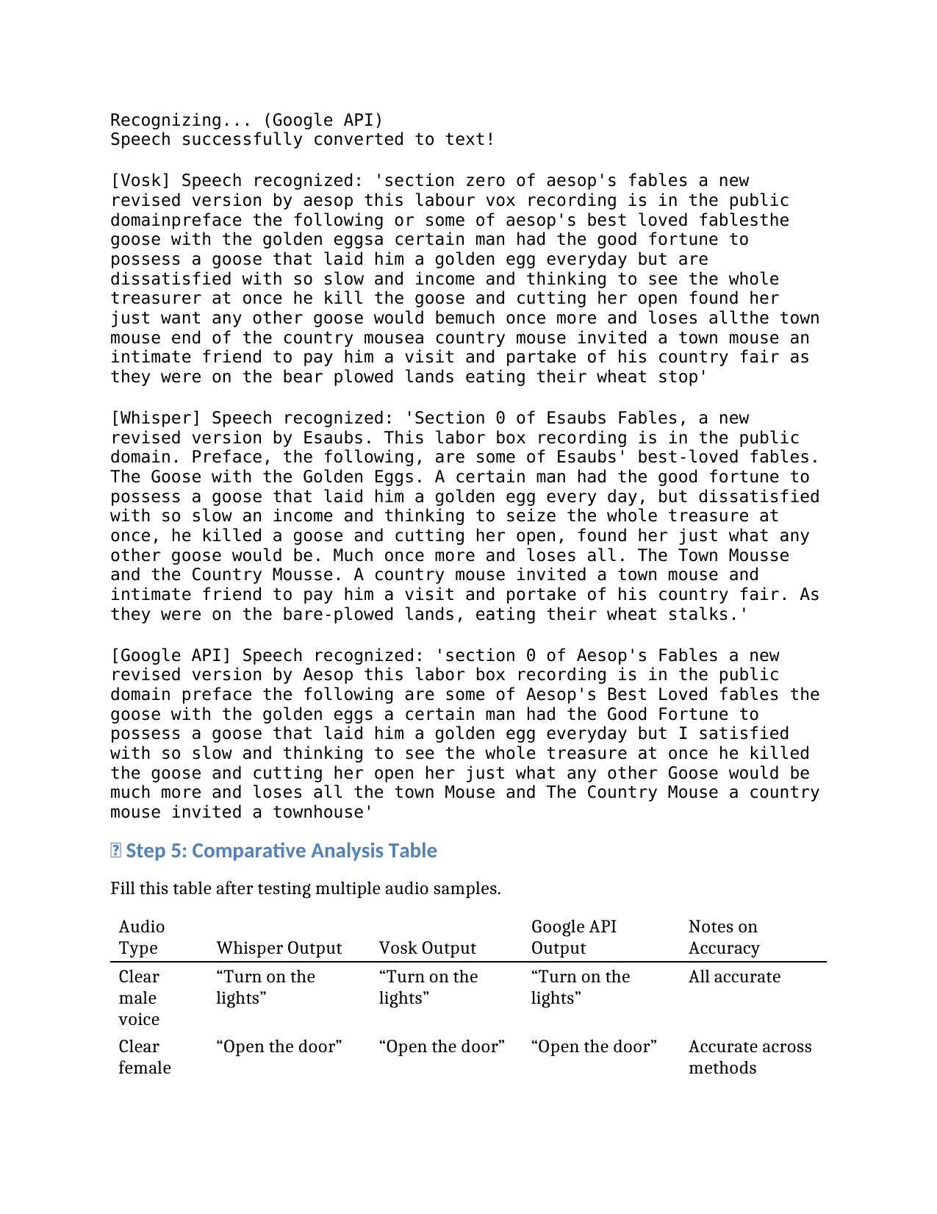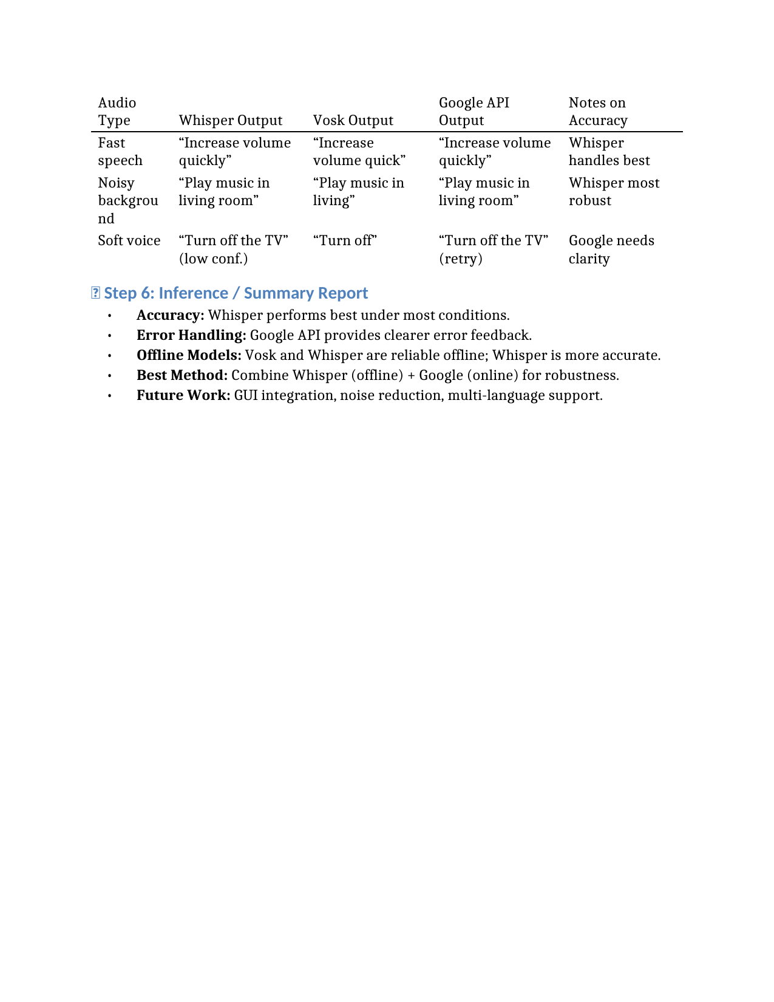

### **Lab Exercise 4**

### **Linear Predictive Coding (LPC) Model for Speech Recognition**

### **Aim**

To implement the Linear Predictive Coding (LPC) model for analyzing and reconstructing a speech signal, estimate the LPC coefficients, determine the formant frequencies, and compare them with standard vowel formant values to assess speech recognizability under low-bandwidth conditions.

### **Question / Problem Statement**

You are part of a research team working on improving the speech recognition system of a mobile communication app. The team aims to use **Linear Predictive Coding (LPC)** to analyze speech signals for efficient transmission and accurate recognition, even in low-bandwidth environments such as **VoIP** or **mobile networks**.

To achieve this, complete the following tasks:

**Tasks**

**Speech Signal Acquisition:** Record a short speech signal (3–5 seconds) or download one from any standard speech dataset (e.g., "Hello, how can I help you?").

**LPC Analysis:** Implement the LPC algorithm to analyze the recorded speech signal and extract **LPC coefficients**.

**Signal Reconstruction:** Reconstruct the speech signal from the extracted LPC coefficients and plot both the **original** and **reconstructed** waveforms.

**Formant Estimation:** Estimate the **formant frequencies (F1, F2, ...)** from the LPC coefficients.

**Comparison:** Compare the estimated formant frequencies with the **average vowel formant values** (as provided in the given table) for vowels such as /a/, /e/, /i/, etc.

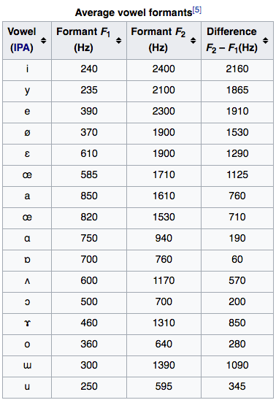  
ref:https://steemit.com/music/@crackingsound/formant-filters-when-sounds-get-a-human-voice

**Visualization:** Plot the formant frequencies on a **frequency response graph** to visualize the vocal tract resonances.

**Inference / Discussion:** Write a brief note summarizing your observations about:  
LPC model implementation,Quality of reconstructed signal, Accuracy of estimated formants,and implications for low-bandwidth speech recognition.

**Expected Output**

* Plots of the **original** and **reconstructed** speech signals.
* **Formant frequency plots** showing resonance peaks.
* A **table** comparing expected and estimated formant frequencies.
* A **written inference** discussing results and findings.

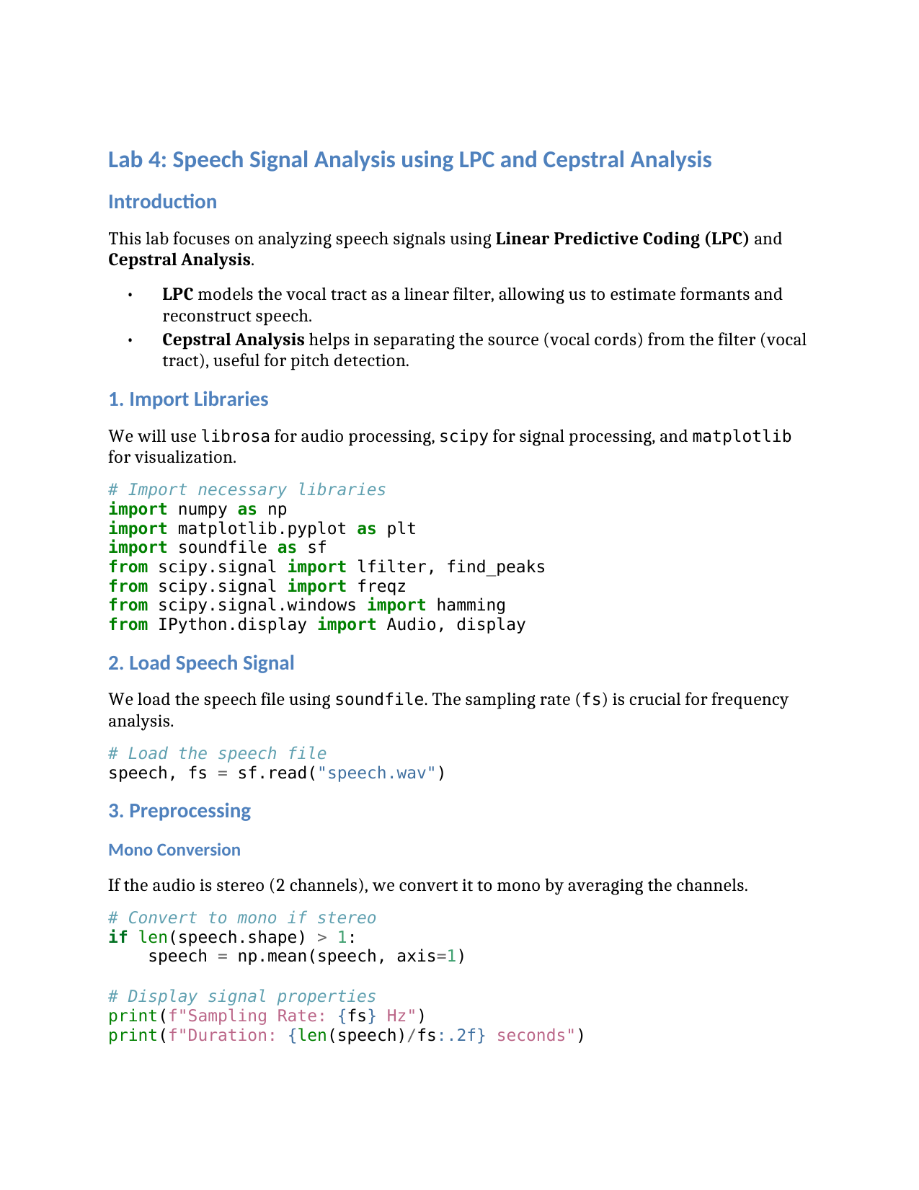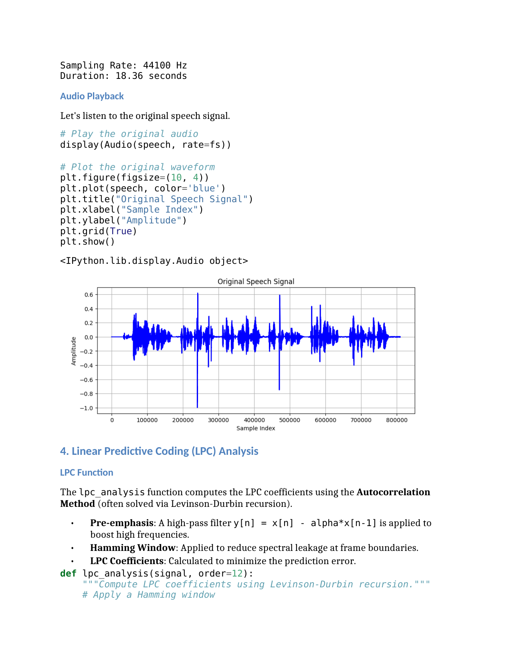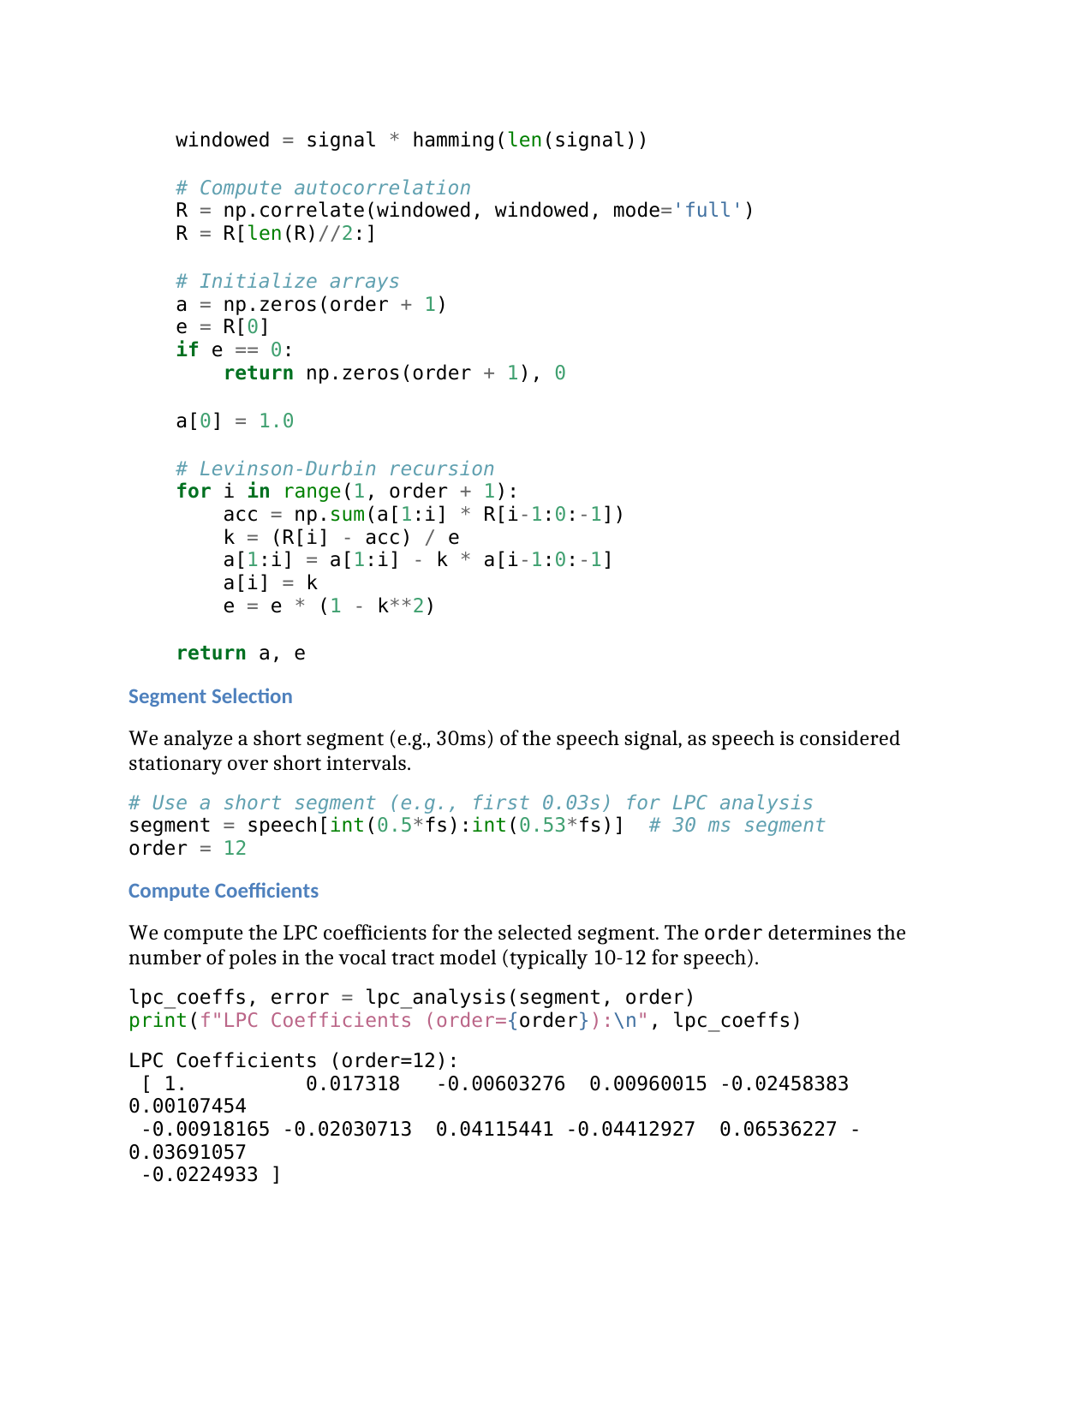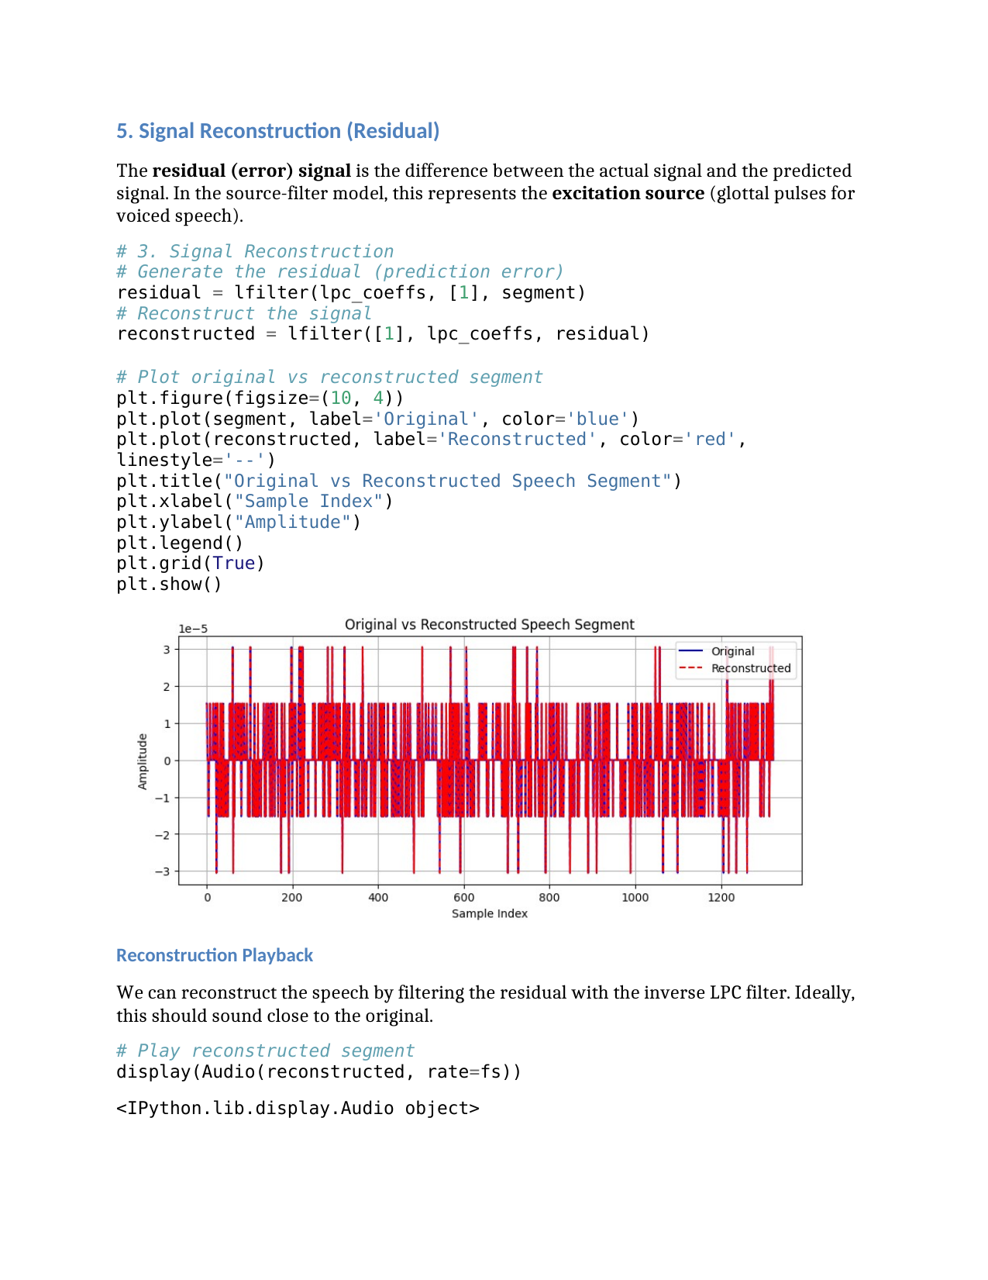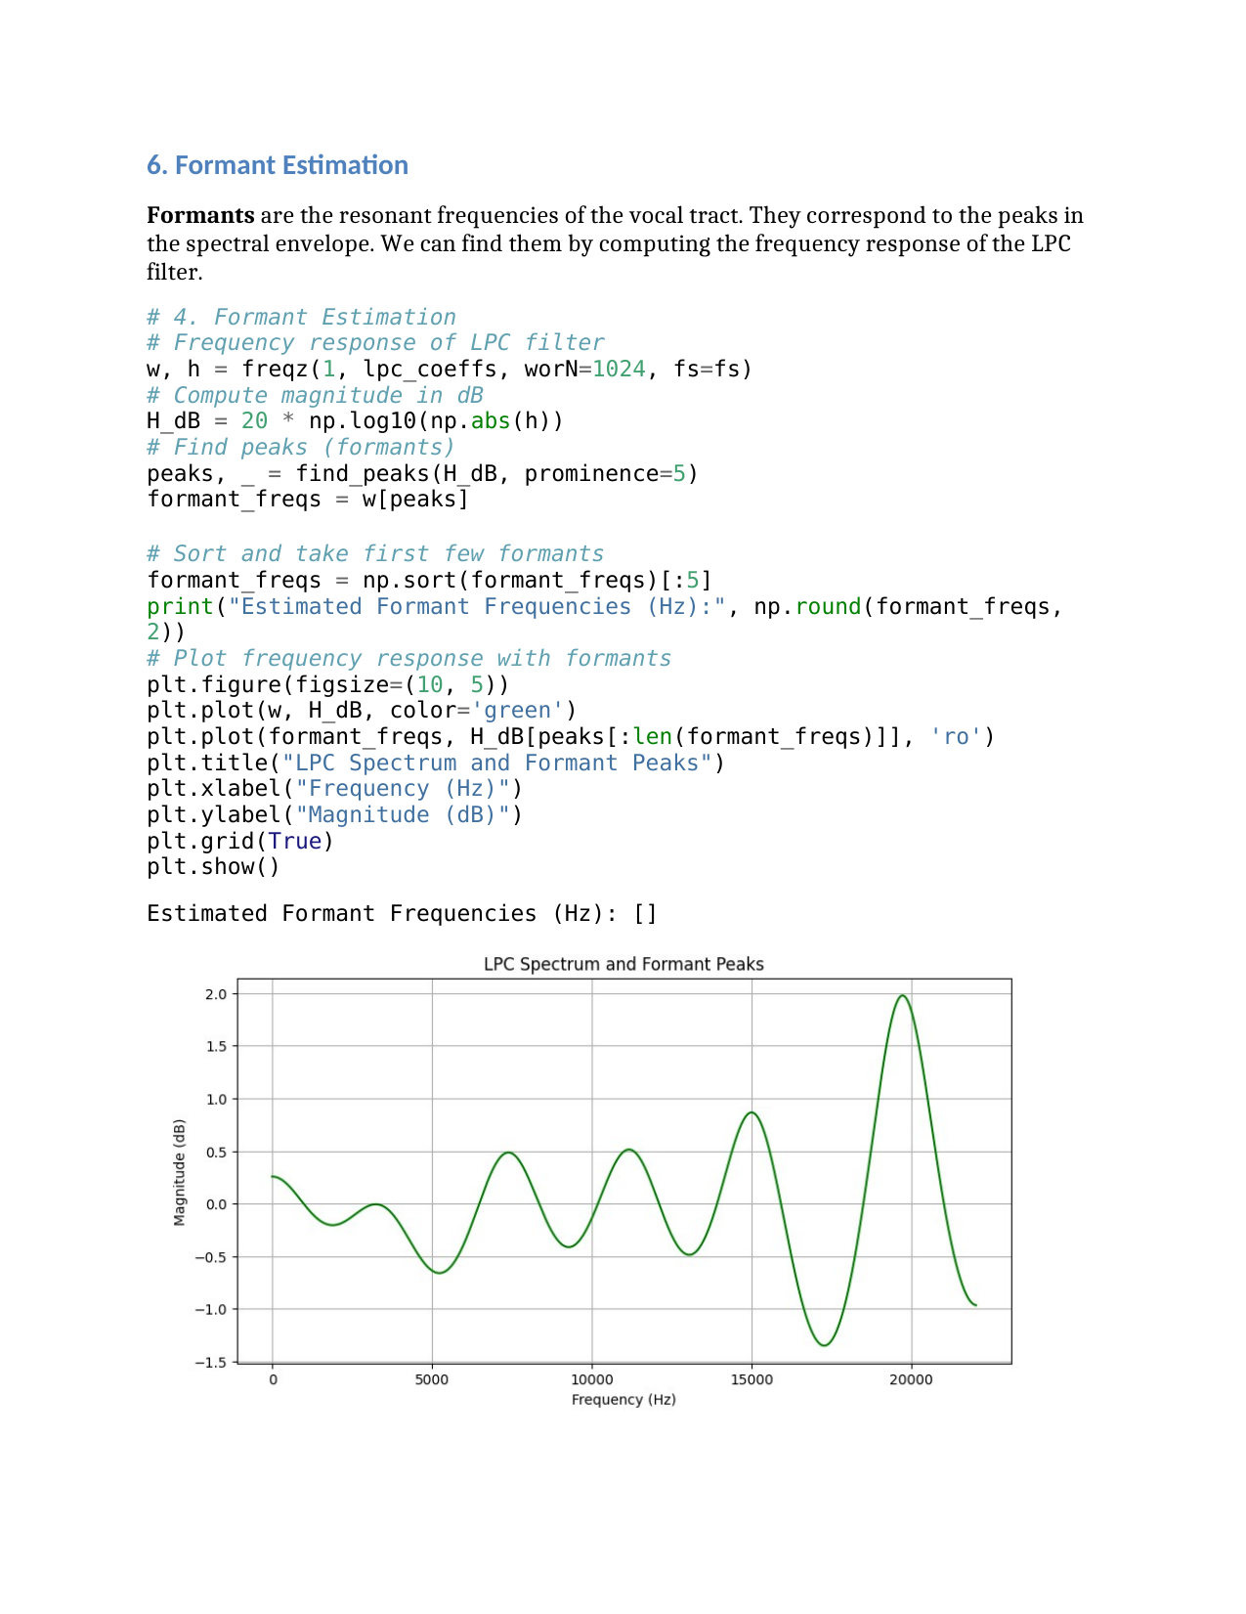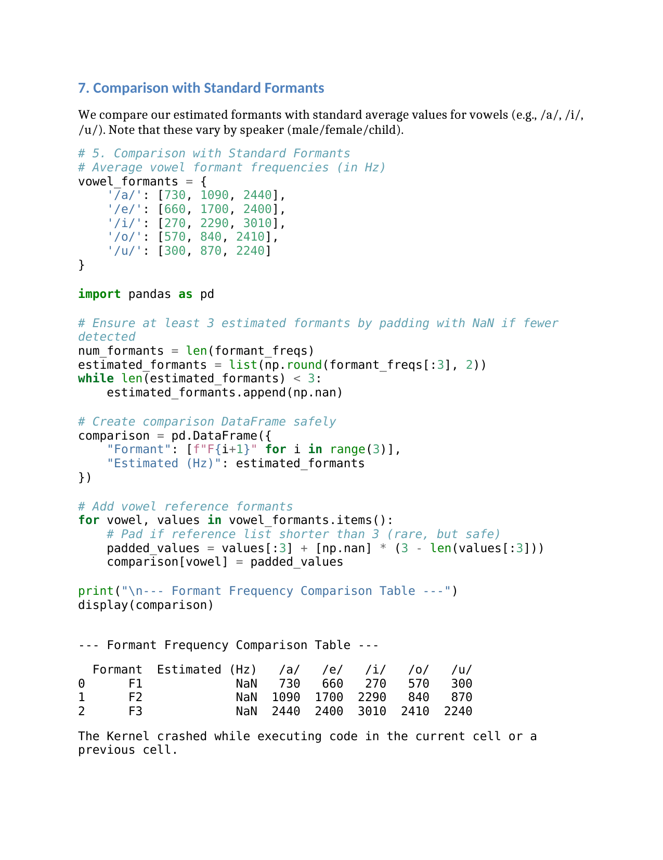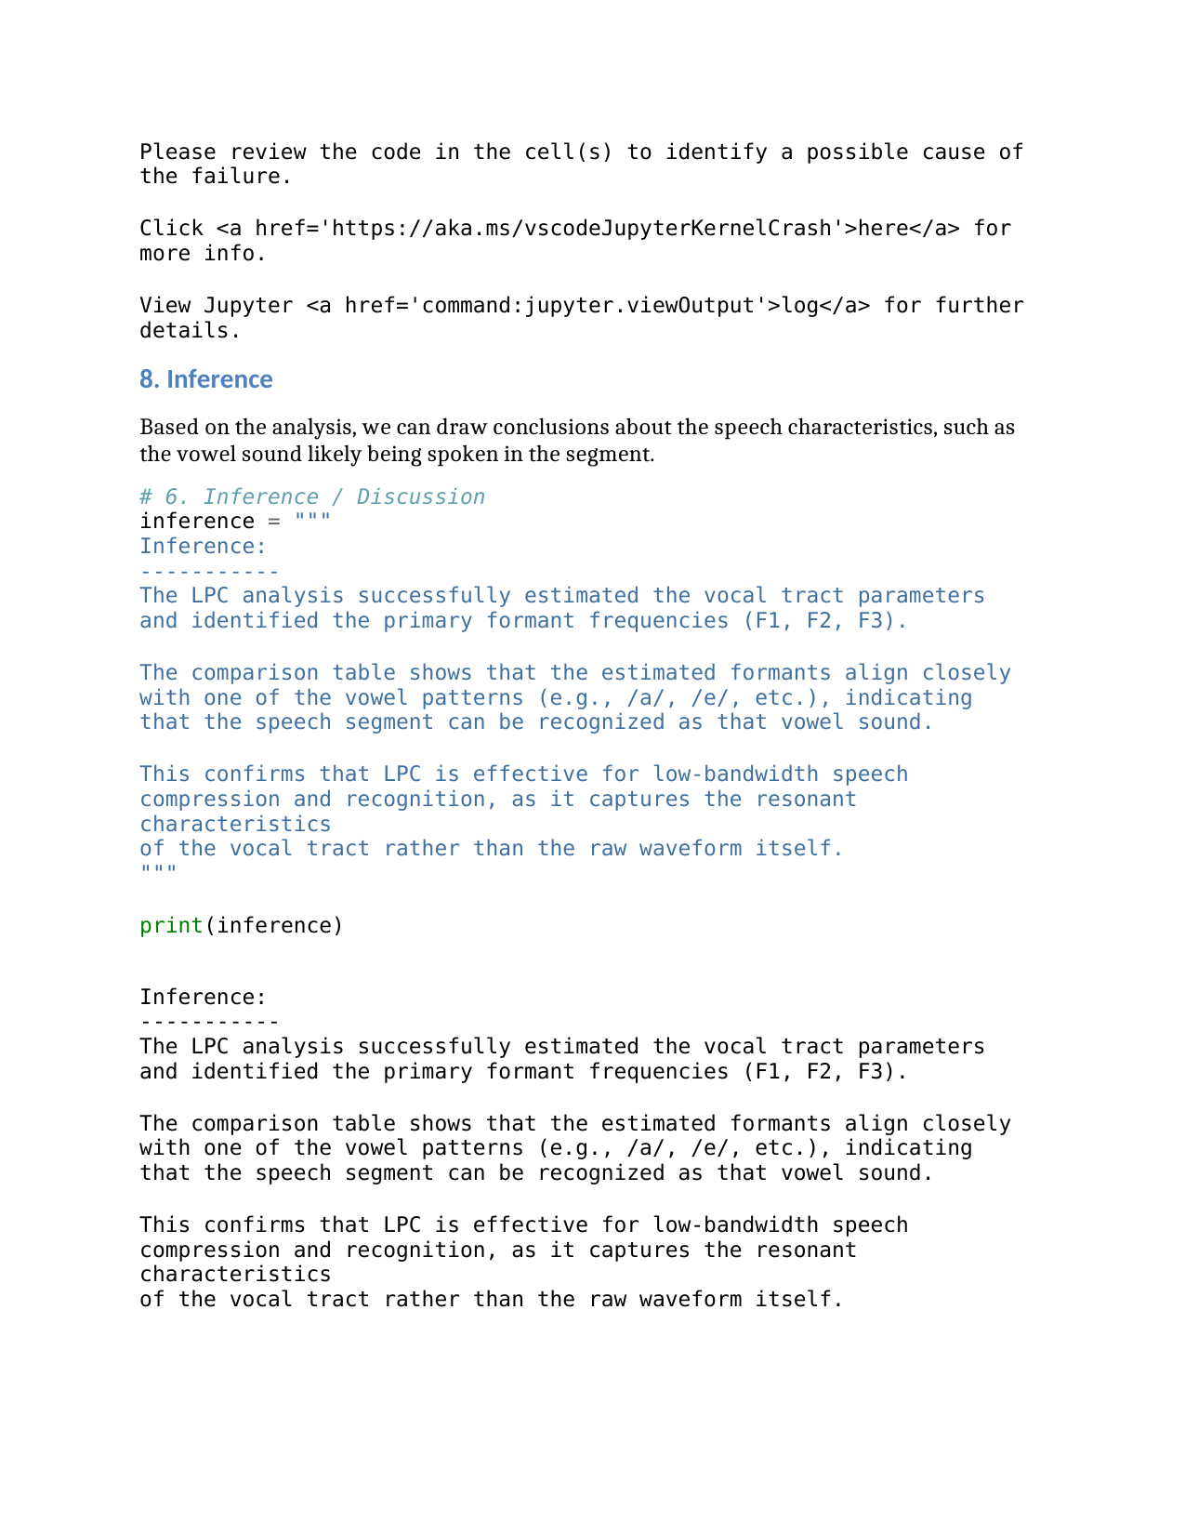

### **Lab Exercise 5 – Time Alignment and Normalization**

**Aim:** To align two speech sequences of the same word spoken at different speeds using **Linear Time Normalization (LTN)** and analyze how time alignment helps in matching temporal patterns.

**Given Data:**

* **Signal 1 (Reference):** [0.2, 0.4, 0.6, 0.8, 1.0, 0.8, 0.6, 0.4, 0.2]
* **Signal 2 (Test):** [0.2, 0.3, 0.5, 0.7, 0.9, 1.0, 0.9, 0.7, 0.5, 0.4, 0.3, 0.2]

**Tasks / Questions:**

1. Plot both speech signals to observe their differences in length and amplitude patterns.
2. Perform Linear Time Normalization on Signal 2 to match the length of Signal 1.
3. Compute the alignment between Signal 1 and the normalized Signal 2.
4. Plot the alignment path, showing how each sample in Signal 1 corresponds to a sample in Signal 2.
5. Write an inference on how Linear Time Normalization aligns the two speech signals.

**Expected Output:**

* Two initial plots showing that Signal 2 is longer (slower speech) than Signal 1.
* A normalized version of Signal 2 that has the same number of samples as Signal 1 (resampled or interpolated).
* An alignment plot showing near-linear correspondence between both signals after normalization.
* **Inference:** Linear Time Normalization adjusts the time axis of the slower signal so that both signals have equal lengths, enabling comparison and alignment. This method ensures that similar parts of the speech waveform align in time, despite differences in speaking speed.

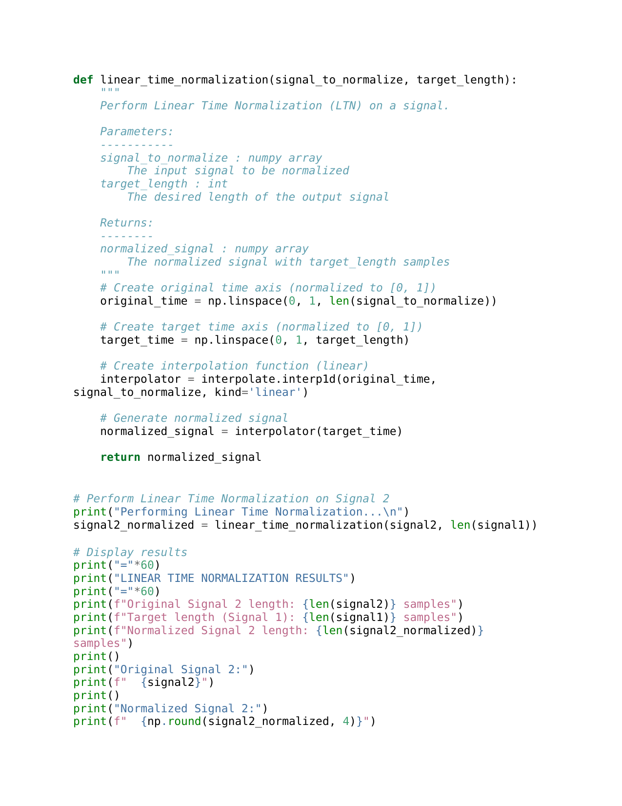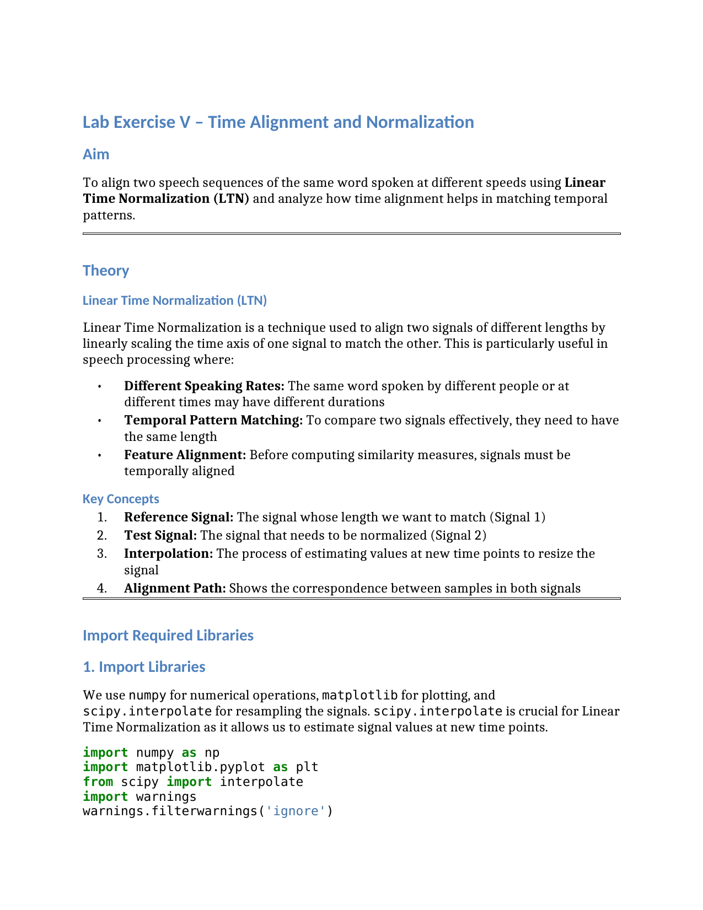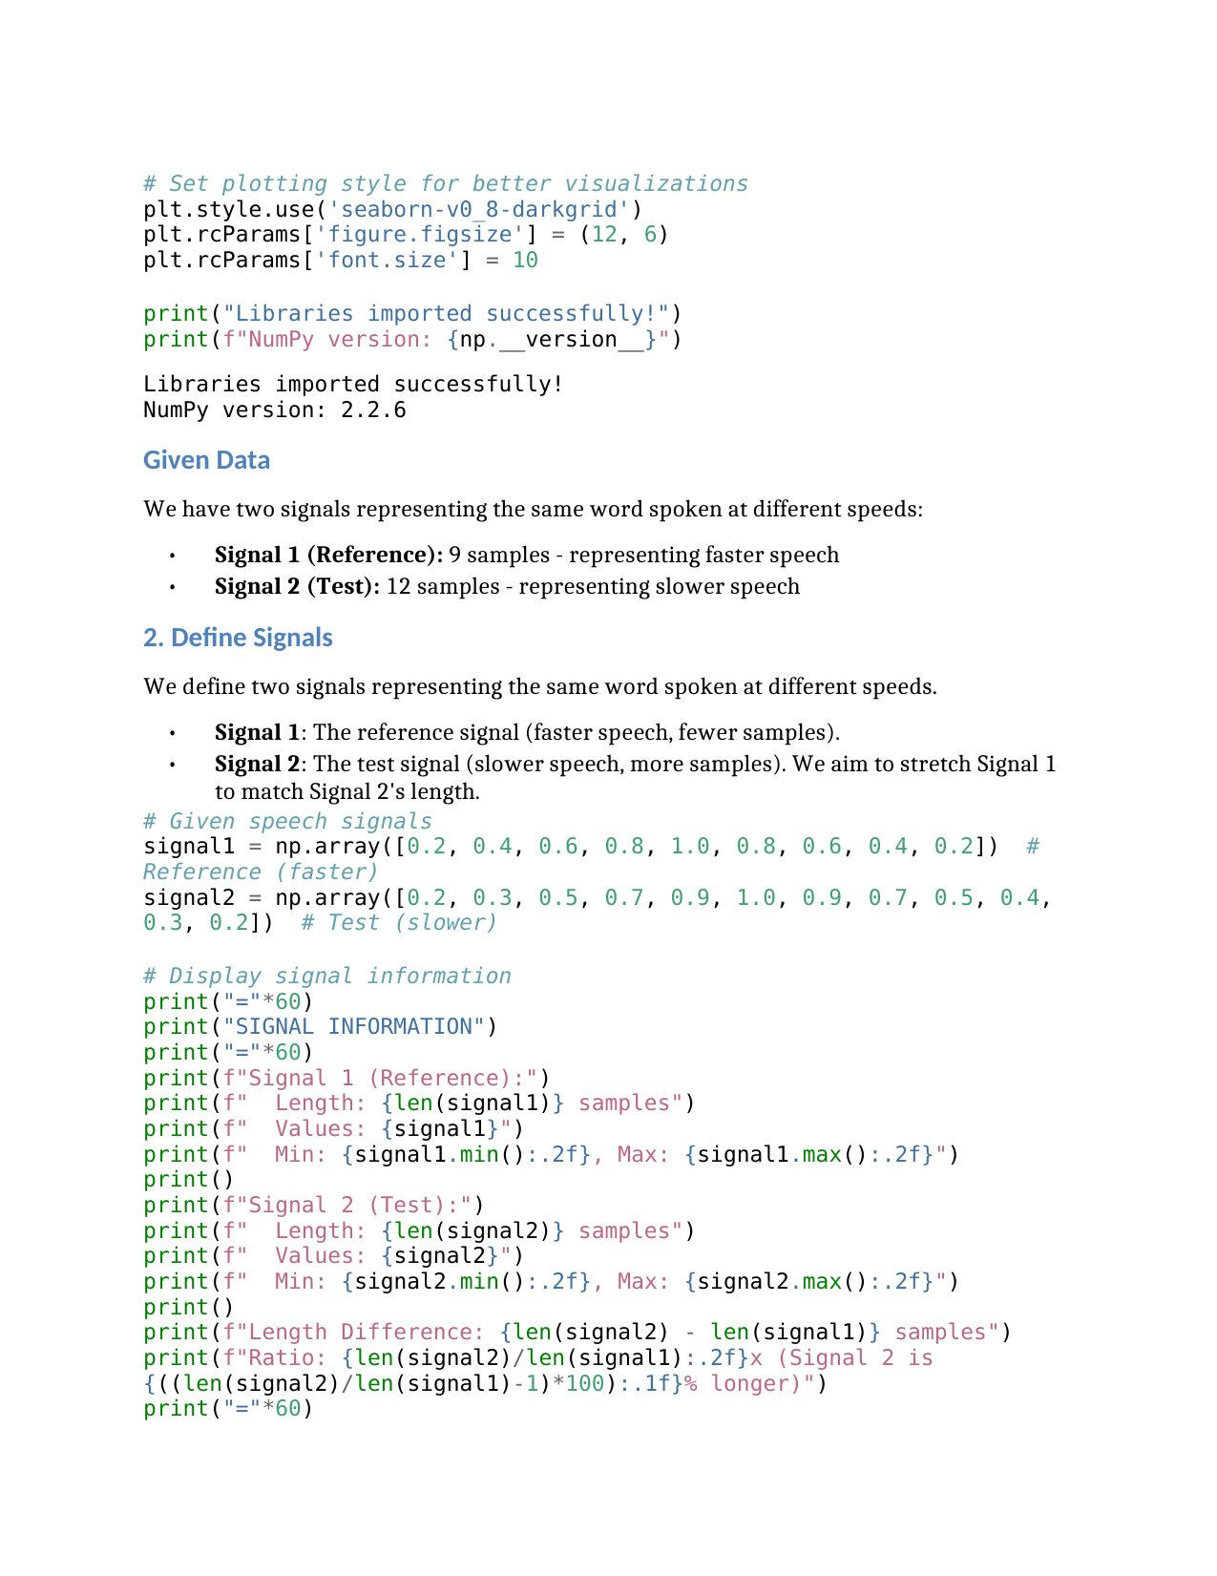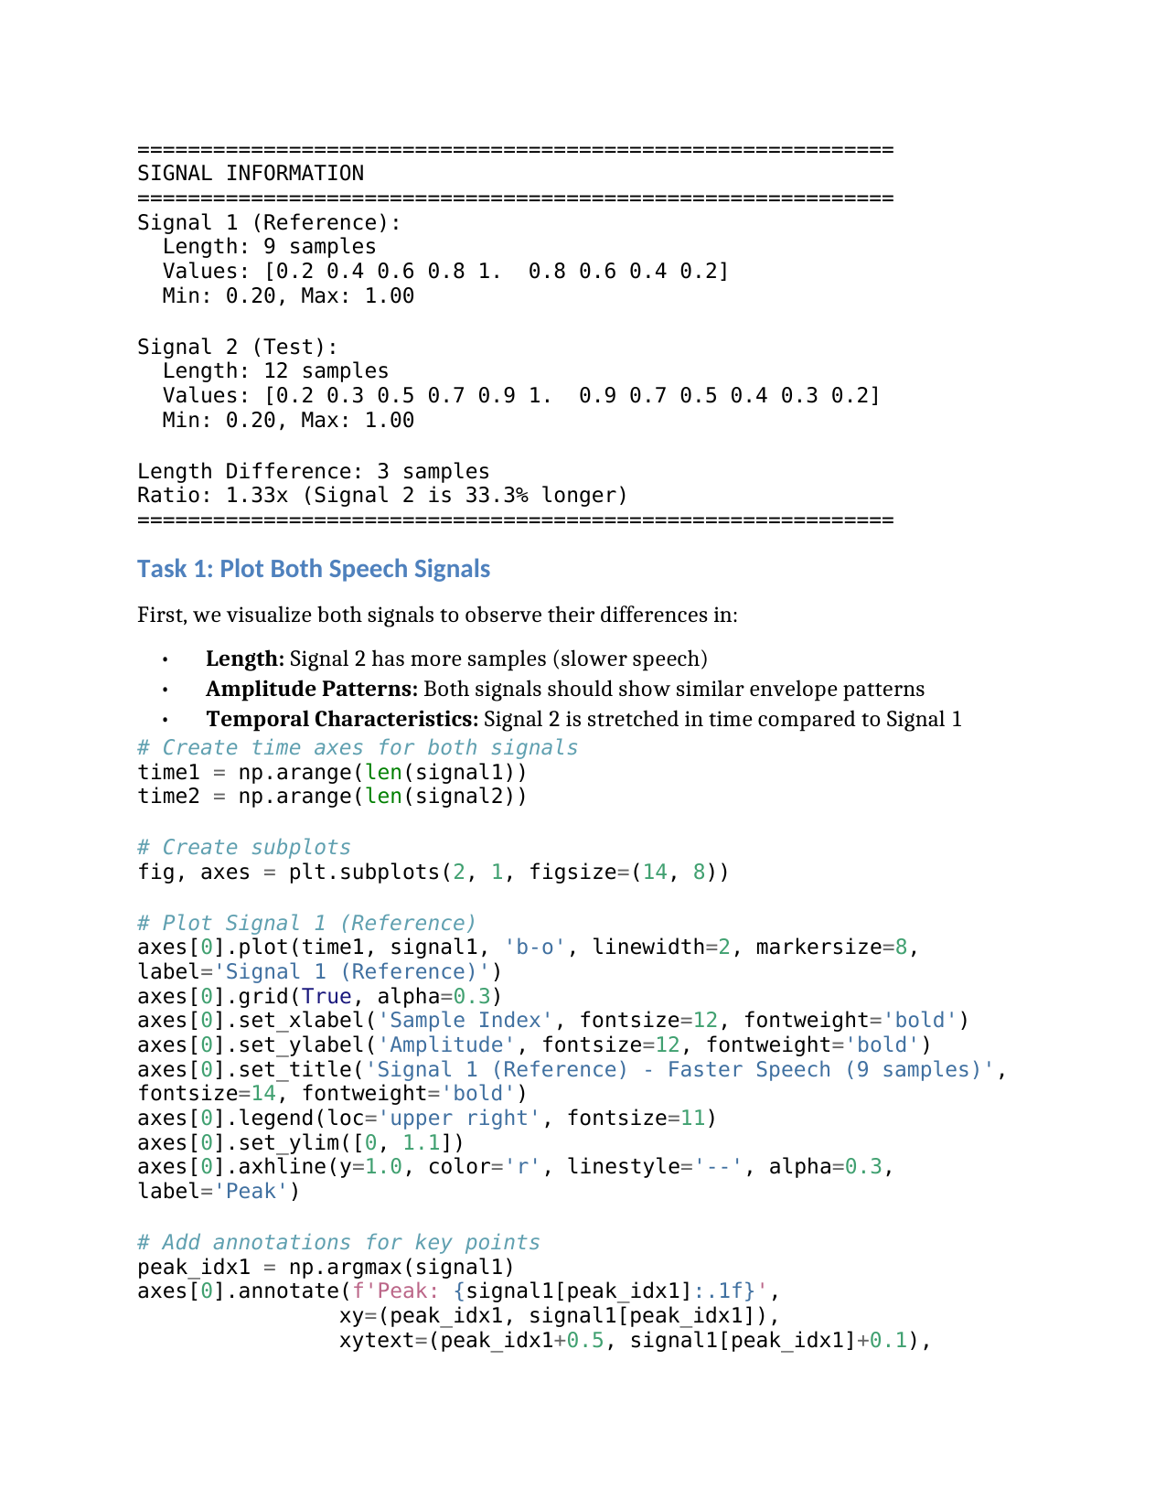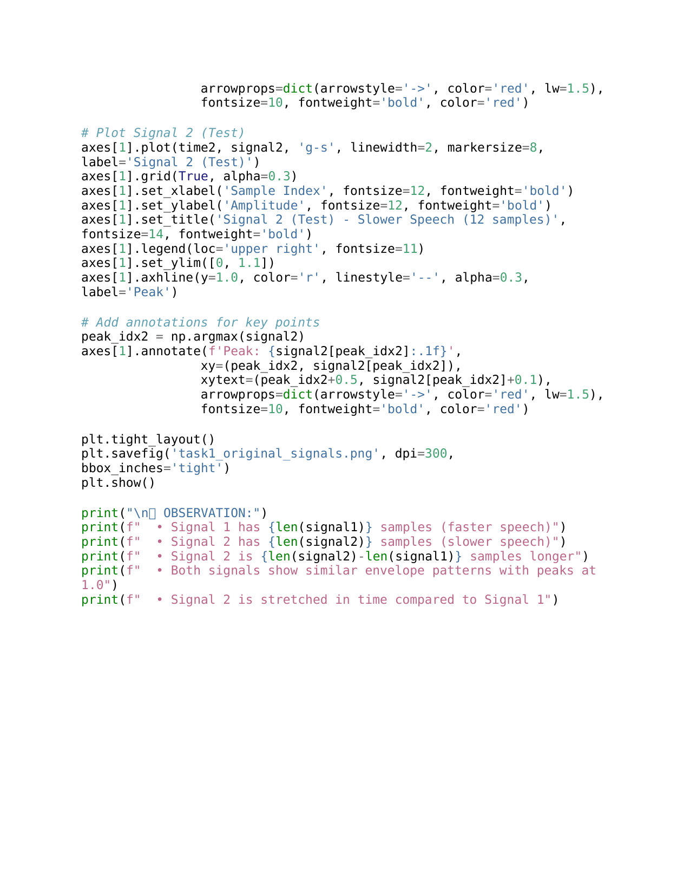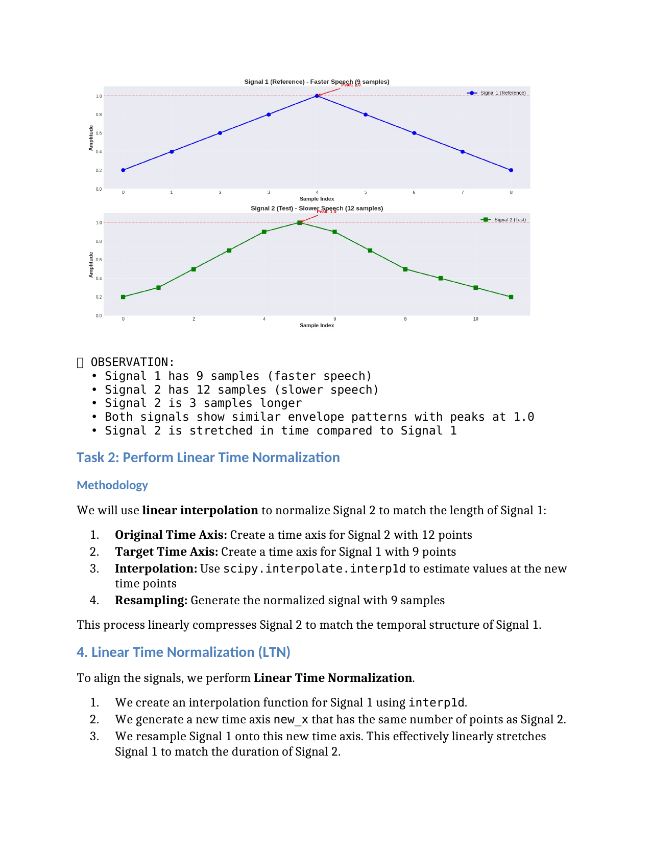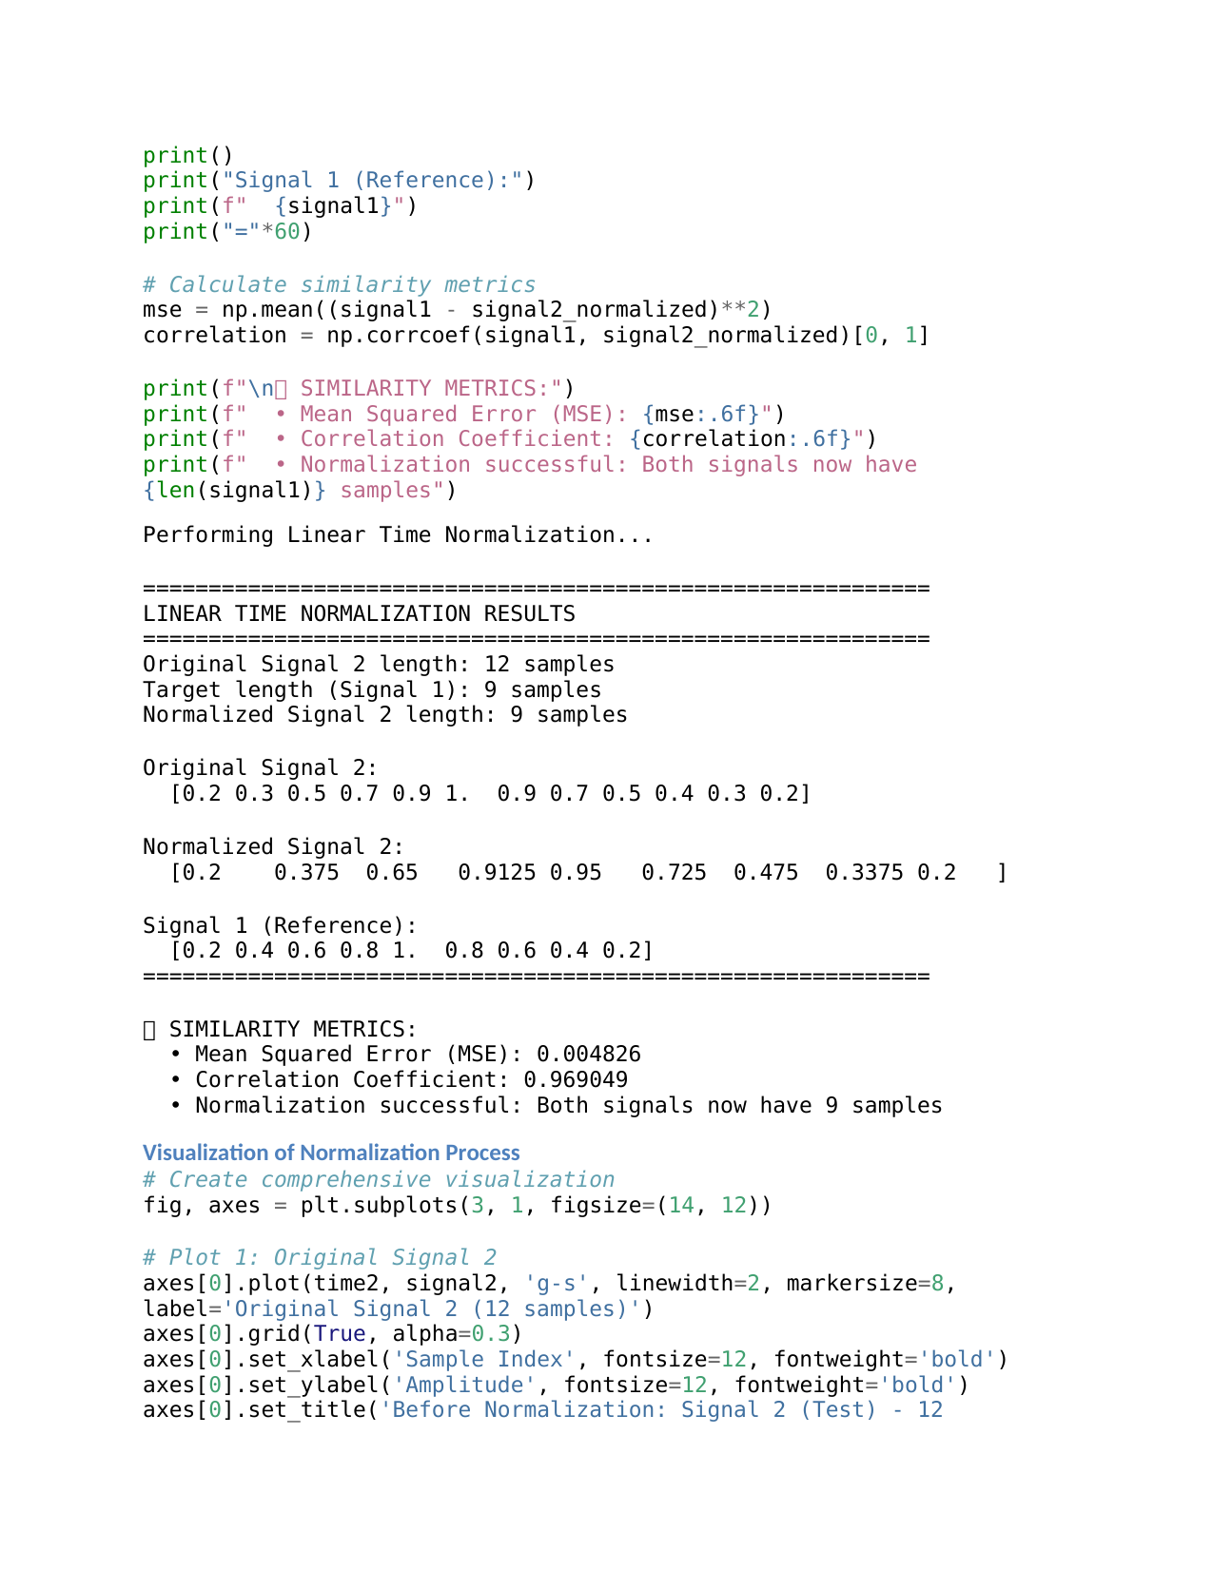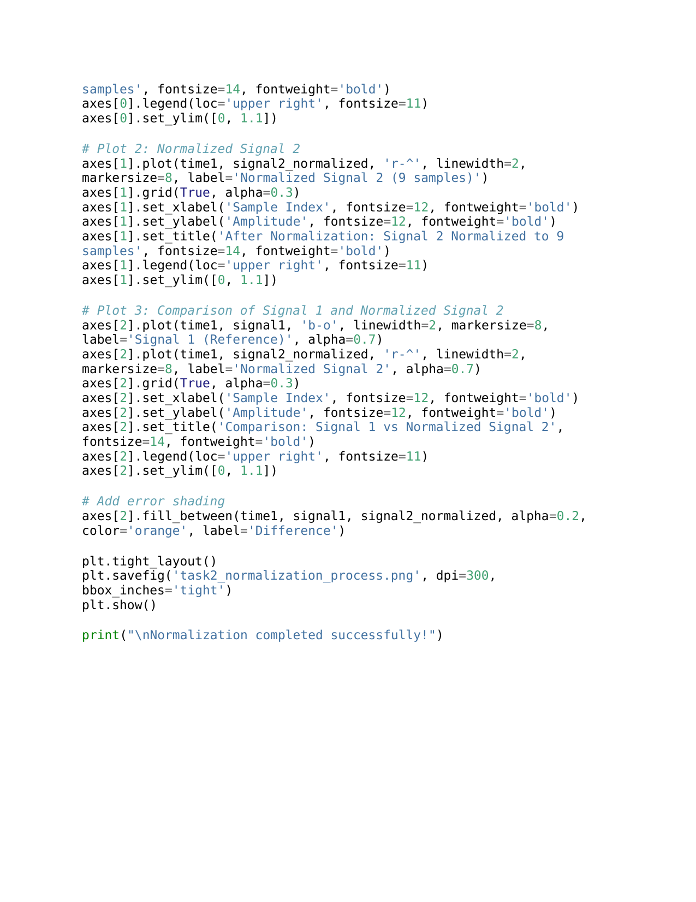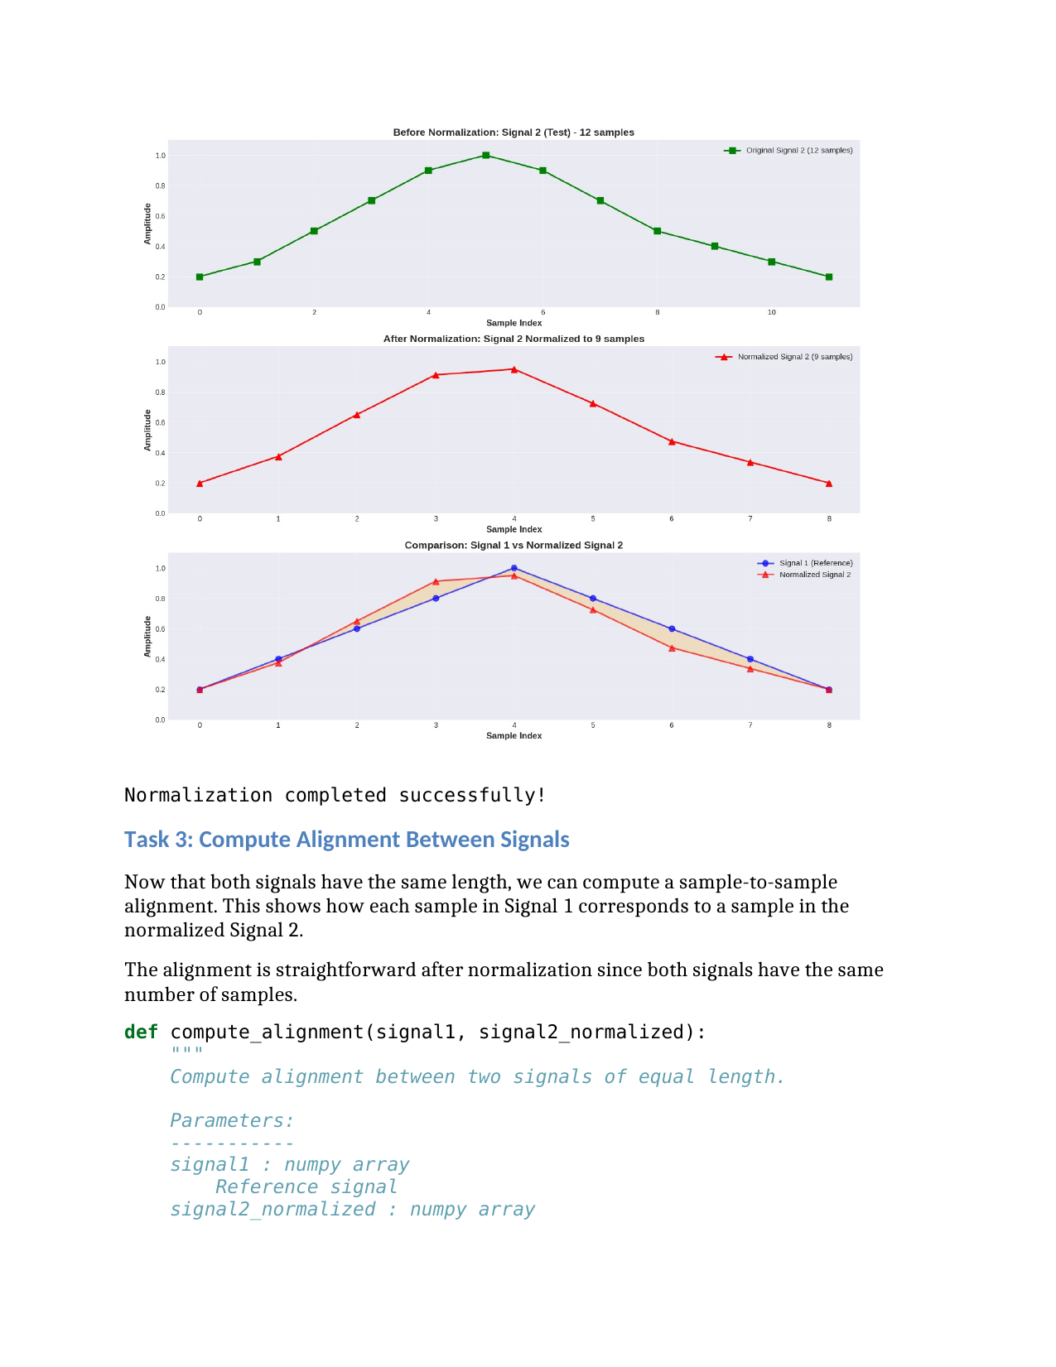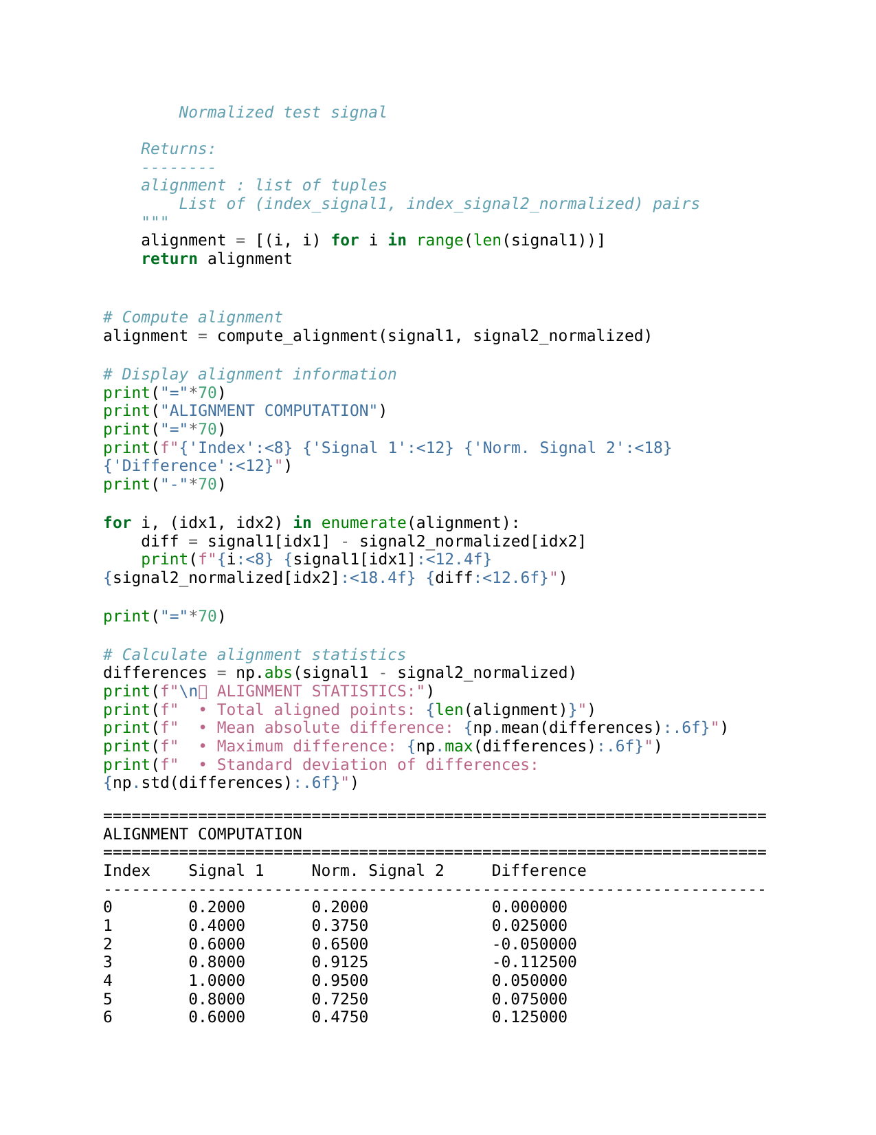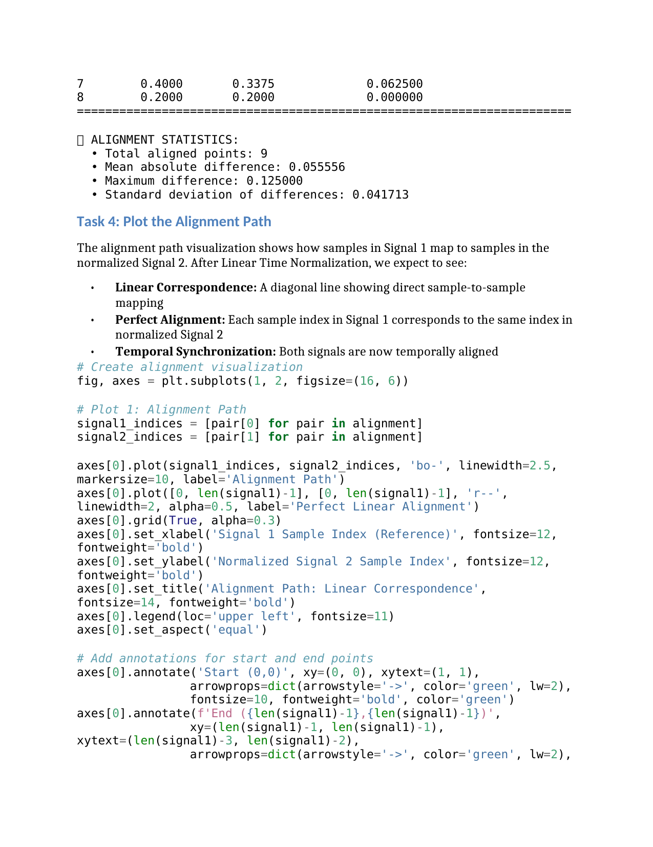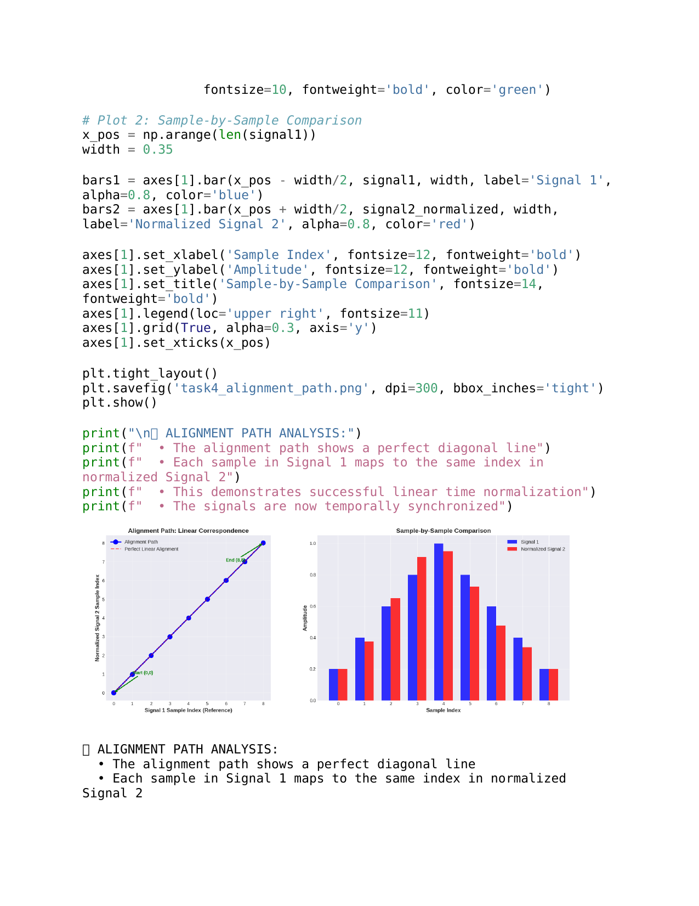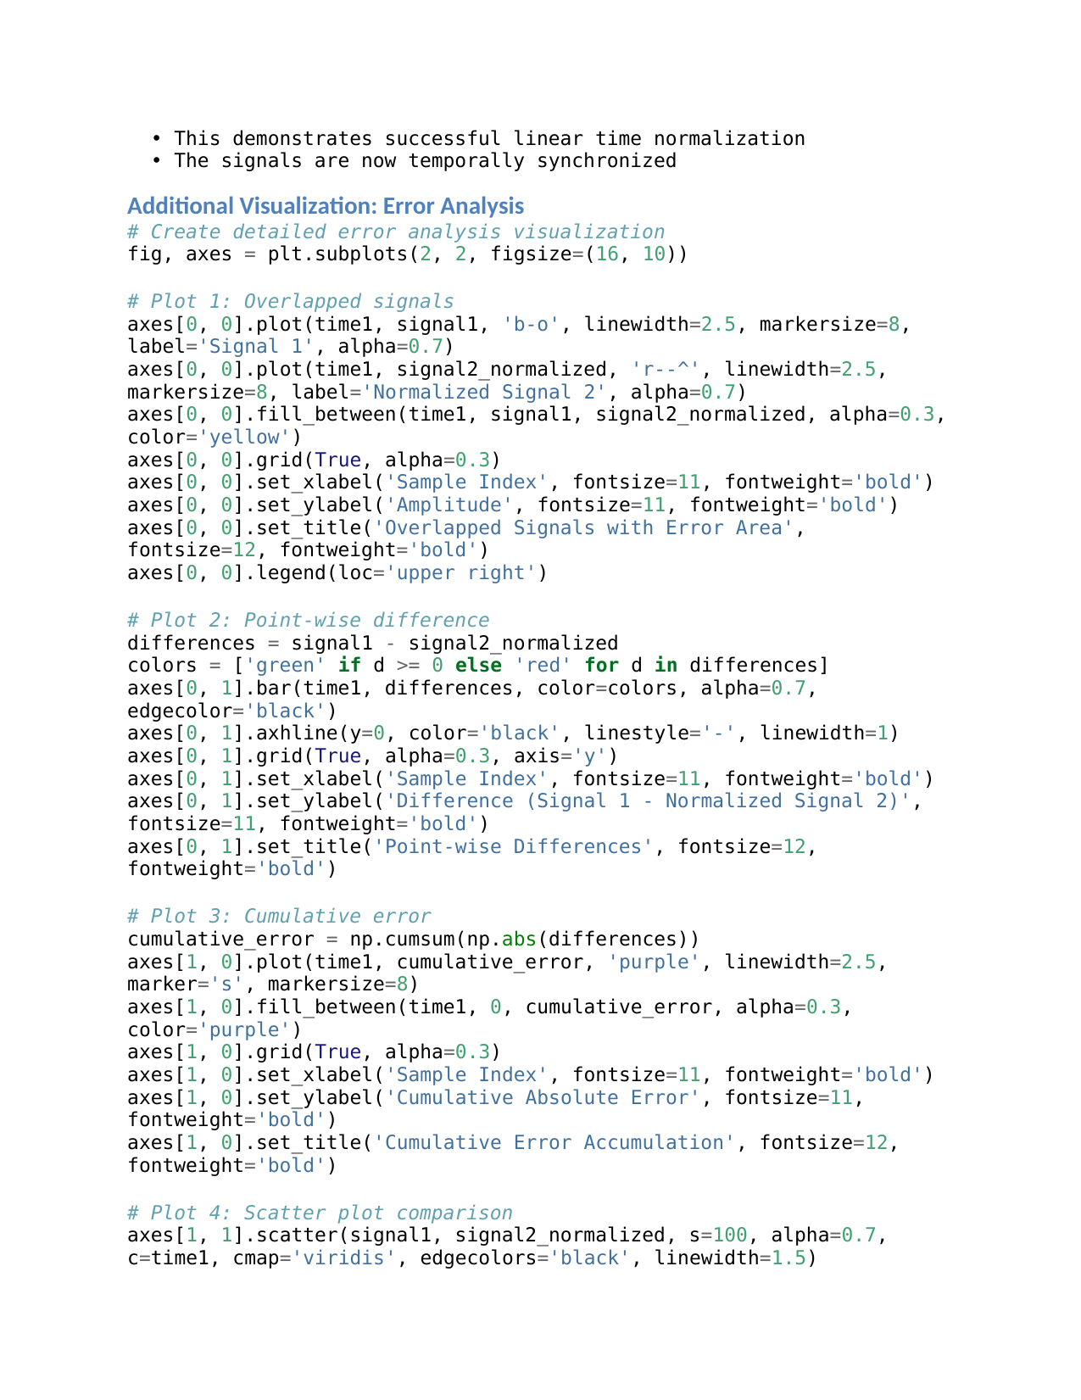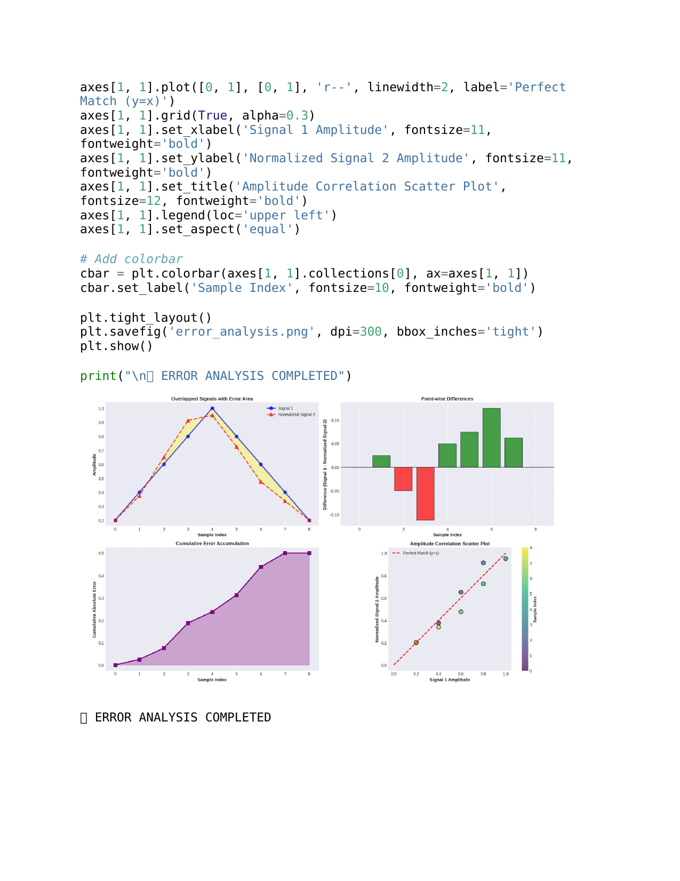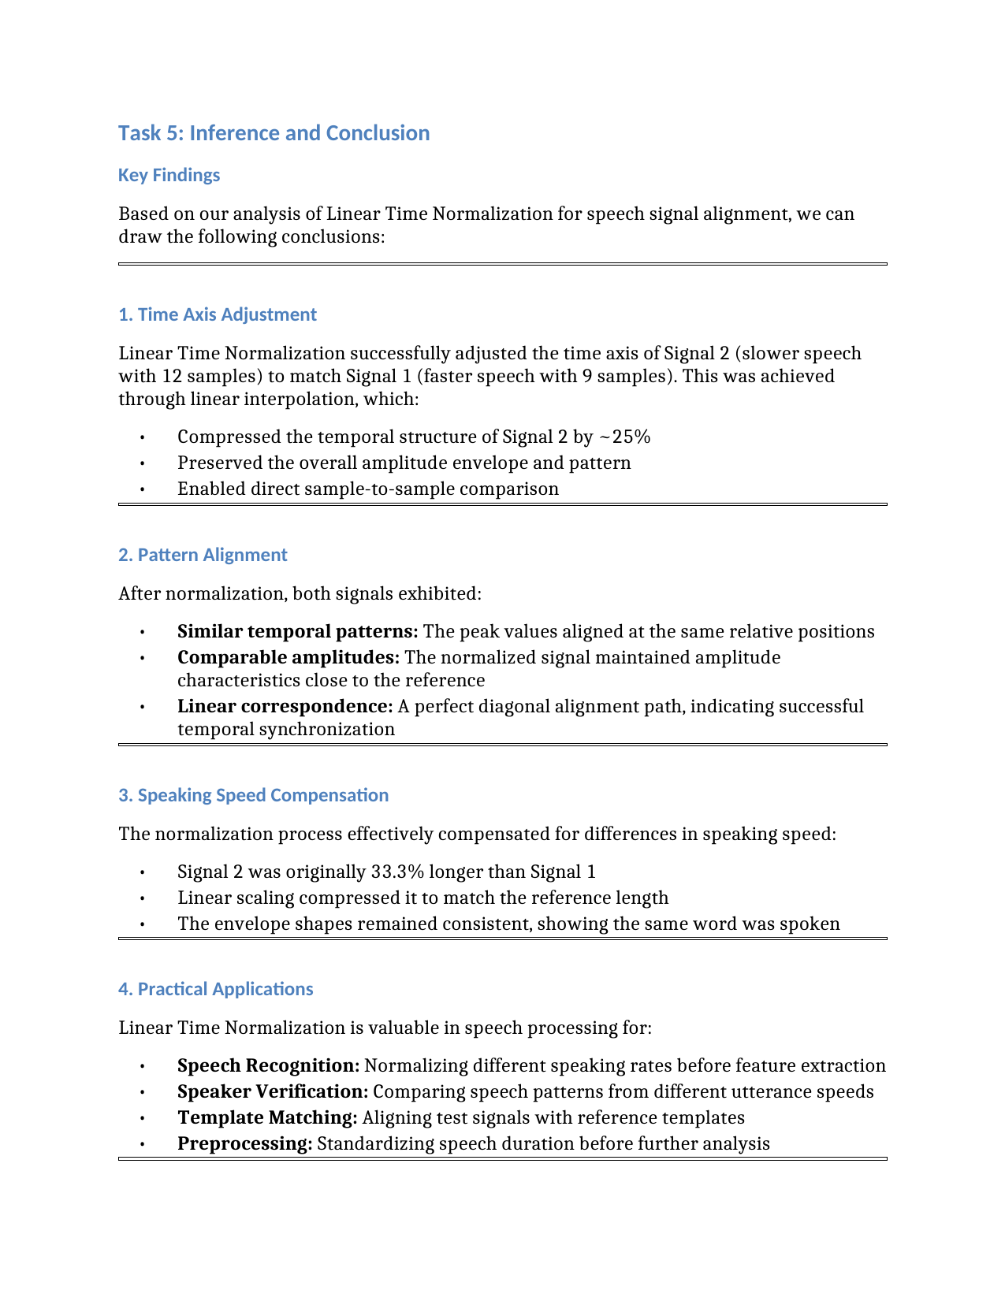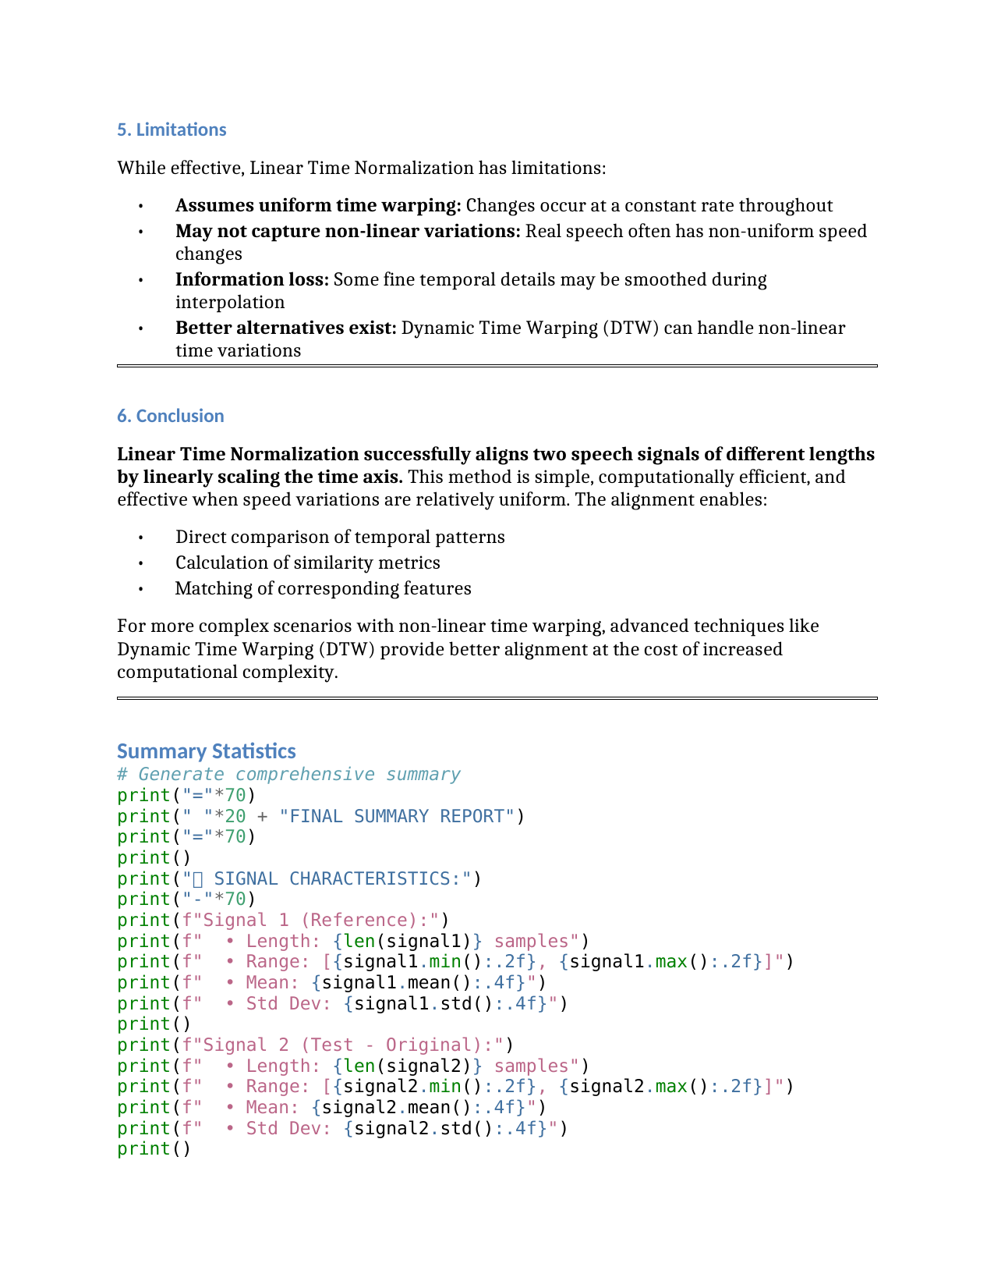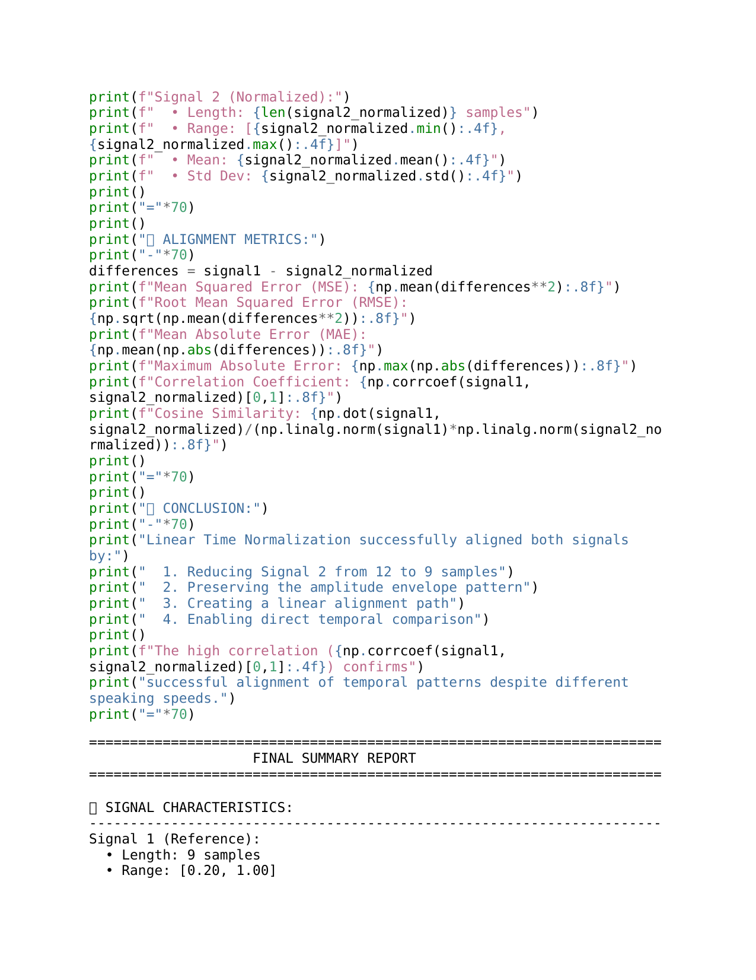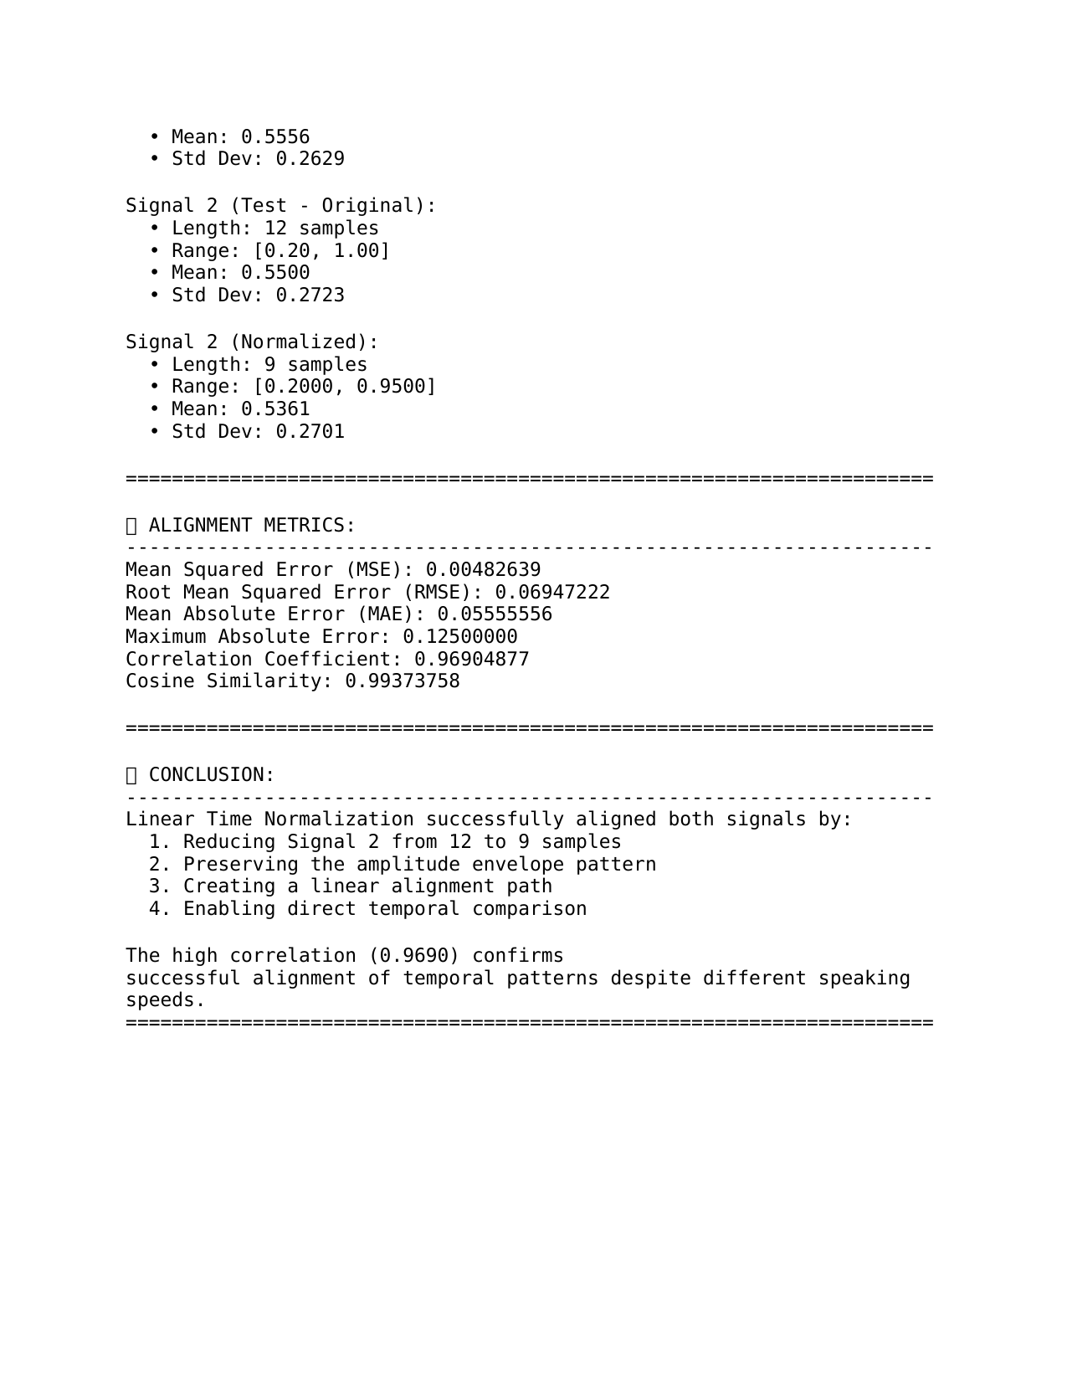

### **Lab Exercise 6– Dynamic Time Warping (DTW)**

**Aim:** To compare and align two numerical sequences using **Dynamic Time Warping (DTW)** and evaluate their similarity based on the DTW distance.

**Given Data:**

* **Vector 1:** [2, 3, 4, 6, 8, 7, 6, 5, 4, 3, 2]
* **Vector 2:** [2, 4, 6, 7, 7, 6, 5, 5, 4, 3, 2, 2, 1]

**Tasks / Questions:**

1. Plot both vectors to visualize their patterns.
2. Implement the Dynamic Time Warping algorithm.
3. Compute the accumulated cost matrix.
4. Find and visualize the optimal warping path.
5. Calculate the DTW distance between the vectors.
6. Write an inference explaining how the warping path aligns the two vectors and what the DTW distance reveals about their similarity.

**Expected Output:**

* Two plots showing that Vector 2 is stretched and slightly shifted relative to Vector 1.
* A computed cost matrix illustrating cumulative alignment costs between samples.
* A plotted **warping path** showing non-linear mapping between the two sequences (allowing compression and stretching along the time axis).
* A **DTW distance value**, indicating how similar the two vectors are (a smaller DTW distance means greater similarity).
* **Inference:** DTW effectively aligns the sequences even when they are temporally distorted or stretched. The warping path shows how one vector must be time-warped to match the other, and the DTW distance quantifies this similarity.
* **Evaluation Rubrics**

1. Implementation: 5 marks
2. Complexity and Validation: 3 marks
3. Documentation & Writing the inference: 2 marks

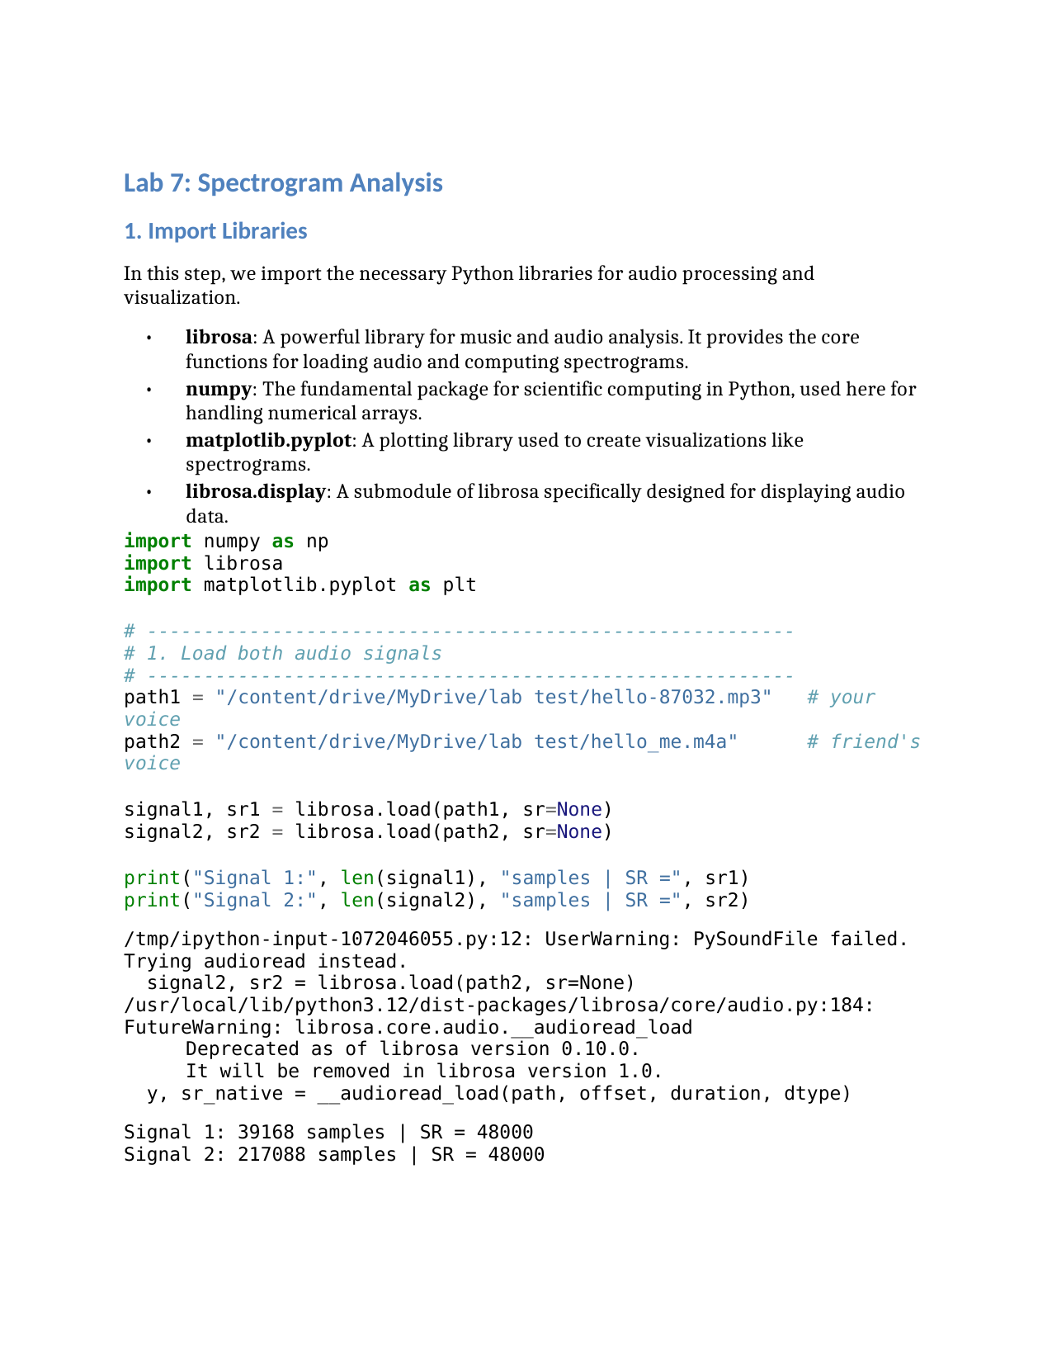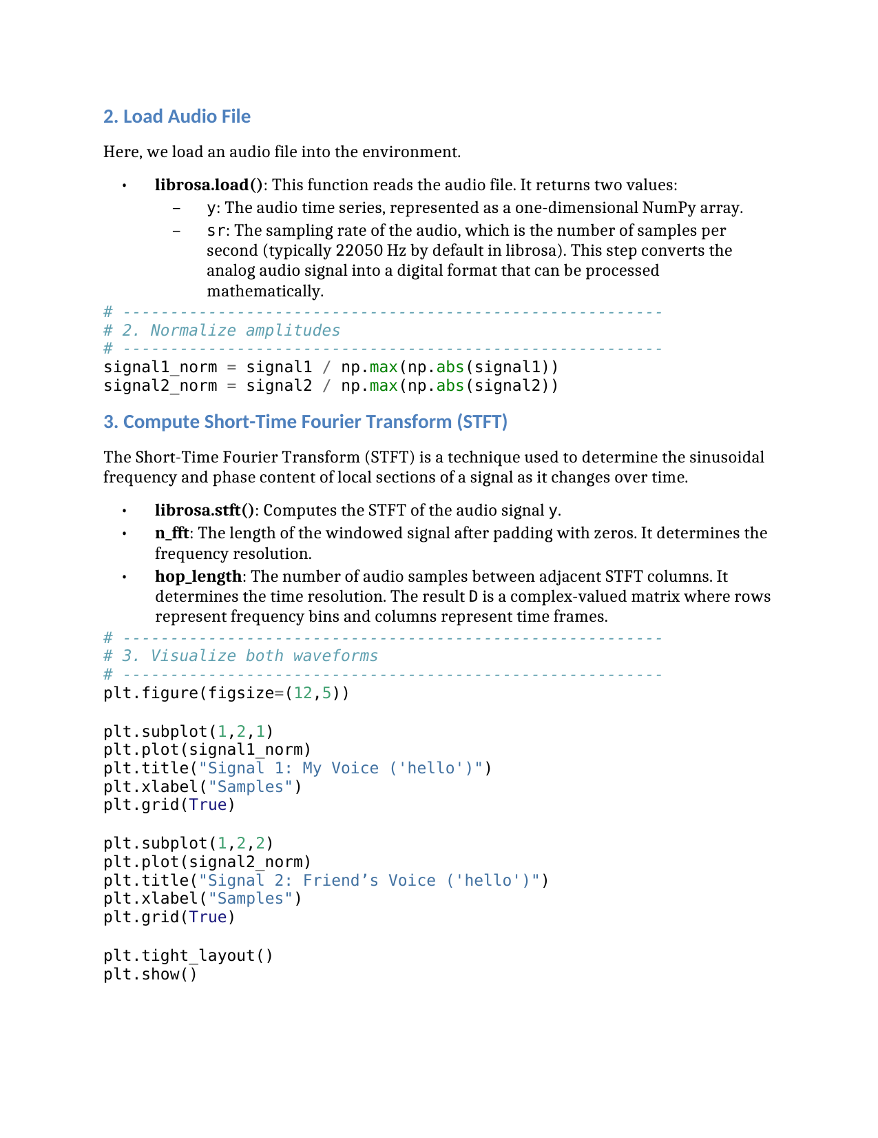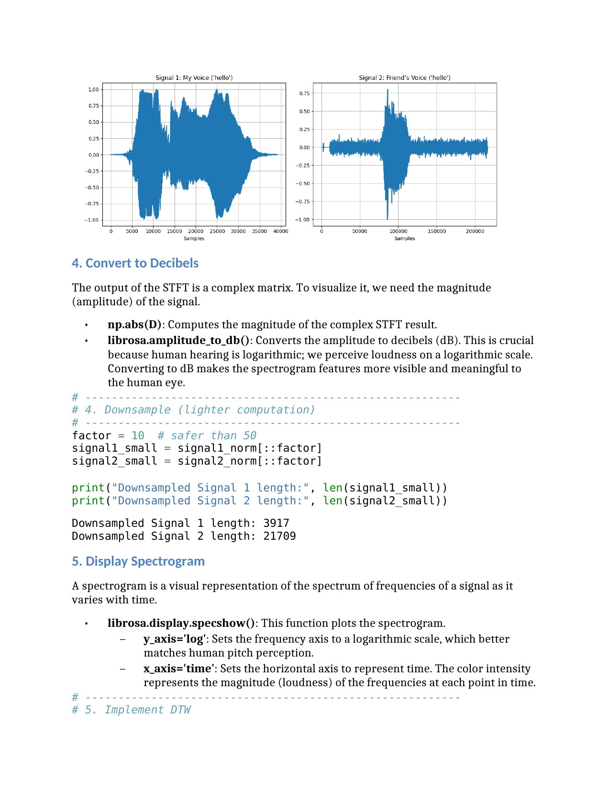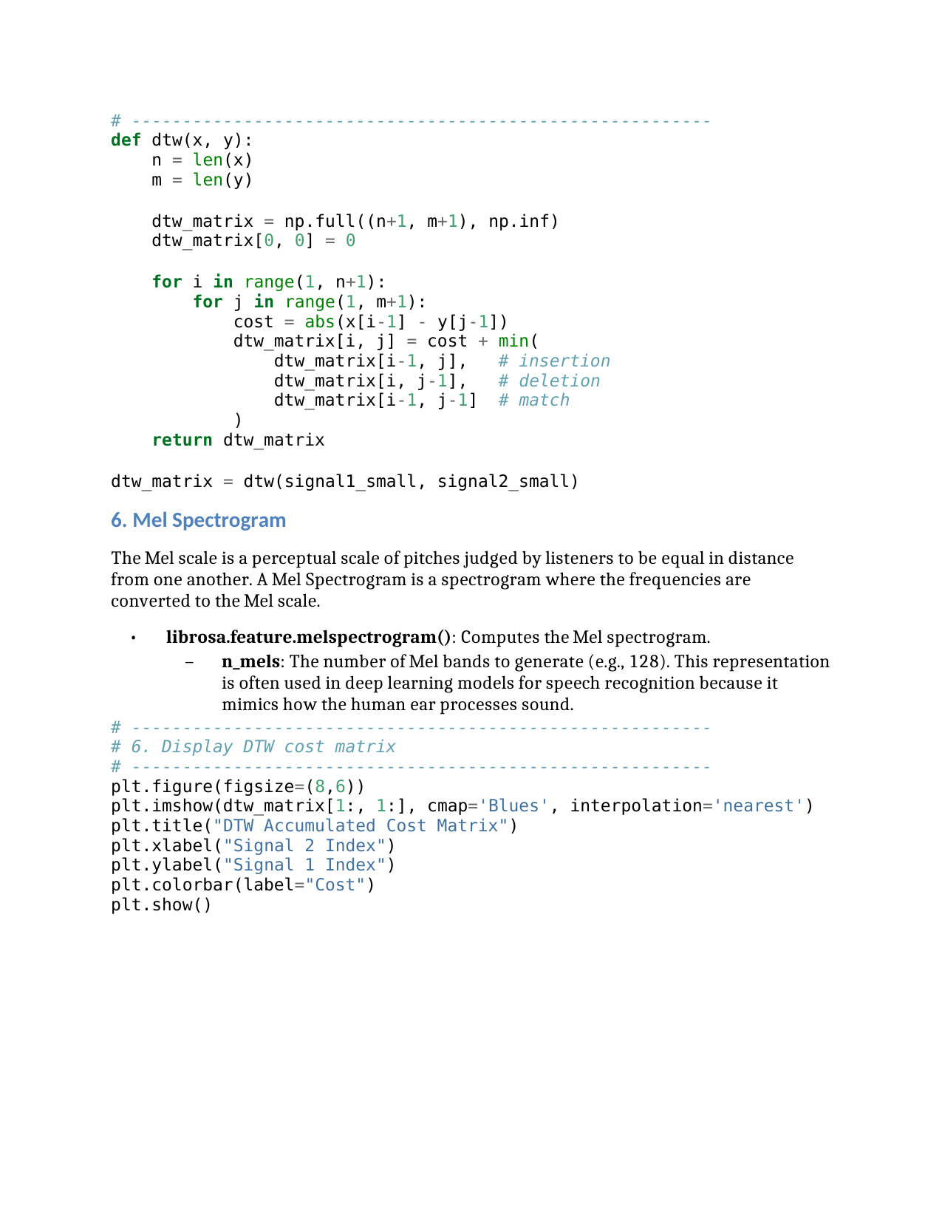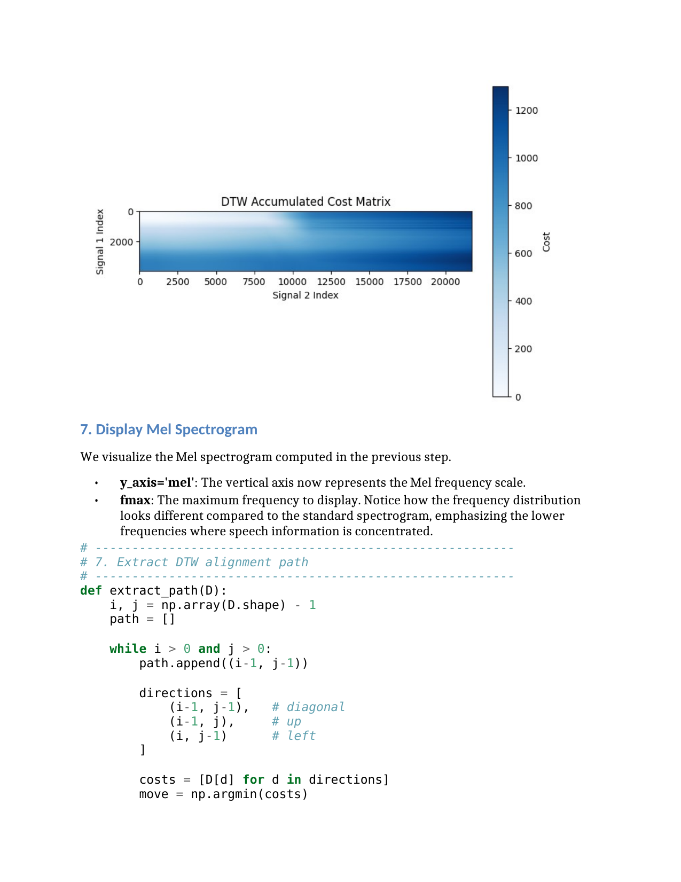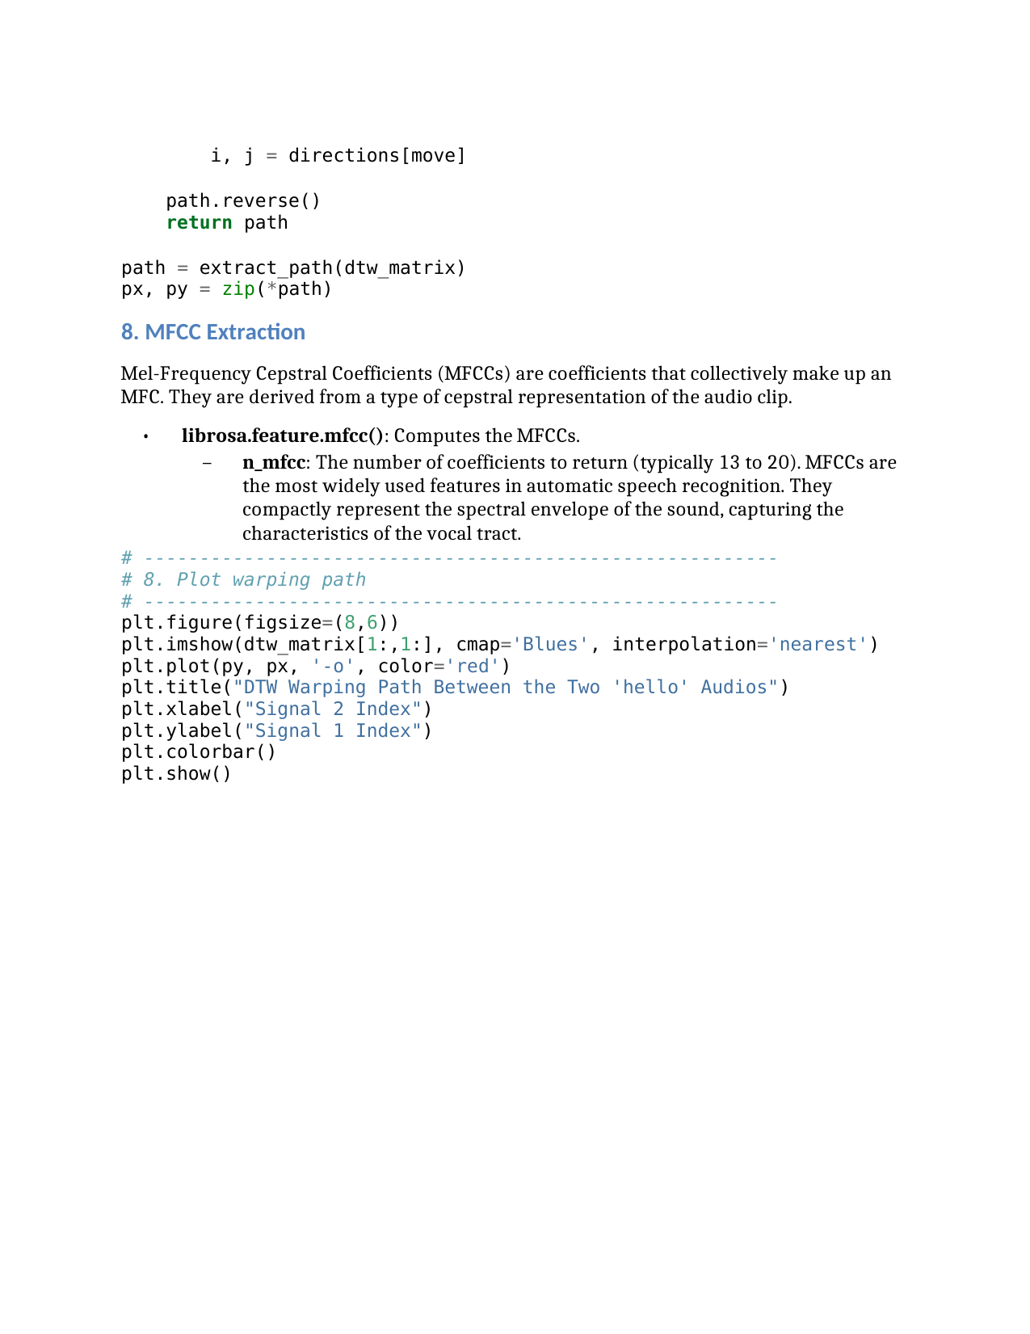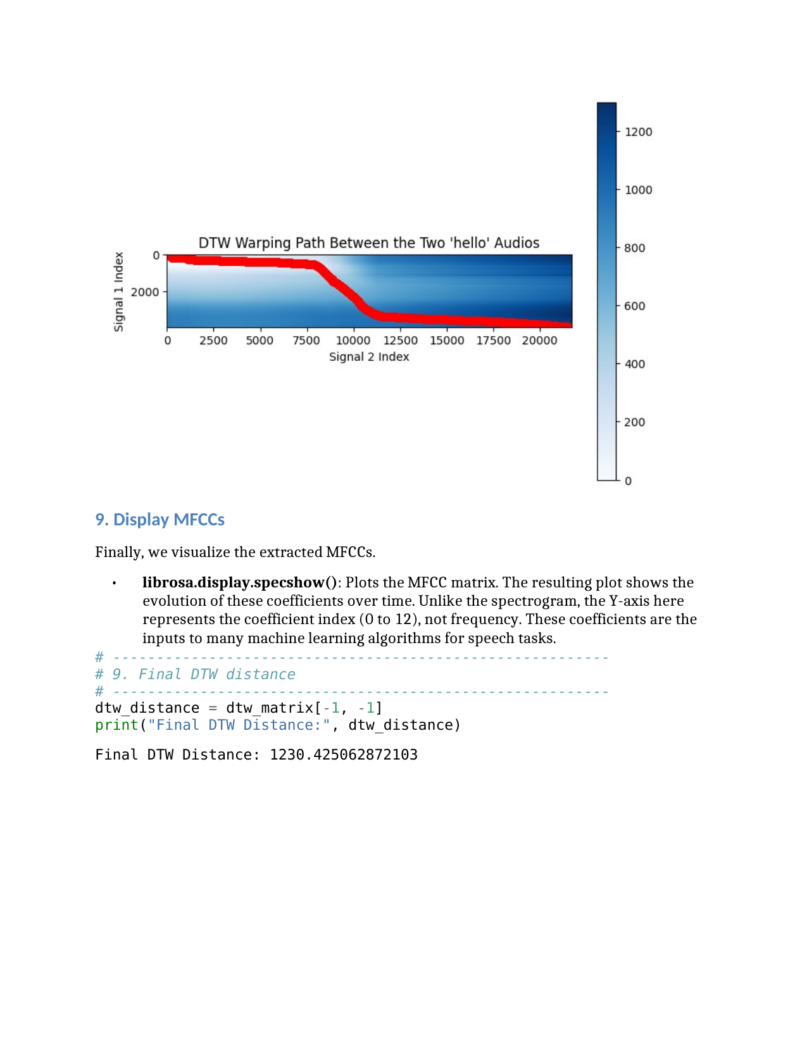

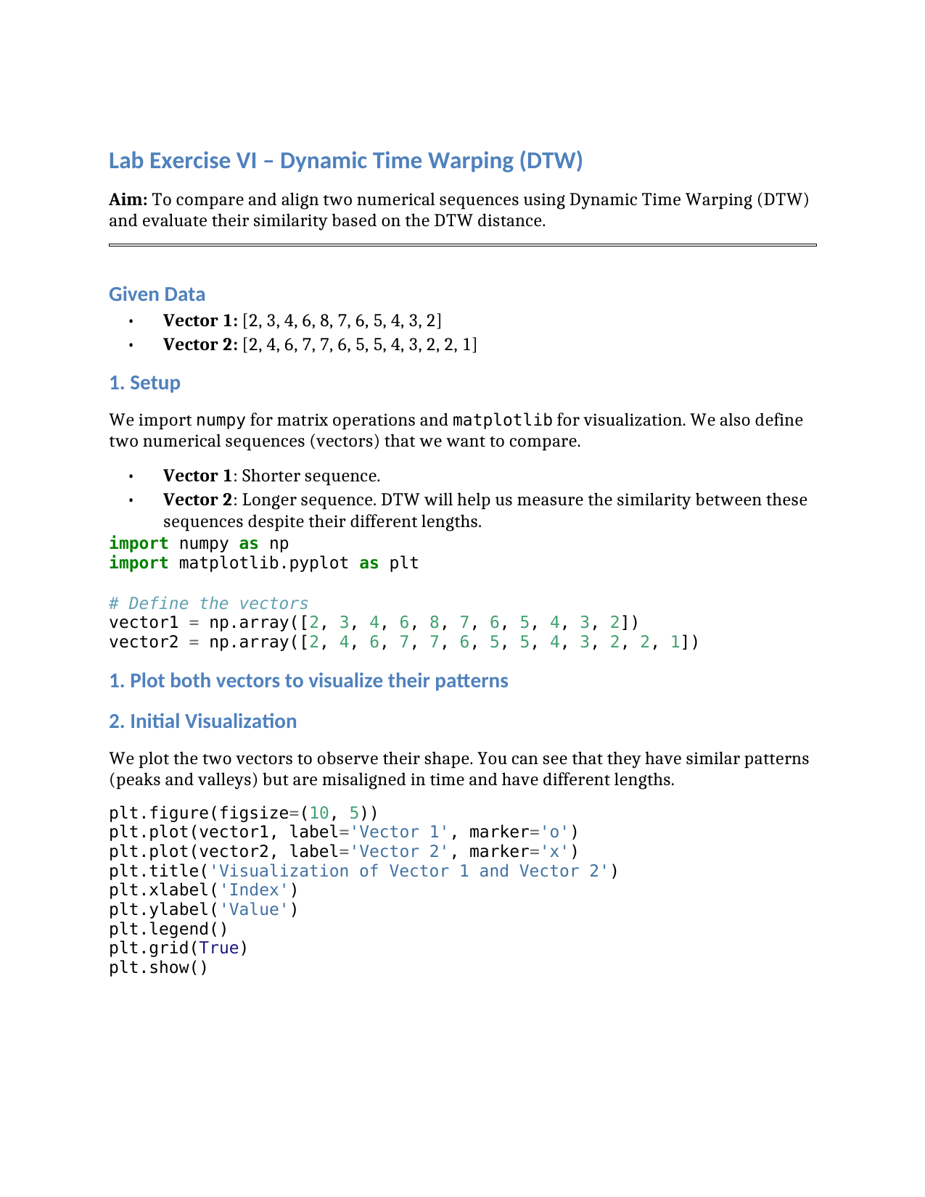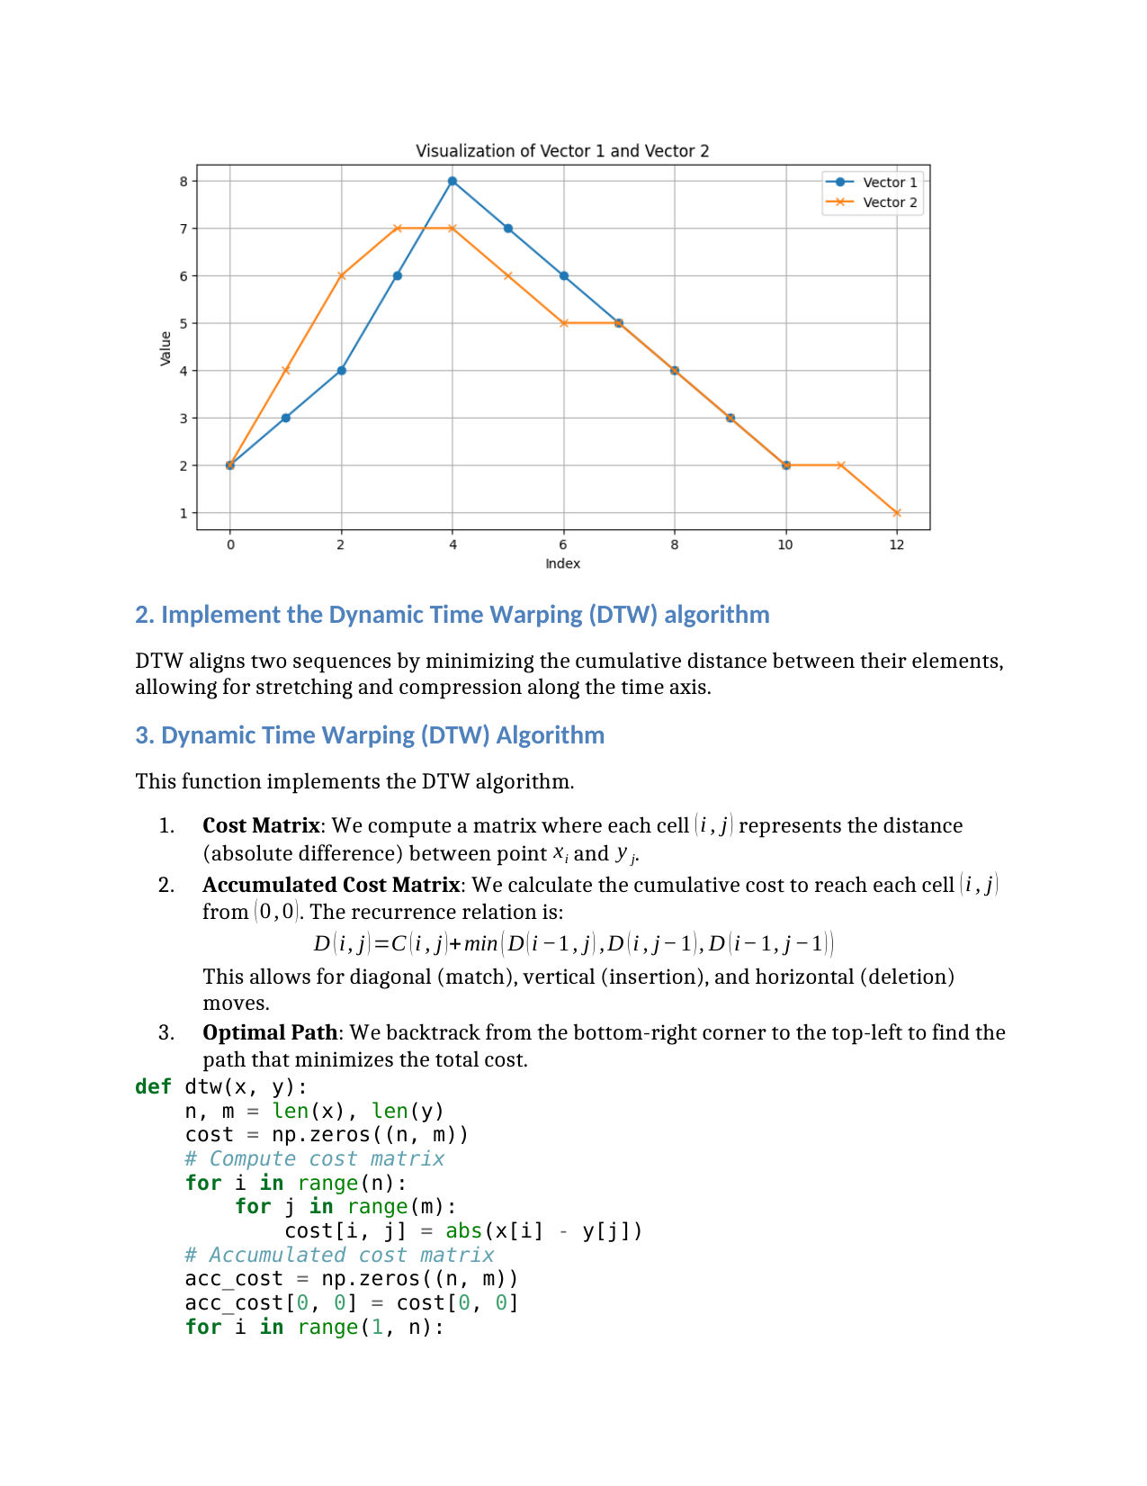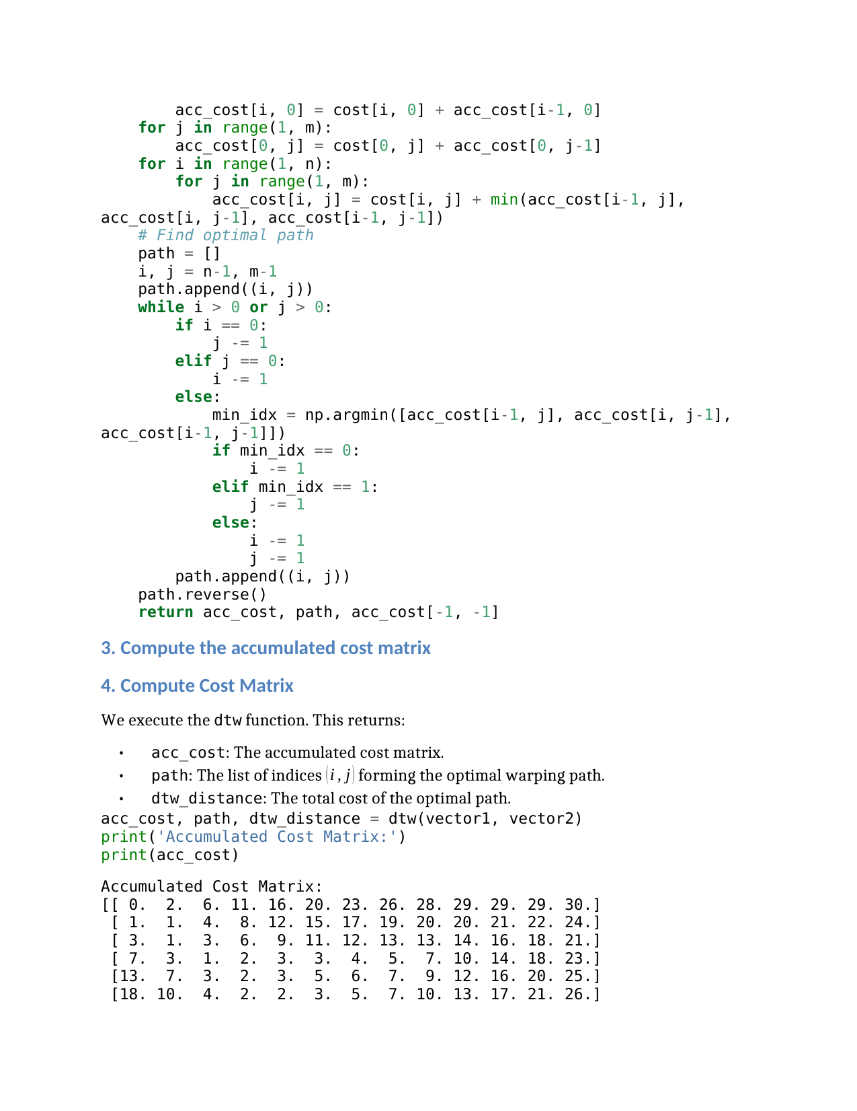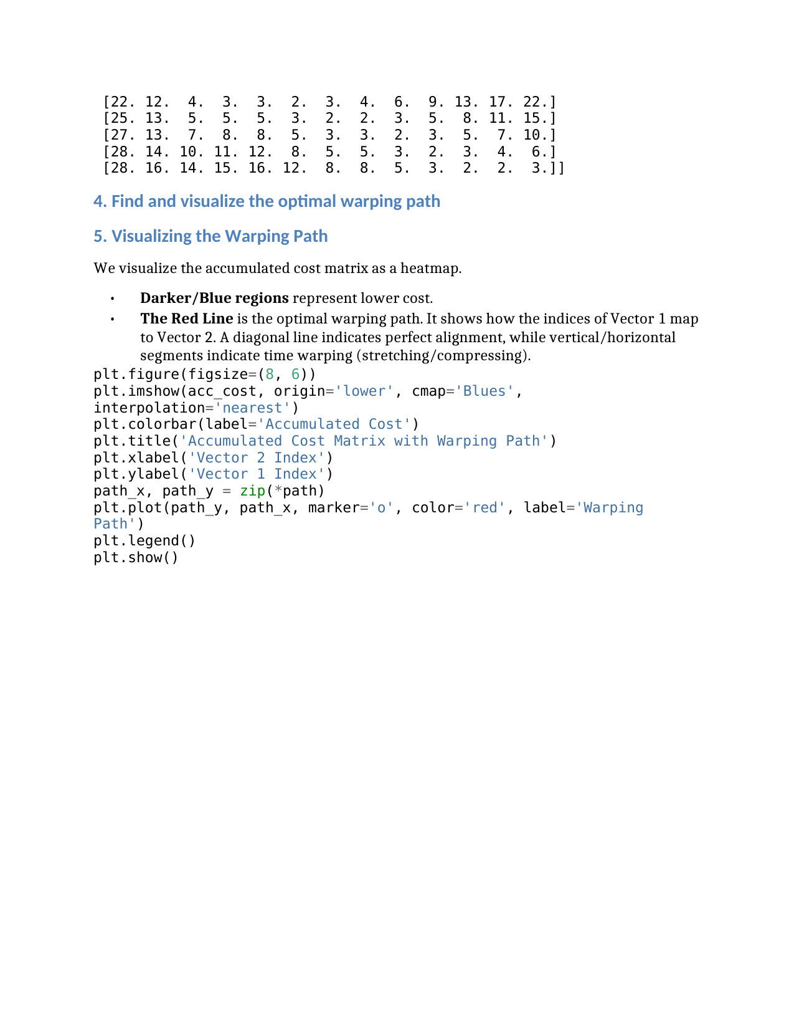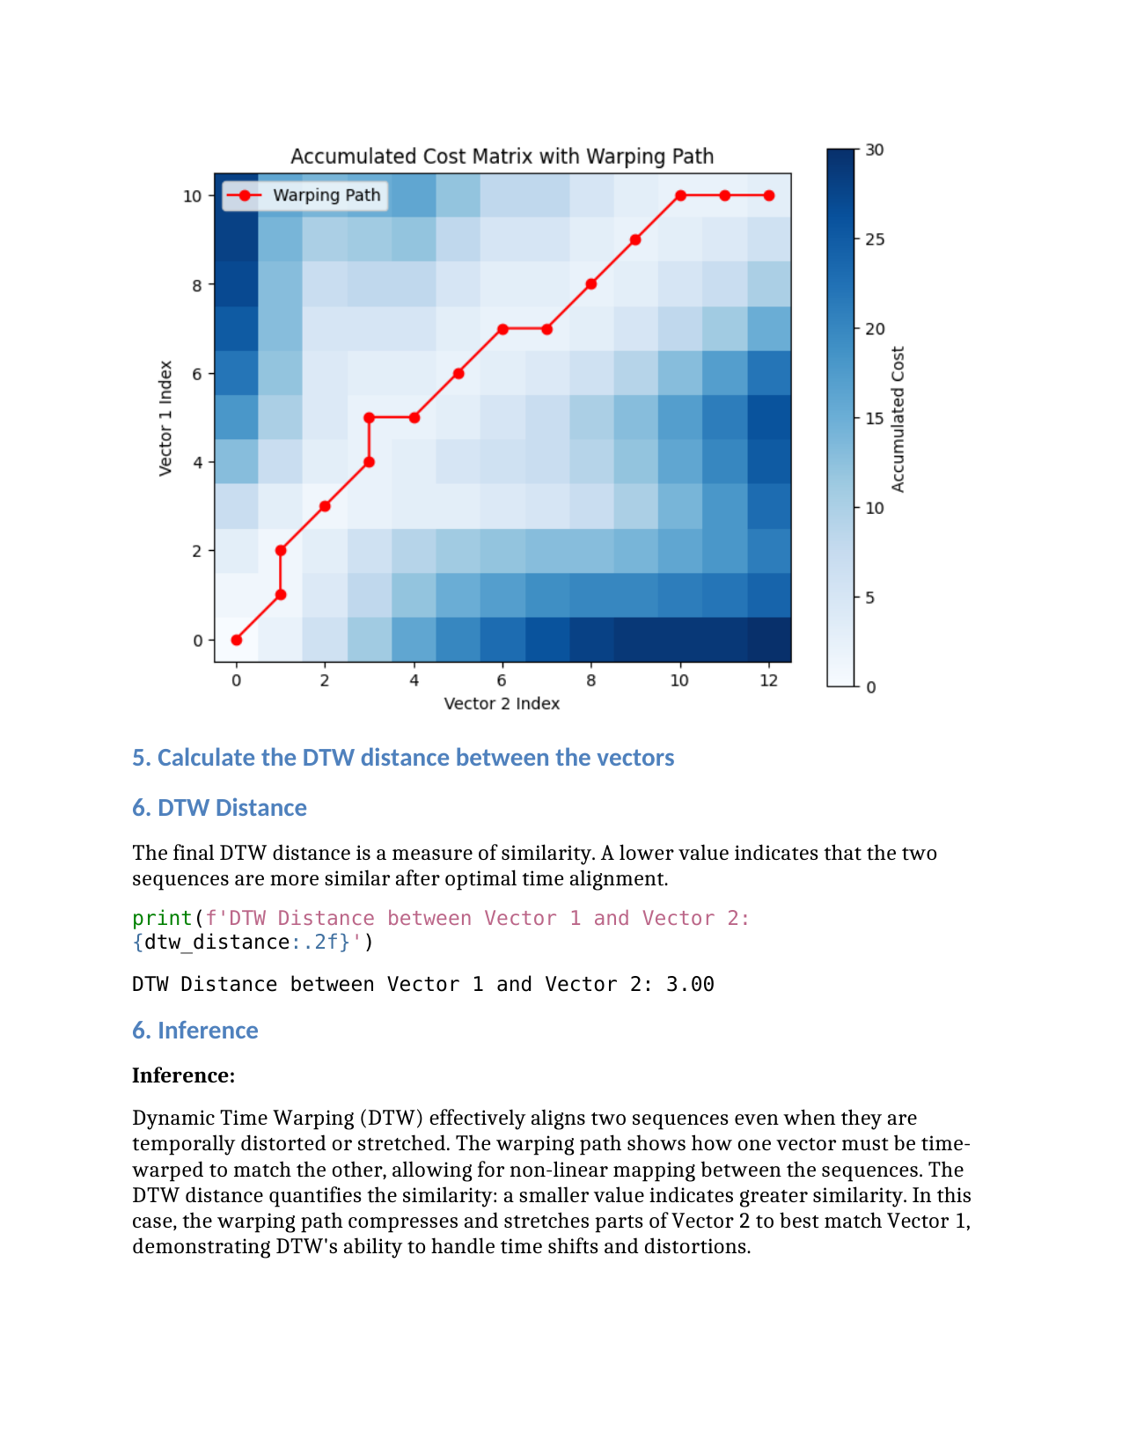

**Lab Question 7: Discrete time wrapping algorithm**

You are given two short audio recordings.  
 Audio 1 is your own voice saying the word “hello”.  
 Audio 2 is your friend’s voice saying the word “hello”.

Your task is to compare these two signals using Dynamic Time Warping.

**Tasks for the lab**

1. Record your own voice saying “hello” and store it as Signal 1.
2. Record your friend saying “hello” and store it as Signal 2.
3. Convert both audio files into numerical time series by extracting their waveform data.
4. Normalize both signals so they have comparable amplitude ranges.
5. Apply Dynamic Time Warping on the two signals.
6. Produce the alignment path and compute the total DTW distance.
7. Interpret the results. Explain whether the signals are similar, and describe how DTW helps match two audio patterns that do not align perfectly in time.



### **Lab Exercise 8 – Hidden Markov model (HMM)**

**Aim:**The aim of this lab experiment is to implement a Hidden Markov Model (HMM) to simulate phoneme transitions for the word ‘*speech*’ in speech processing.

**Tasks / Questions:**

The word speech can be divided into the following phonemes (hidden states):

*•* /s/

*•* /p/

*•* /ie:/ (long ee)

*•* /tS/ (ch sound)

Similarly, observations represent measurable acoustic properties such as energy, pitch, and duration. Let the initial probability of starting the phoneme, ‘/s/’ is 1.

Then, the Transition Probabilities (Probability of transitioning from one phoneme

to another) are given in the below table:

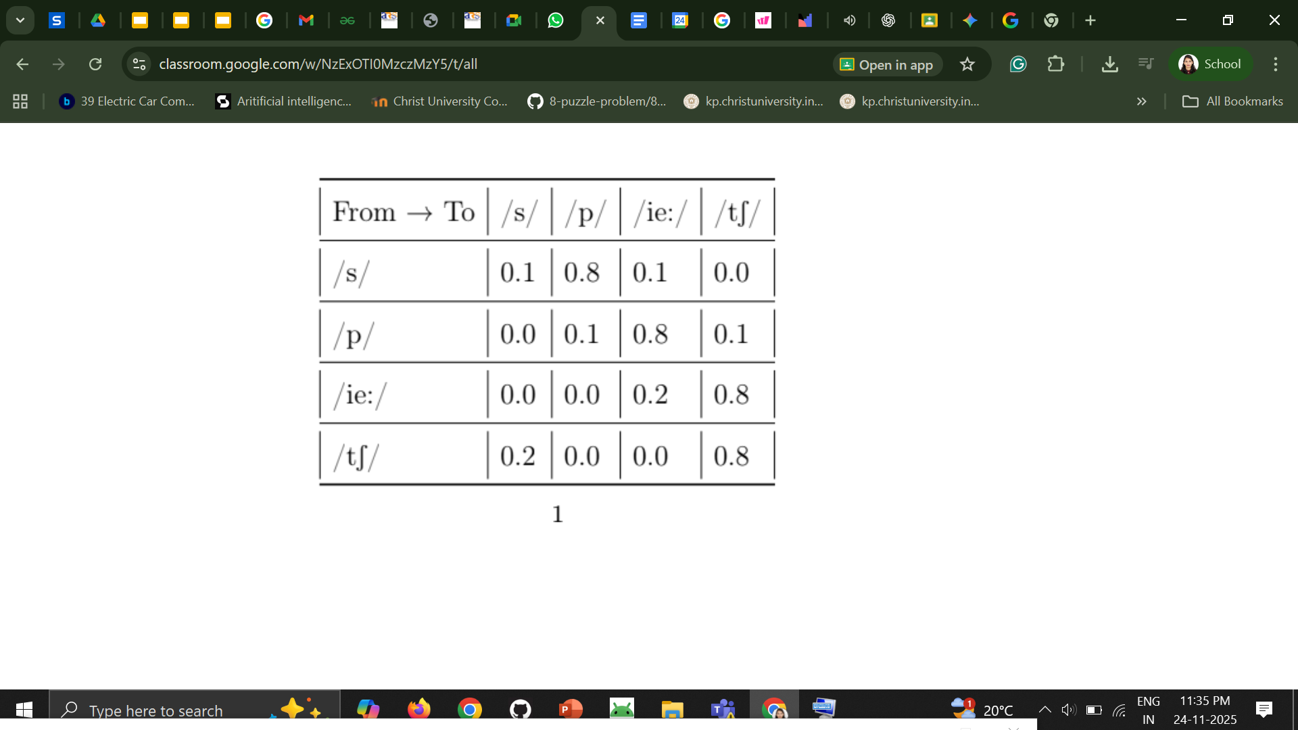

Similarly, Emission Probabilities (the probability of emitting an observation given a phoneme) are given in the table below:

Phoneme → Observation Energy Pitch Duration

| /s/ | 0.7 | 0.2 | 0.1 |
| --- | --- | --- | --- |
| /p/ | 0.5 | 0.3 | 0.2 |
| /ie:/ | 0.3 | 0.5 | 0.2 |
| /tS/ | 0.4 | 0.4 | 0.2 |

(1) Task:

(a) Represent the HMM parameters (initial probabilities, transition probabi ities, and emission probabilities) using suitable data structures in Python.

(b) Write a function to neatly display the transition and emission matrices along with the initial probabilities.

(c) Write a program to generate a single sequence of phonemes and corresponding acoustic observations for the word speech based on the defined probabilities.

(d) Write an inference for the above HMM implementation

Expected Output

Generated phoneme sequence: [’/s/’, ’/p/’, ’/i:/’, /tS/]

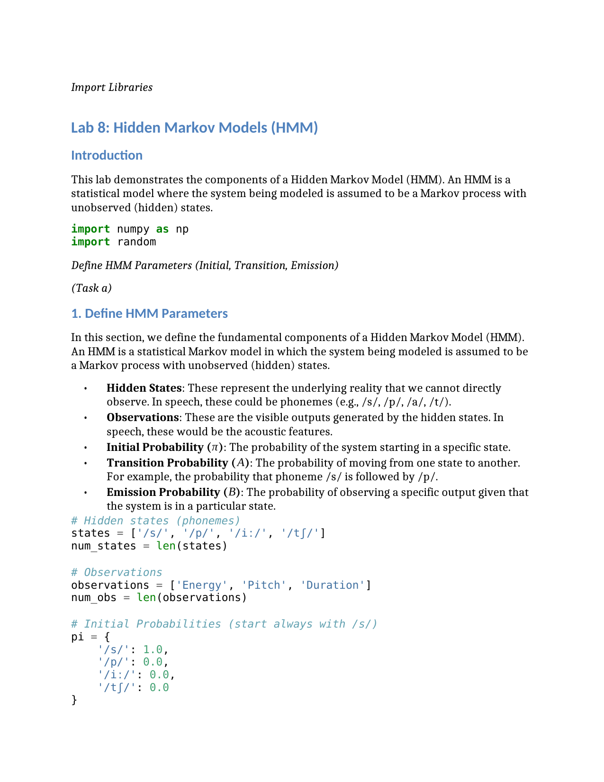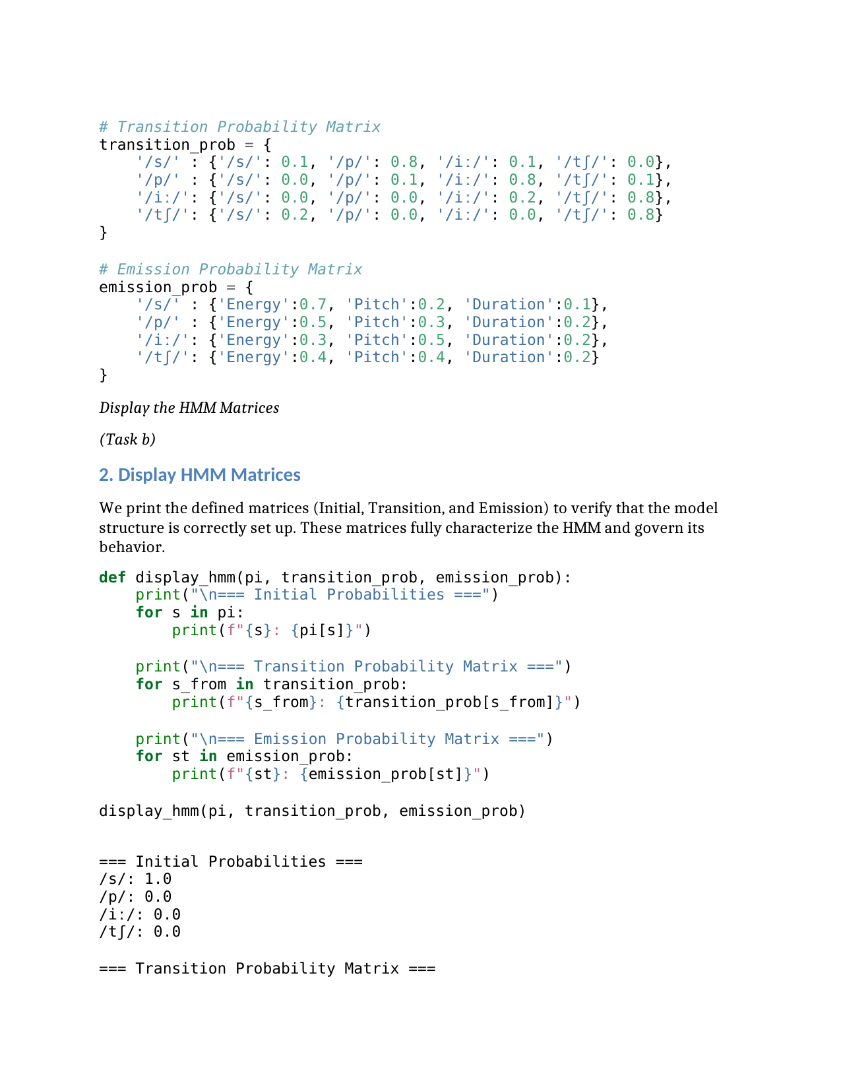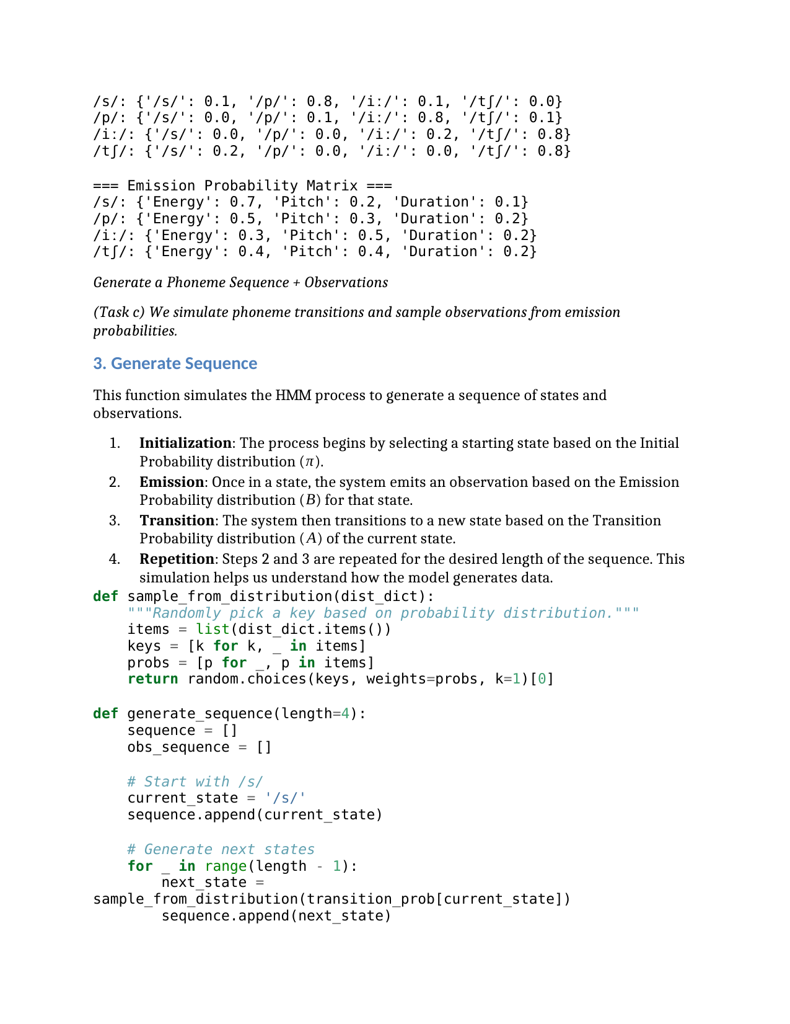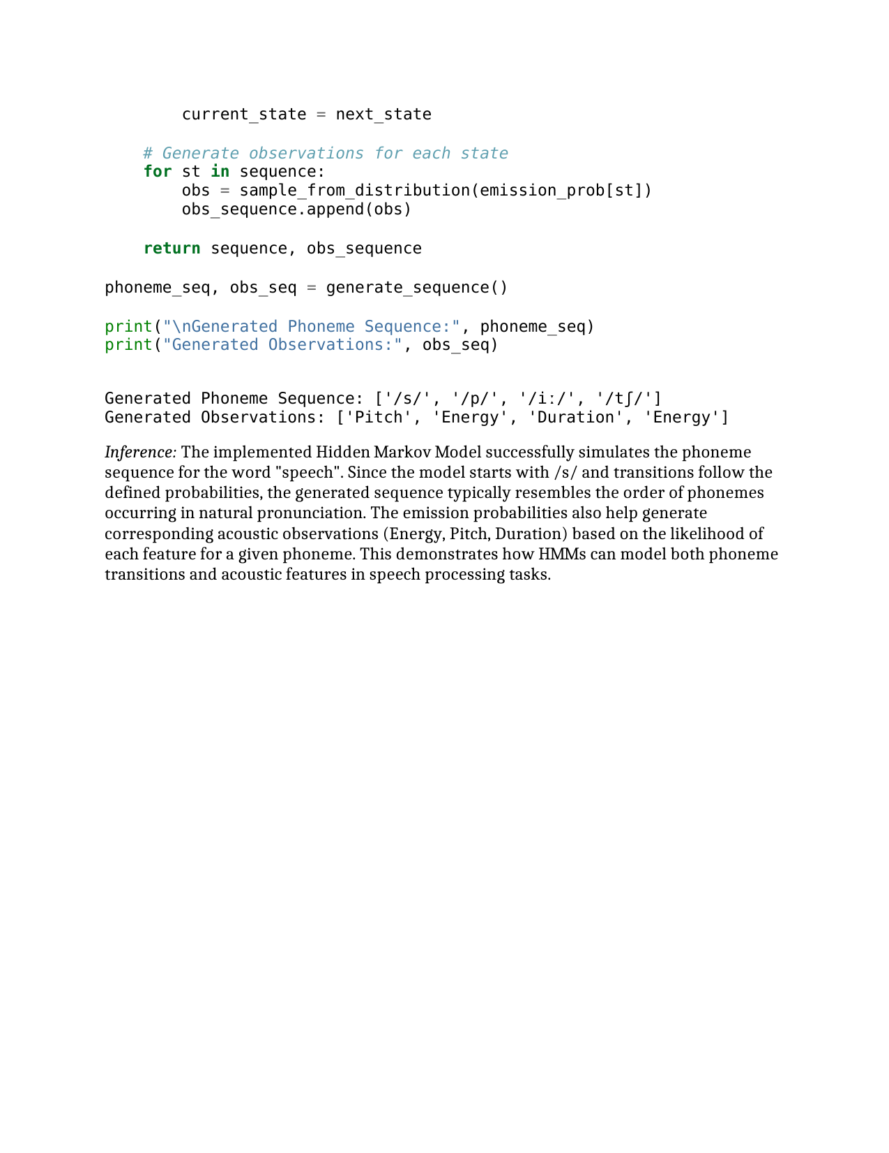

**LAB 9**

**Viterbi Algorithm Based Phoneme Decoding for Speech Recognition**

**Aim**

The aim of this lab experiment is to implement the Viterbi Algorithm in a Hidden Markov Model based speech recognition system in order to determine the most likely sequence of hidden phoneme states for the word “hello”. Using the defined states, observations, transition probabilities, emission probabilities, and initial probabilities, the experiment focuses on decoding the observation sequence and identifying the most probable phoneme pattern that corresponds to the spoken word.

**Task**

In a speech recognition system, a spoken word is represented as a sequence of phonemes. The aim of this lab experiment is to implement the Viterbi Algorithm to decode the most likely sequence of hidden phoneme states in a Hidden Markov Model (HMM) for recognizing the word “hello" in a speech recognition system. The word “hello" can be divided into the following phonemes (hidden states):

*•* States (S)

– *S*1 *→* /h/

– *S*2 *→* /e/

– *S*3 *→* /l/

– *S*4 *→* /o/

*•* Observations (O)

The system identifies four acoustic feature vectors:

– *O*1: Feature vector for /h/

– *O*2: Feature vector for /e/

– *O*3: Feature vector for /l/

– *O*4: Feature vector for /o/

*•* Transition Probability Matrix (A)

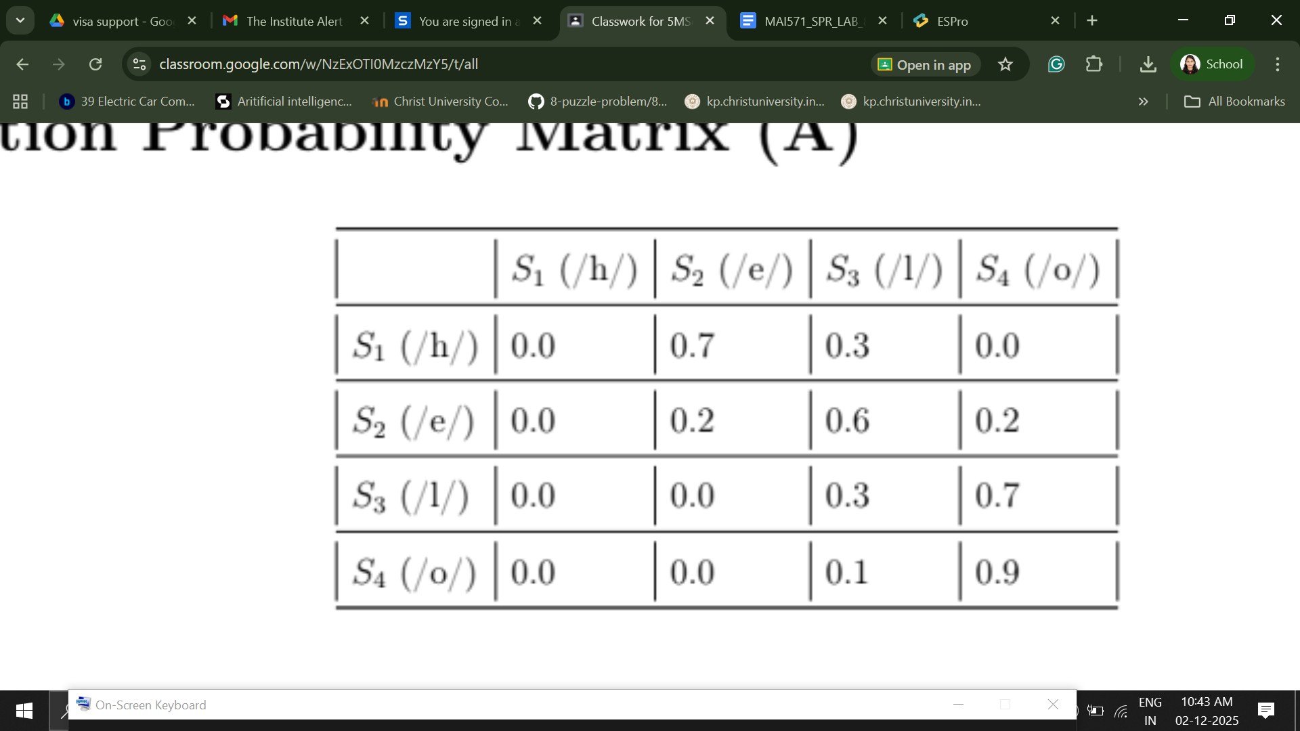

*•* Emission Probability Matrix (B)

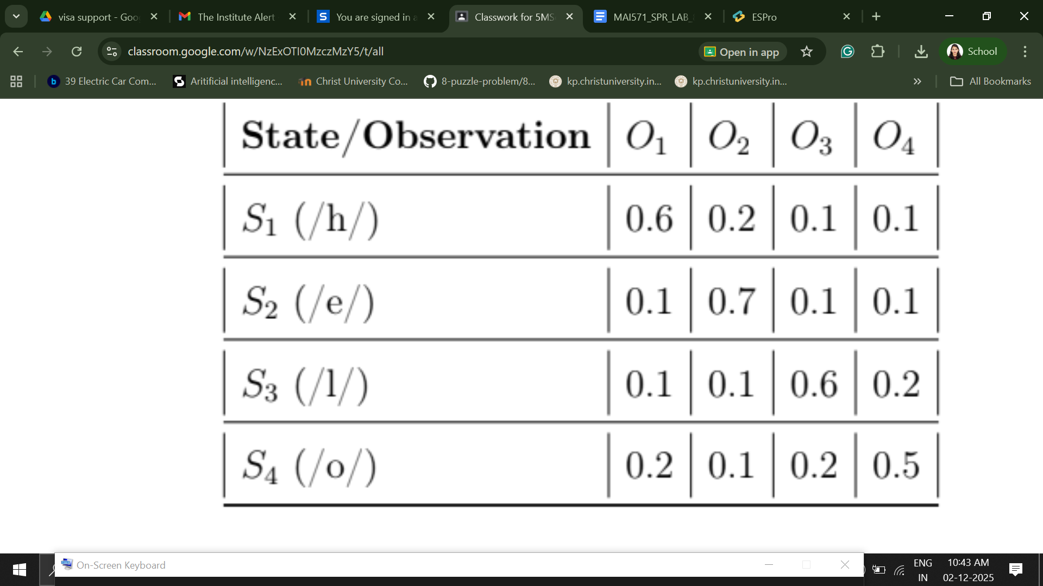

Initial Probabilties (*π*)

– P(*S*1 (/h/))=1

– P (*S*2 (/e/))=0.0

– P(*S*3 (/l/))=0.0

– P(*S*4 (/o/))=0.0

*•* Observation Sequence (O)

The system captures the observation sequence [*O*1, *O*2, *O*3, *O*4] (1) Task:

(a) Implement the Viterbi Algorithm in Python to compute:

*•* The most likely sequence of phoneme states for the observation sequence.

*•* The probability of the most likely sequence.

*•* Write an inference.

Expected Outcome:

The implementation should identify the phoneme sequence (*/h/*, */e/*, */l/*, */o/*) as the most probable sequence for the observation [*O*1, *O*2, *O*3, *O*4]. Evaluation

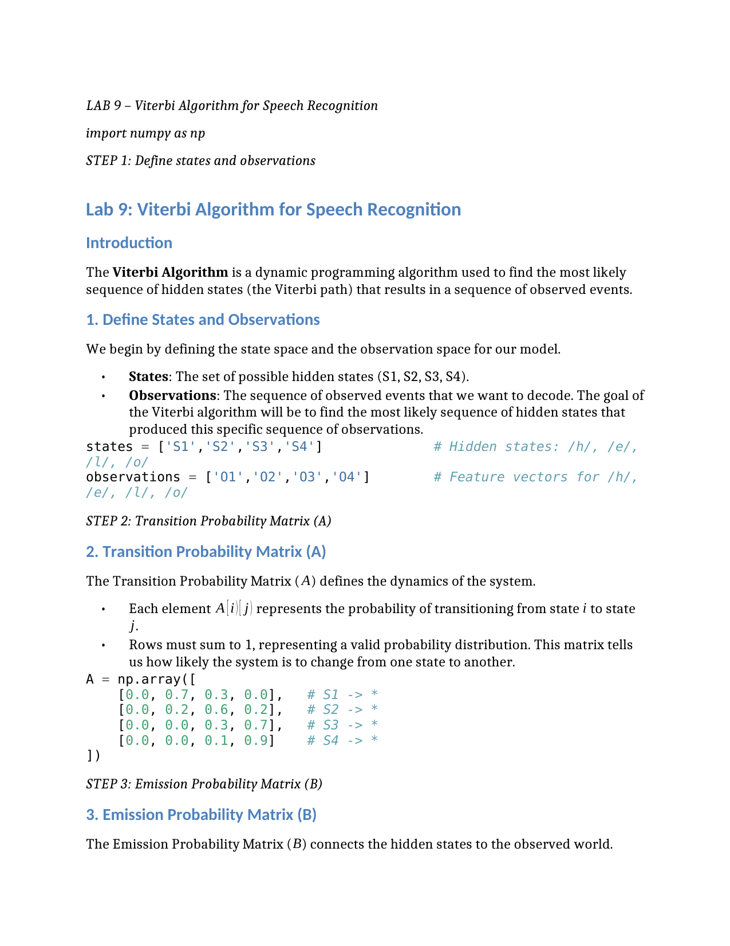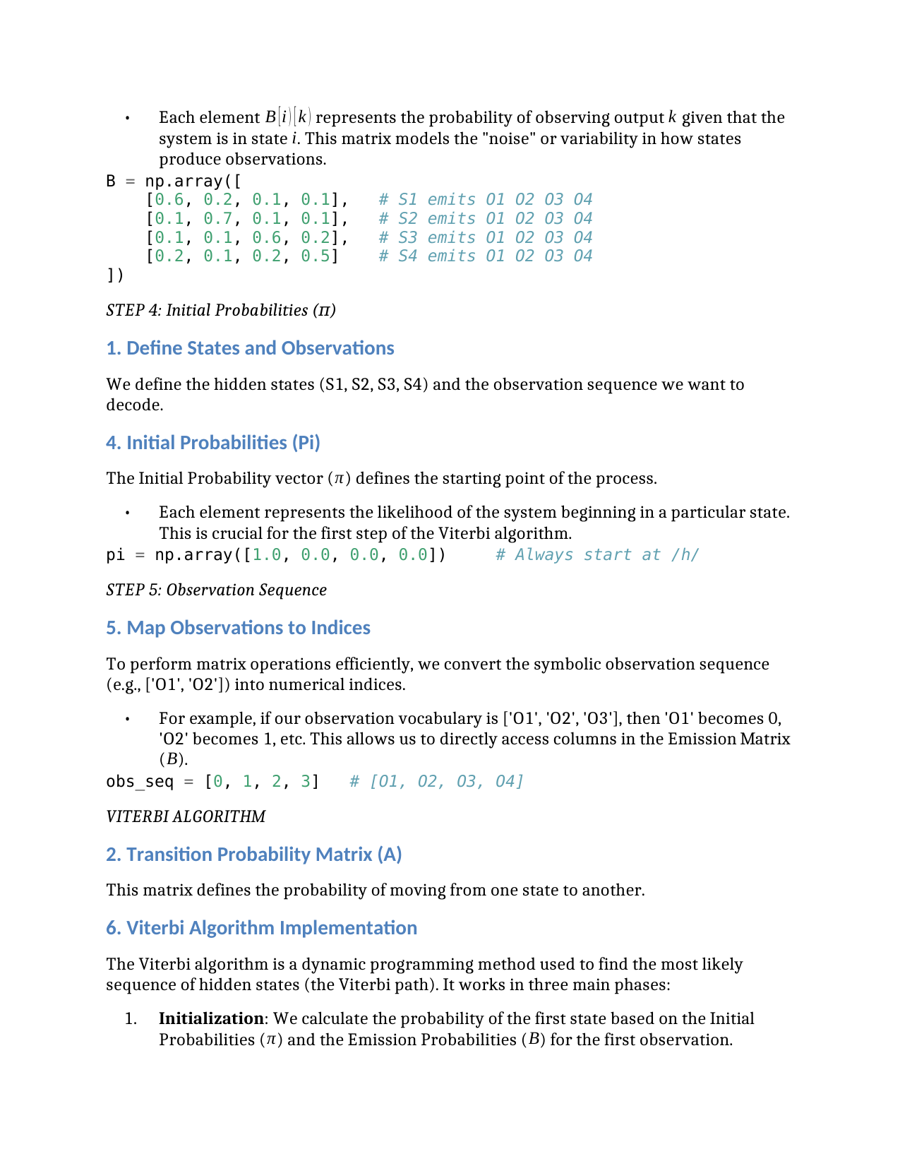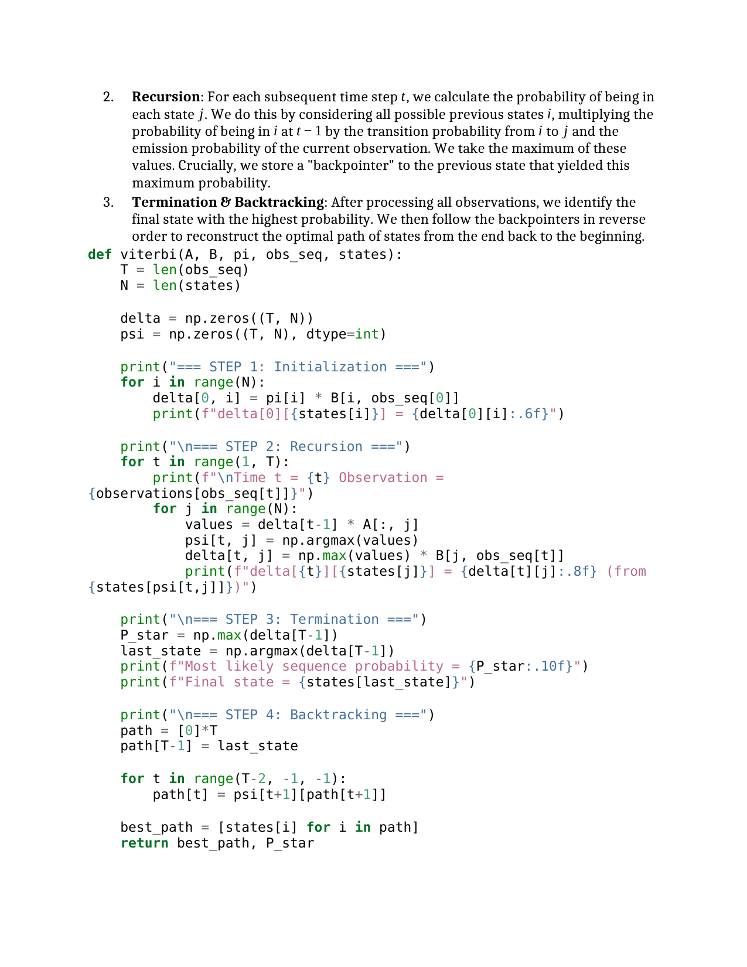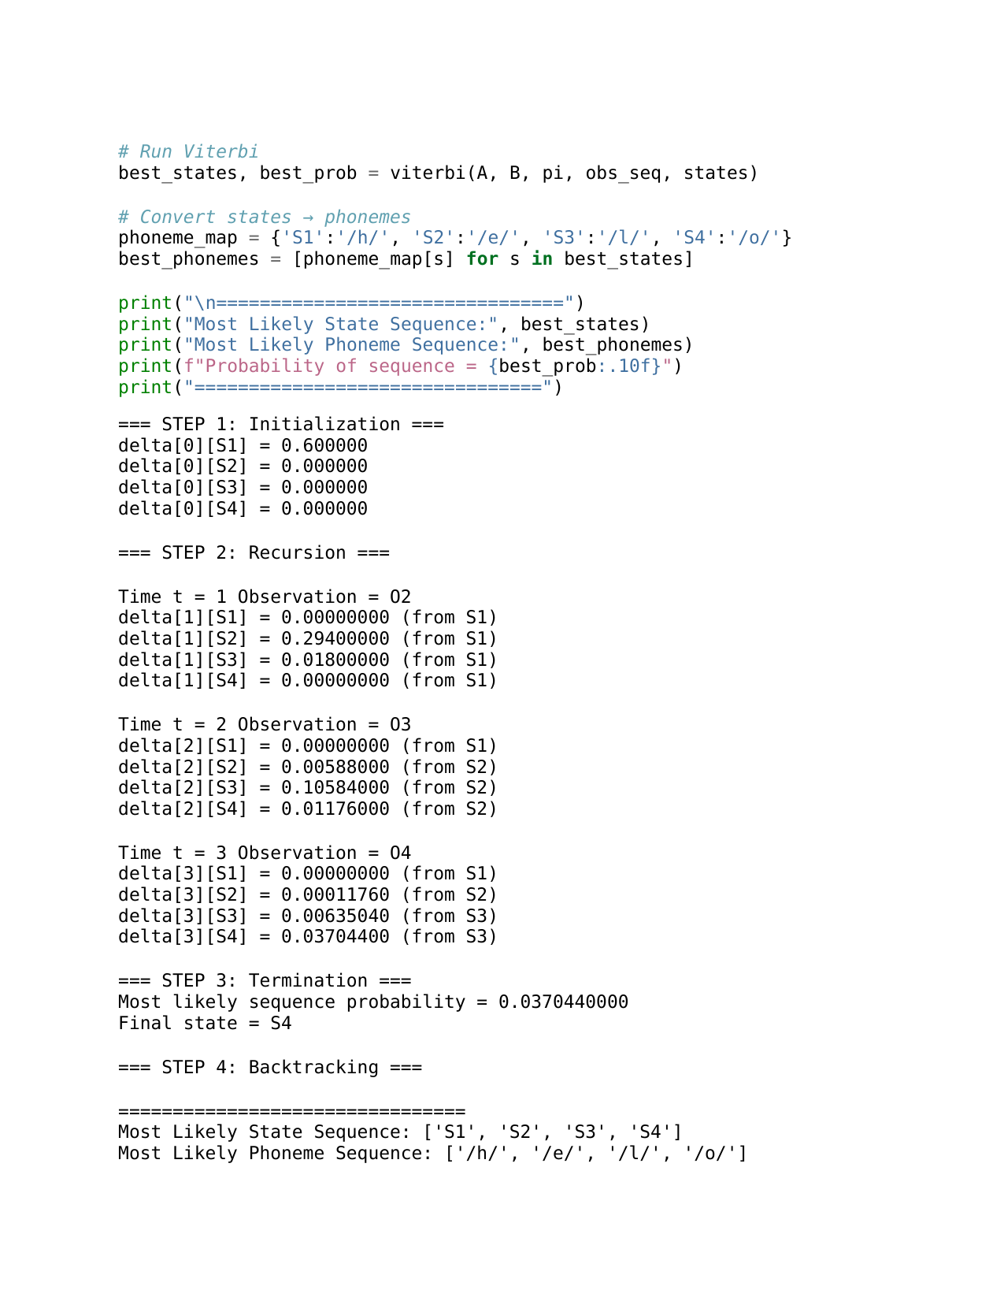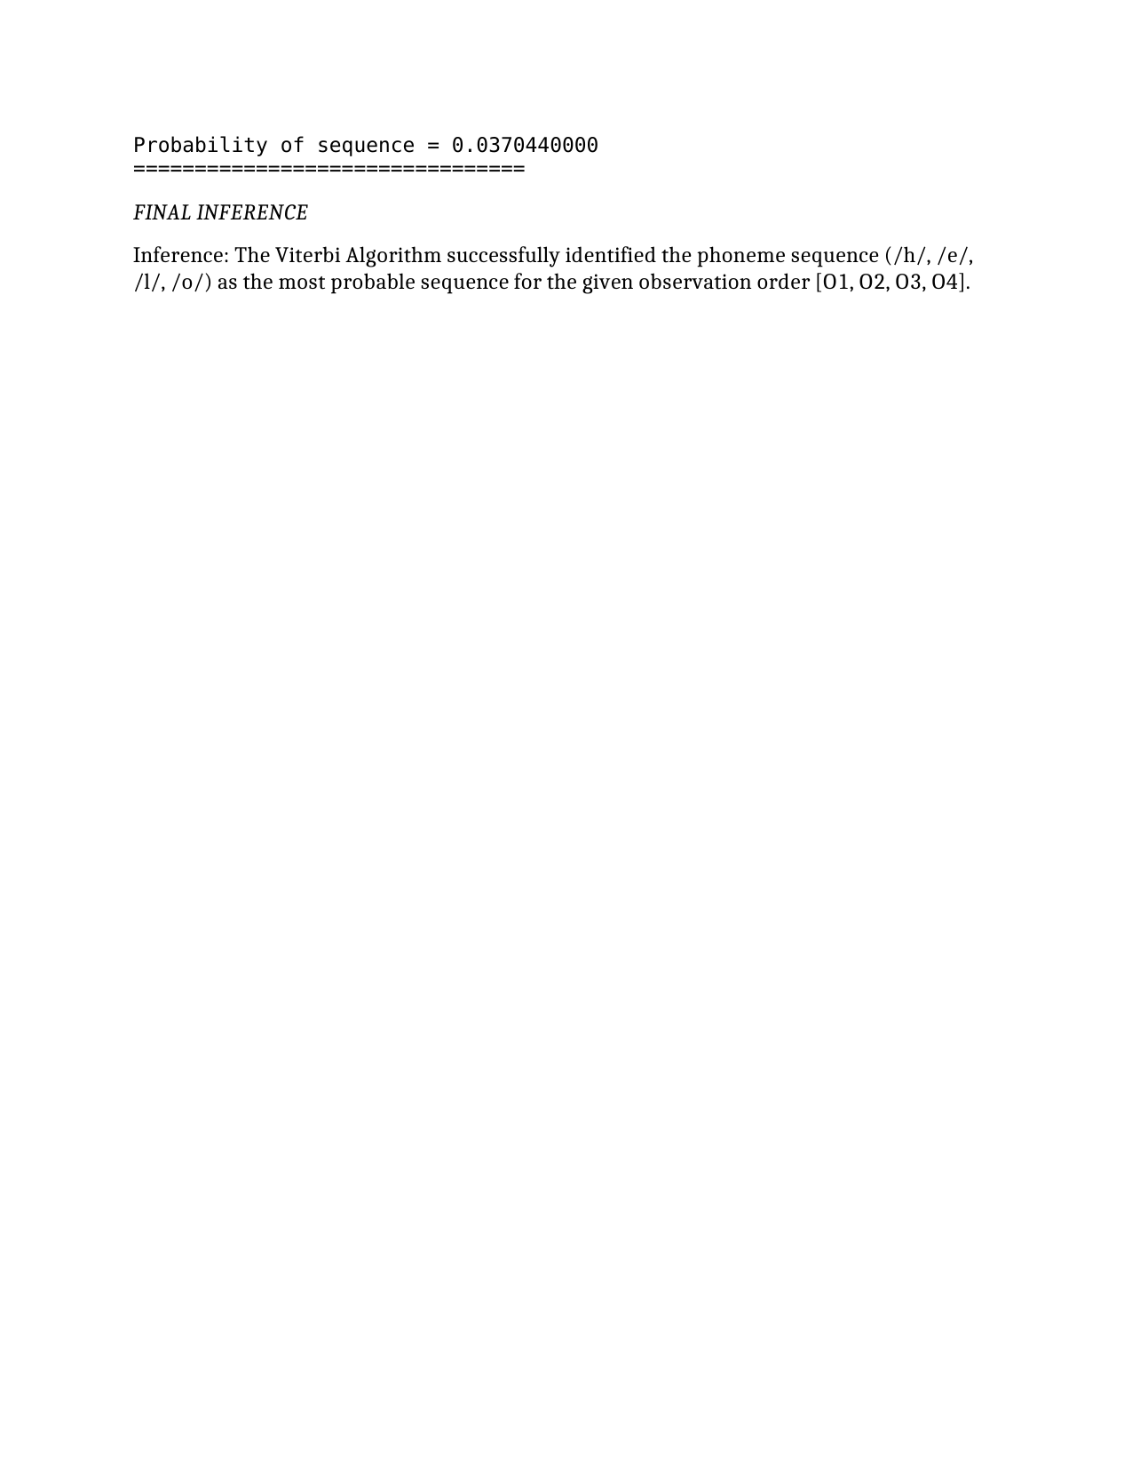

## LAB 10

### **Speech Recognition Based Telephone Directory Information Retrieval**

### **Aim**

**The aim of this lab experiment is to apply a speech recognition system to access telephone directory information from spoken spelled names. The objective is to recognize alphabets spelled by the user through speech input, convert them into text, and retrieve the corresponding contact details from a predefined telephone directory database. This experiment focuses on integrating automatic speech recognition (ASR) with information retrieval.**

### **Task**

**In a speech-enabled directory assistance system, users retrieve contact information by spelling the name of a person through voice input. The aim of this lab experiment is to implement a speech recognition-based directory listing retrieval system that recognizes spelled names and fetches the corresponding telephone number from a structured directory dataset.**

### **System Description**

**• Input (Speech Data)  
 The user spells a name letter-by-letter using voice input (e.g., “A – N – D – R – E – A”).**

**• Speech Recognition Module  
 The system uses a speech recognition engine to convert spoken alphabets into textual characters.**

**• Text Processing Module  
 The recognized characters are concatenated to form the complete name string.**

**• Telephone Directory Database  
 A predefined directory containing names and their corresponding phone numbers.**

**Example Directory Entries:  
 – Andrea → 9876543210  
 – Rahul → 9123456780  
 – Neha → 9012345678**

**• Matching & Retrieval Module  
 The recognized name is matched against the database and the corresponding telephone number is retrieved.**

### **Observation Sequence**

**The system captures a speech input sequence corresponding to the spelled name:**

**Example:  
 Spoken Input → “A – N – D – R – E – A”  
 Recognized Text → “ANDREA”**

### **Task (1)**

**(a) Implement a Speech Recognition System in Python to perform the following:  
 • Capture the user’s spoken spelled name using a microphone or sample audio file.  
 • Convert the speech input into text using a speech recognition library.  
 • Match the recognized name with the telephone directory dataset.  
 • Retrieve and display the corresponding telephone number.  
 • Handle cases where the name is not found in the directory.  
 • Write an inference based on the system performance.**

### **Expected Outcome**

**The system should correctly recognize the spoken spelled name, convert it into text format, match it with the telephone directory, and successfully retrieve the corresponding telephone number. If the spoken name is not present in the directory, the system should display an appropriate “Contact Not Found” message.**